–

Non conformity Report
IDENTIFICATION
1. Originator’s Name: B. Caserza – F. Terzi | 5. Date: 03/08/2005
2. Contractor/Supplier: Ansaldo Superconduttori S.p.A. | 6. Part description: HCMBBLA001-02000200
3. Contract No: F302/LHC/LHC | 7. Qty: 1
4. Project Engineer: F. Savary | 8. Dwg No: LHCMBB_A0002/F (683RM08451)

9. Found during what activity:
□ Incoming inspection | ☑ Final inspection
□ In-process inspection | □ Other:

10. Description of non conformity (use continuation page if necessary)
During He leak test of CM 2200, pressurized to 26 bar, an instability of the signal of leak detector installed on insulating vacuum has been detected(see annexed graph on continuation page).
In particular two instabilities has been recorded quite the end of the pressure test, but after about 15min. of stable signal.

11. Action taken to prevent misuse (use continuation page if necessary)

IMPORTANCE
12. |  ◻ Non critical | □ Critical

DISPOSITION
13. | □ Use-as-is | □ Repair | □ Reject | ◻ Rework | □ Return to supplier
Description of proposed action (use continuation page if necessary)

CORRECTIVE/PREVENTIVE ACTION
14. Description of proposed action (use continuation page if necessary)
ASG will push the operator to pay more attention about LD signal and relevant graph on chart recorder.
Operator has been informed that, in case of instabilities, the leak test shall be continued for at least 20 min. after these instabilities are reduced to background level.

APPROVAL OF NON CRITICAL NON CONFORMITIES
15 | Project Engineer: | Date:

APPROVAL OF CRITICAL NON CONFORMITIES
16 | Project Management: | Date:

CLOSURE OF THE NON CONFORMITY
Planned actions have been completed and corrective/preventive actions have been initiated
 | For non critical non conformities  Quality Manager or Project Engineer | For critical non conformities  Project Engineer
17 | Name:  Date: | Name:  Date:

10. Description of non conformity (continuation page)

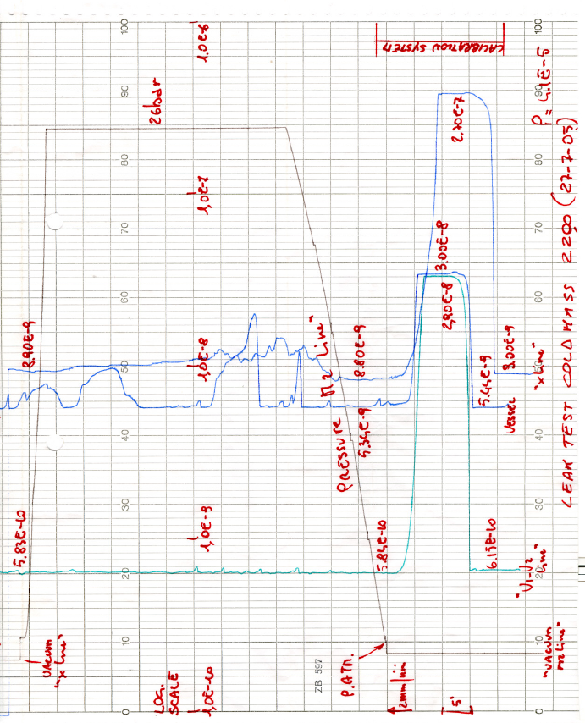
Fig. 1/1

