–

Non conformity Report
IDENTIFICATION
1. Originator’s Name: F. Terzi | 5. Date: 18/10/2005
2. Contractor/Supplier: Ansaldo Superconduttori S.p.A. | 6. Part description: HCMB__A133
3. Contract No: F462/LHC/LHC | 7. Qty:
4. Project Engineer: F. Savary, M. Bajko | 8. Dwg No:

9. Found during what activity:
☑ Incoming inspection | □ Final inspection
□ In-process inspection | □ Other:

10. Description of non conformity (use continuation page if necessary)
Yoke laminations regarding different batches received at ORMET from FSG, showed oxidation on the punched surface:
- FSG493-FSG501-FSG509-FSG510-FSG524 (already assembled in yoke packs) showed soft oxidation
- FSG530-FSG540-FSG549-FSG550 (already assembled in yoke packs) showed hard oxidation
- FSG502-FSG529 showed soft oxidation
- FSG522-FSG541 in stand-by at ORMET, not already assembled in yoke paks, showed hard oxidation

Please find some pictures on continuation page.

11. Action taken to prevent misuse (use continuation page if necessary)

IMPORTANCE
12. | □ Non critical | □ Critical

DISPOSITION
13. | □ Use-as-is | □ Repair | □ Reject | □ Rework | □ Return to supplier
Description of proposed action (use continuation page if necessary)

CORRECTIVE/PREVENTIVE ACTION
14. Description of proposed action (use continuation page if necessary)

APPROVAL OF NON CRITICAL NON CONFORMITIES
15 | Project Engineer: | Date:

APPROVAL OF CRITICAL NON CONFORMITIES
16 | Project Management: | Date:

CLOSURE OF THE NON CONFORMITY
Planned actions have been completed and corrective/preventive actions have been initiated
 | For non critical non conformities  Quality Manager or Project Engineer | For critical non conformities  Project Engineer
17 | Name:  Date: | Name:  Date:

IDENTIFICATION
10. Description of non conformity (continuation page)
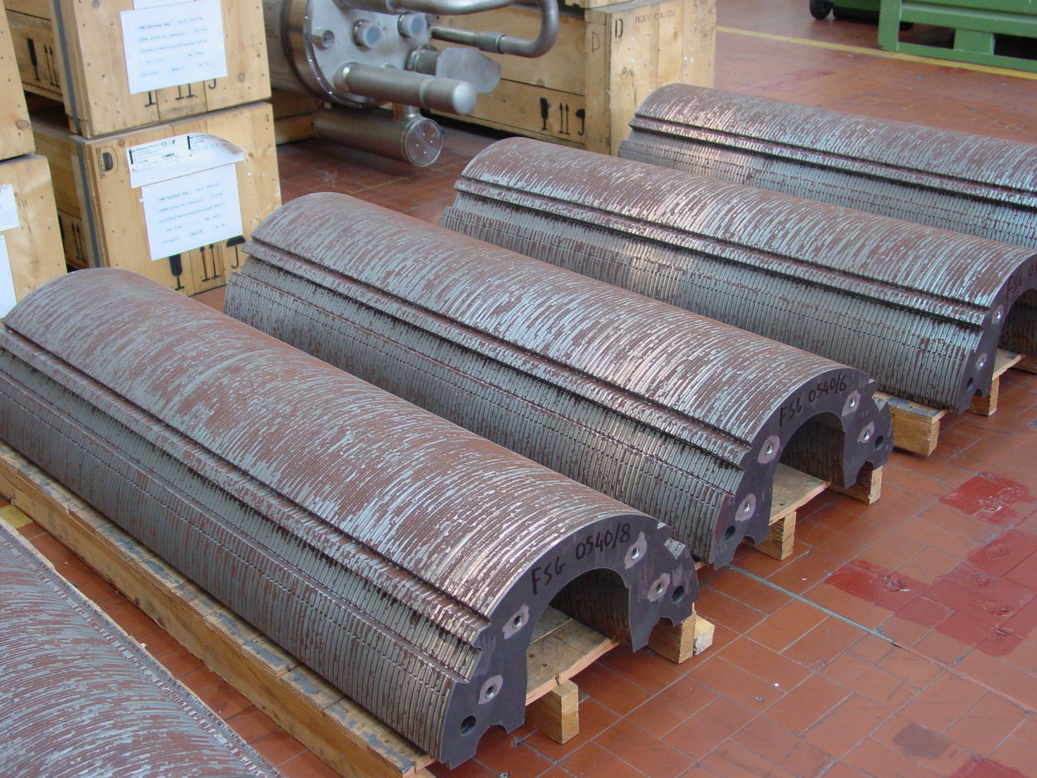
1/4 - Batch FSG540

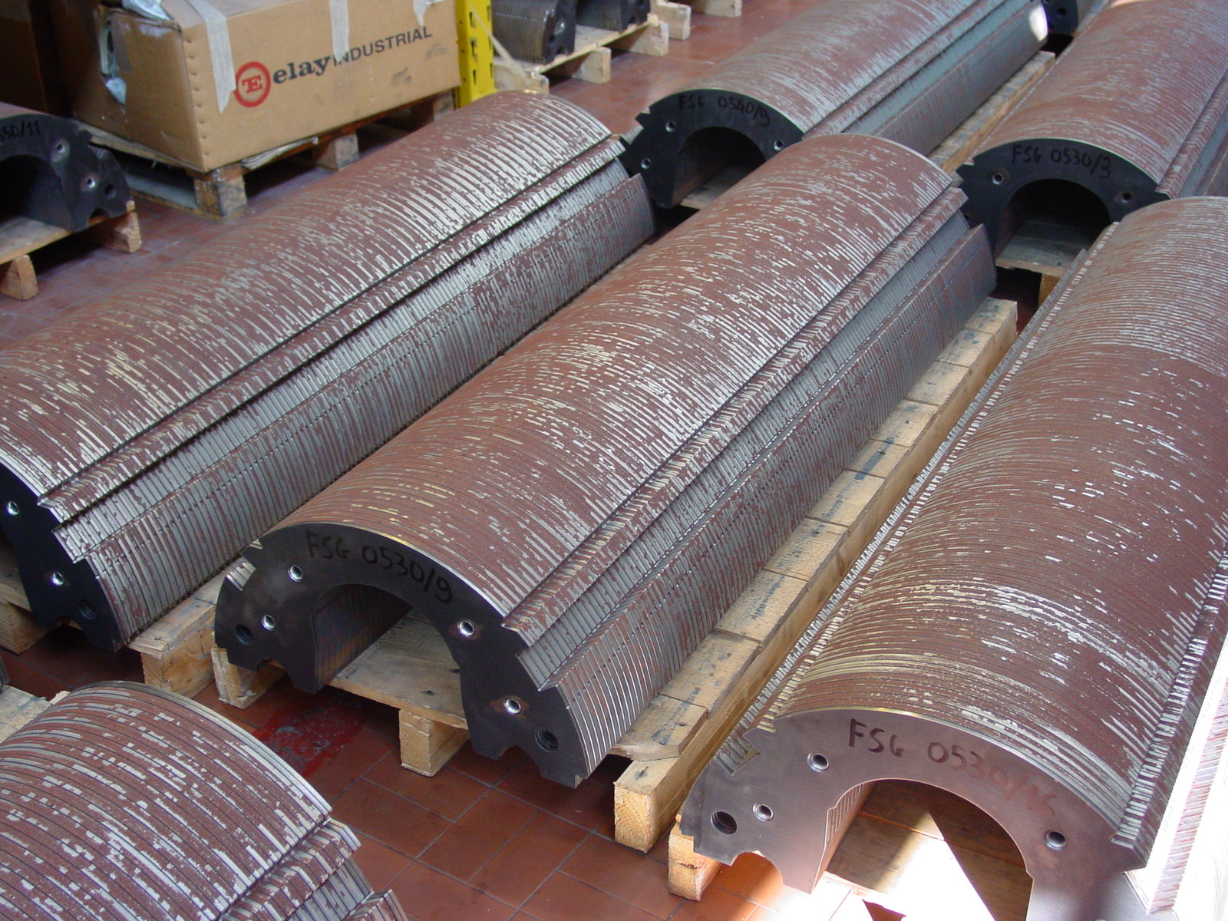
2/4 - Batch FSG530

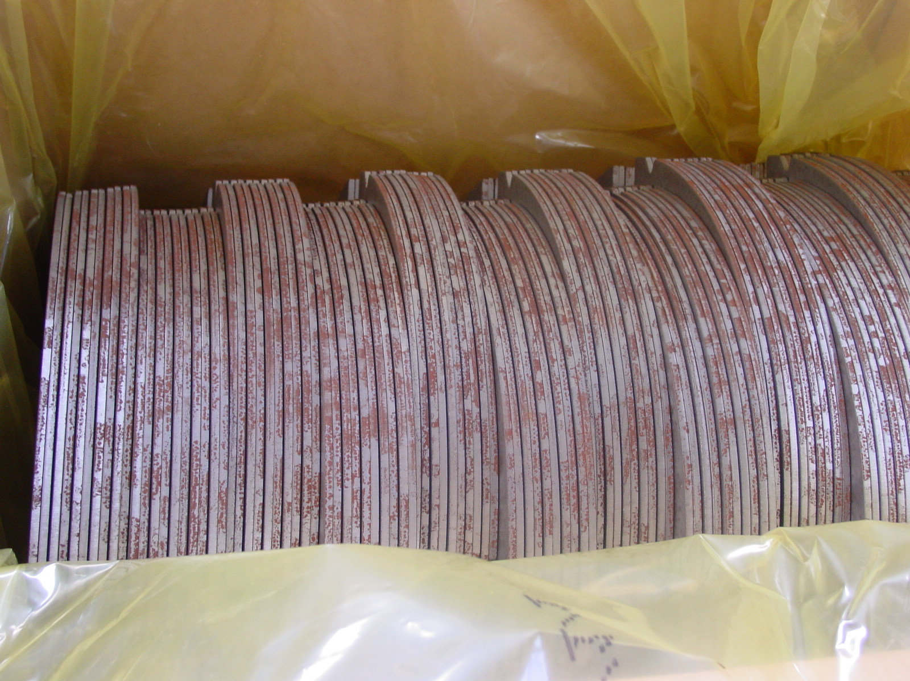
3/4 – Batch FSG541

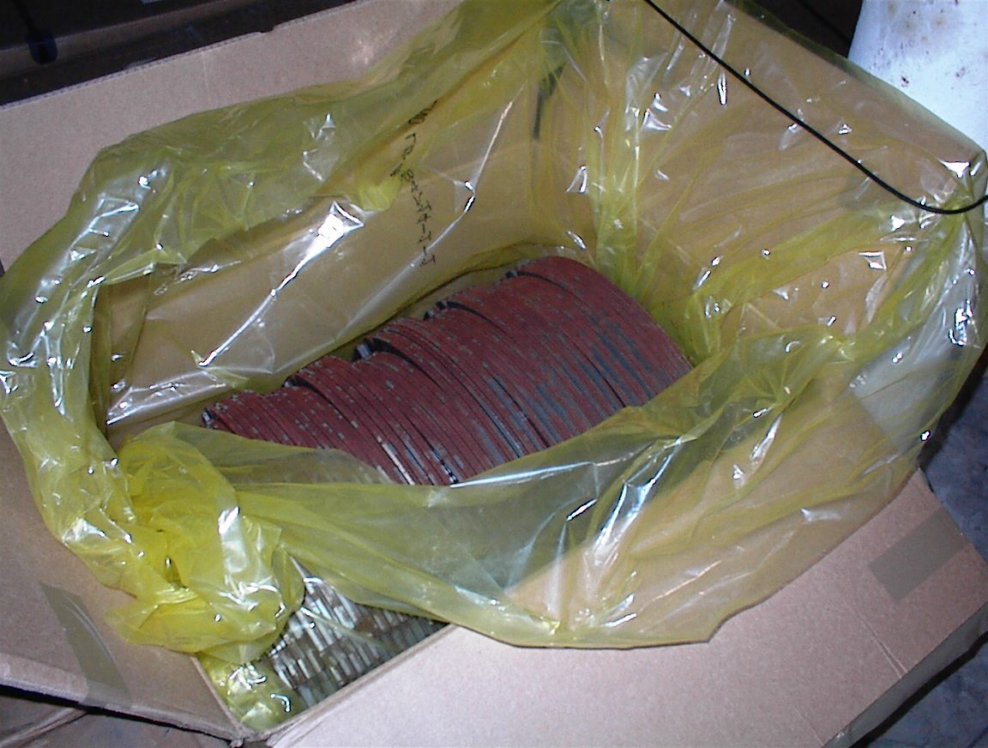
4/4 – Batch FSG522

