–

Non conformity Report
IDENTIFICATION
1. Originator’s Name: F. Terzi | 5. Date: 23/01/2006
2. Contractor/Supplier: Ansaldo Superconduttori S.p.A. | 6. Part description: HCMBBRA001-02000316
3. Contract No: F462/LHC/LHC | 7. Qty: 1
4. Project Engineer: F. Savary, M. Bajko | 8. Dwg No: LHCMBB_A0002/F (683RM08451)

9. Found during what activity:
□ Incoming inspection | ☑ Final inspection
□ In-process inspection | □ Other:

10. Description of non conformity (use continuation page if necessary)
During visual inspection of inner layer 02I01268 regarding CM 2316, a large defect has been detected (see annexed pictures on continuation page).
The damage has been caused by a pin detached from the tooling we are using for stiffening the coil end on winding machine.
The operator couldn't see that pin during winding because it was under the tool.

11. Action taken to prevent misuse (use continuation page if necessary)

IMPORTANCE
12. |  □ Non critical | □ Critical

DISPOSITION
13. | □ Use-as-is | □ Repair | □ Reject | □ Rework | □ Return to supplier
Description of proposed action (use continuation page if necessary)
The damaged layer has been rejected: ASG put aside that layer for CERN inspection.
ASG is also asking CERN for a new inner layer cable.

CORRECTIVE/PREVENTIVE ACTION
14. Description of proposed action (use continuation page if necessary)

APPROVAL OF NON CRITICAL NON CONFORMITIES
15 | Project Engineer: | Date:

APPROVAL OF CRITICAL NON CONFORMITIES
16 | Project Management: | Date:

CLOSURE OF THE NON CONFORMITY
Planned actions have been completed and corrective/preventive actions have been initiated

 | For non critical non conformities  Quality Manager or Project Engineer | For critical non conformities  Project Engineer
17 | Name:  Date: | Name:  Date:

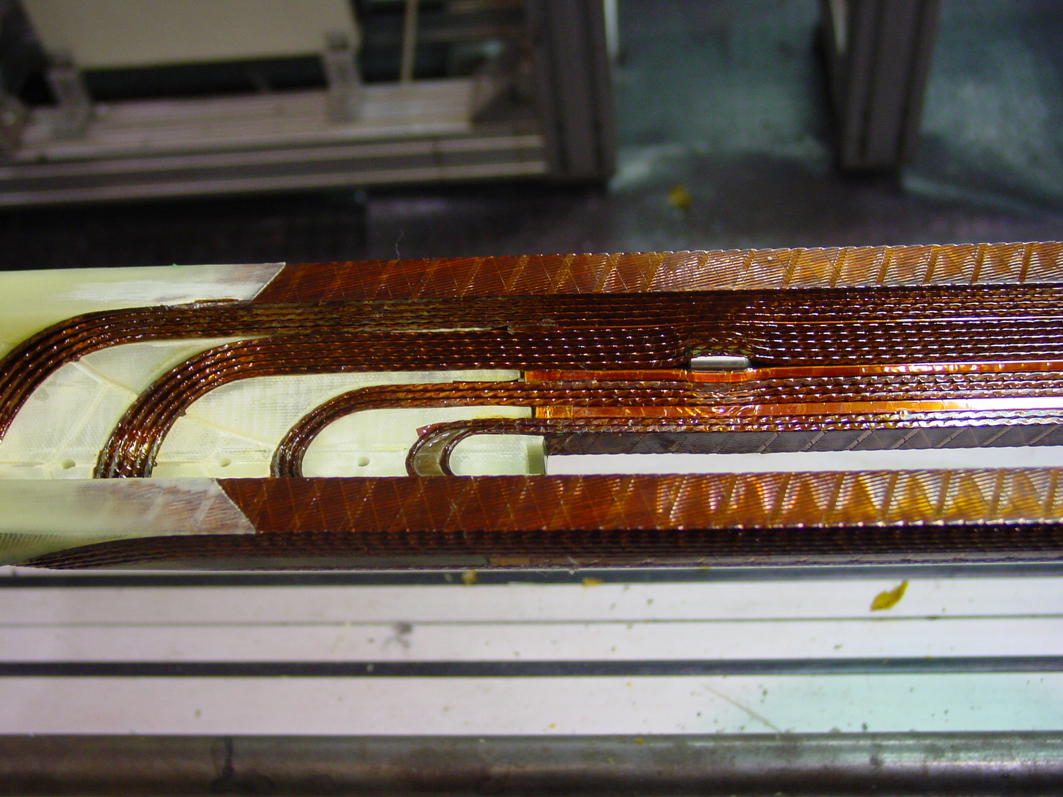
1/4

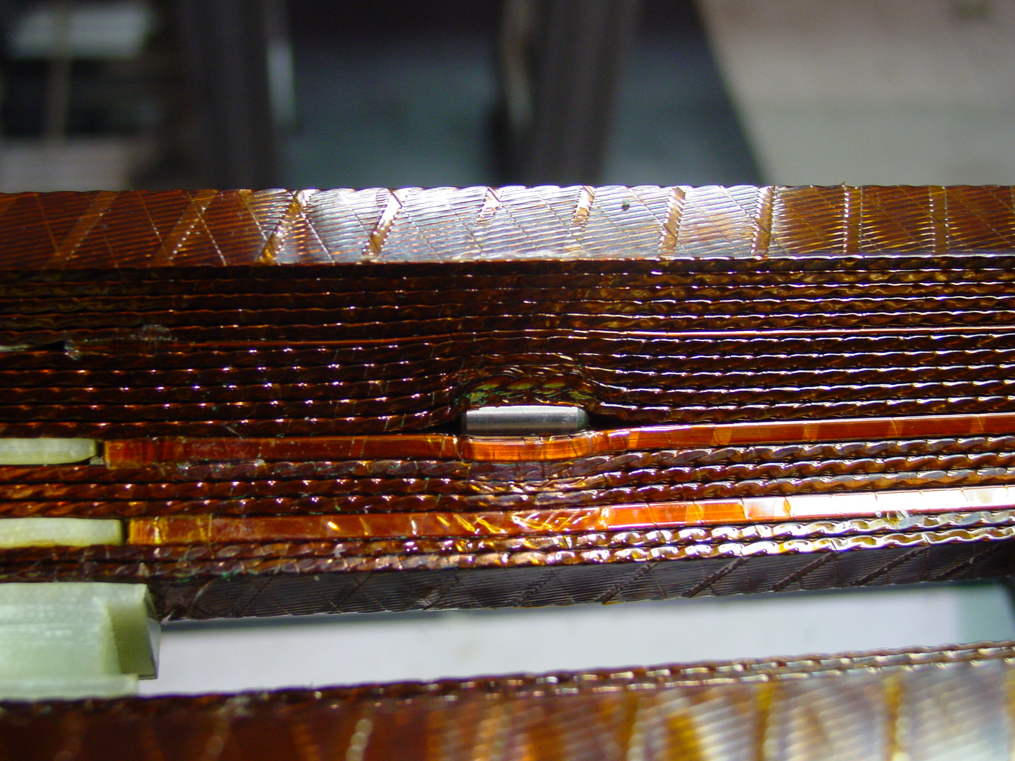
2/4

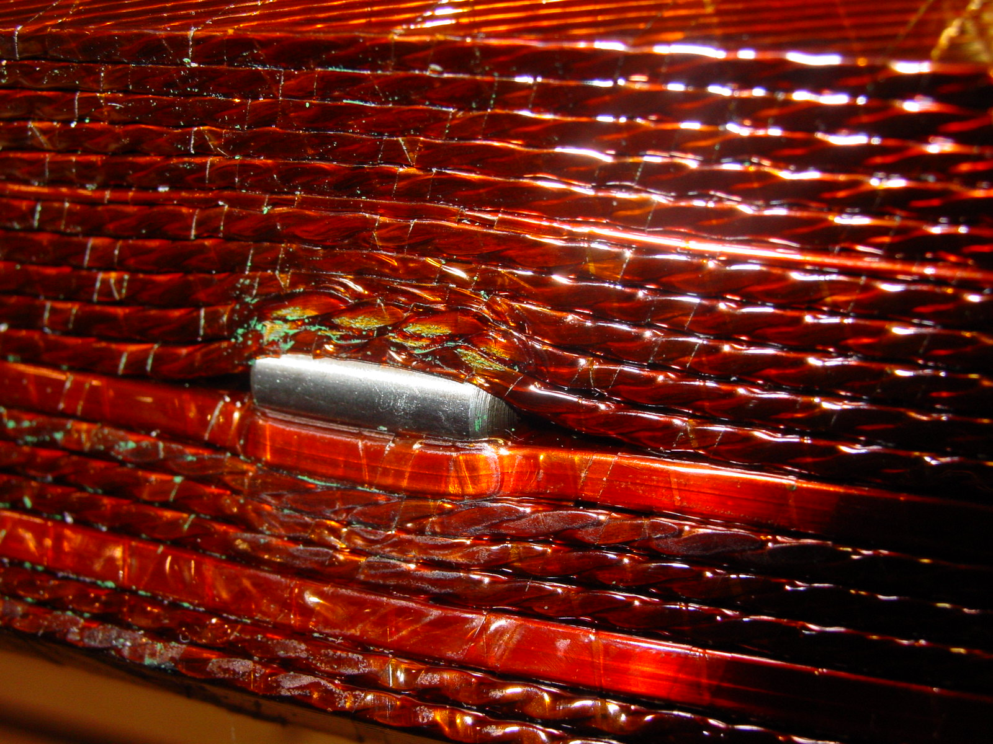
3/4

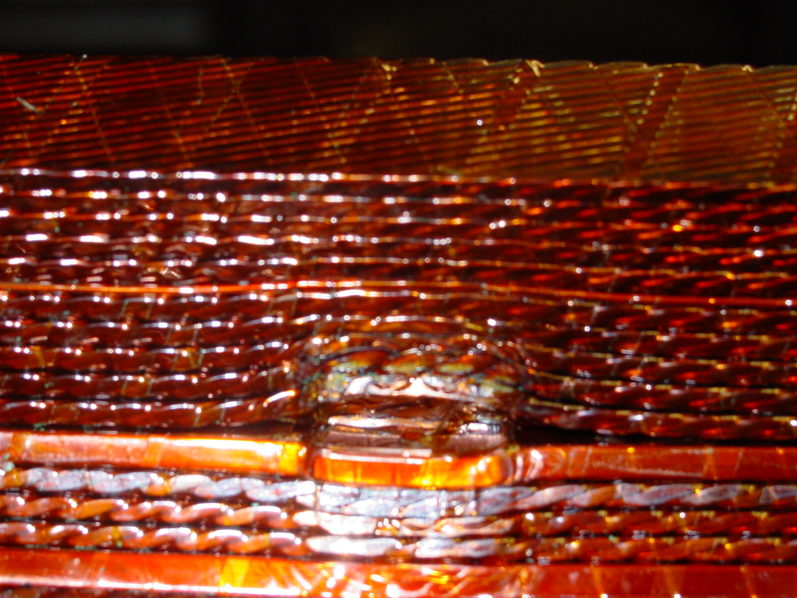
4/4

