–

Non conformity Report
IDENTIFICATION
1. Originator’s Name: F. Terzi | 5. Date: 10/02/2006
2. Contractor/Supplier: Ansaldo Superconduttori S.p.A. | 6. Part description: HCMB__A001-02000324
3. Contract No: F462/LHC/LHC | 7. Qty: 1
4. Project Engineer: F. Savary, M. Bajko | 8. Dwg No: LHCMB__A0012/E (620RM08202/F)

9. Found during what activity:
☑ Incoming inspection | □ Final inspection
□ In-process inspection | □ Other:

10. Description of non conformity (use continuation page if necessary)
During winding of inner layer nr. 02I01300 (sc cable nr. 01E00351E) for CM 2324, a crash of the winding mandrel caused the damage of the coil (see annexed picture on continuation page).
This crash has been caused by a wrong clamping of the mandrel to the frame of the winding machine.
All the personnel has been pushed to pay more attention in checking the tooling and the machine before starting winding process.

11. Action taken to prevent misuse (use continuation page if necessary)

IMPORTANCE
12. | ☑ Non critical | □ Critical

DISPOSITION
13. | □ Use-as-is | □ Repair | ☑ Reject | □ Rework | □ Return to supplier
Description of proposed action (use continuation page if necessary)
Inner layer 02I01300 shall be rejected.
ASG is asking CERN a new inner layer cable.

CORRECTIVE/PREVENTIVE ACTION
14. Description of proposed action (use continuation page if necessary)

APPROVAL OF NON CRITICAL NON CONFORMITIES
15 | Project Engineer: | Date:

APPROVAL OF CRITICAL NON CONFORMITIES
16 | Project Management: | Date:

CLOSURE OF THE NON CONFORMITY
Planned actions have been completed and corrective/preventive actions have been initiated
 | For non critical non conformities  Quality Manager or Project Engineer | For critical non conformities  Project Engineer
17 | Name:  Date: | Name:  Date:

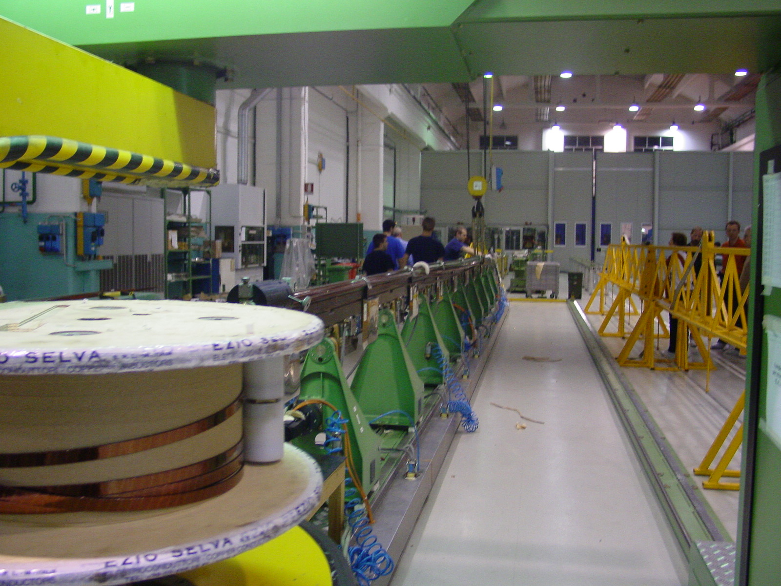
1/3

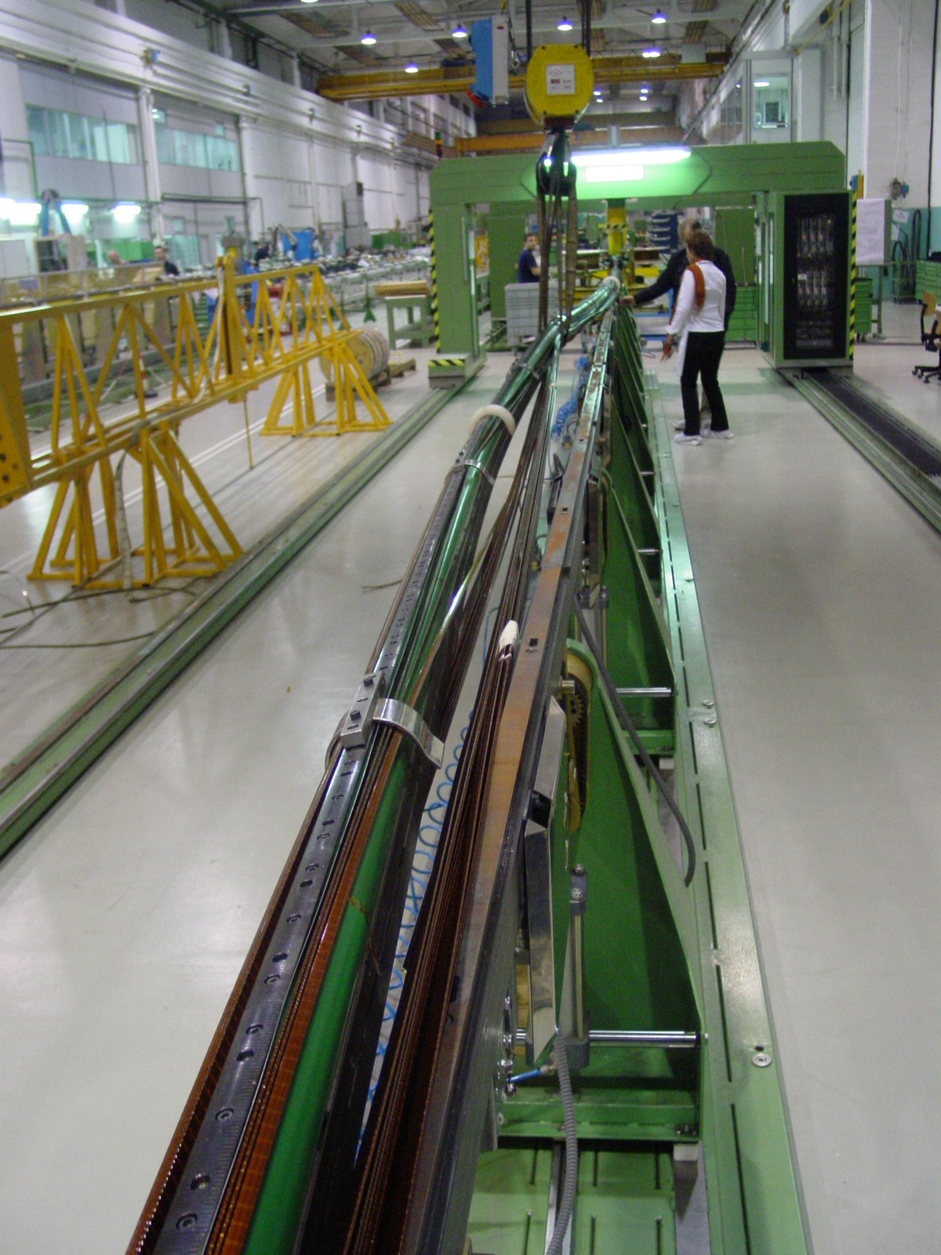
2/3
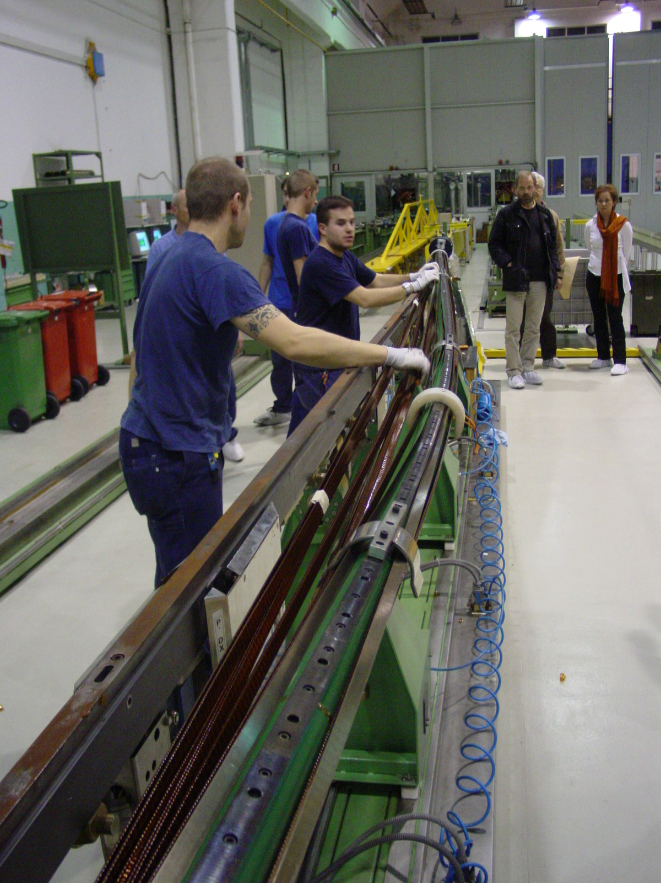
3/3

