–

Non conformity Report
IDENTIFICATION
1. Originator’s Name: F. Terzi | 5. Date: 10/02/2006
2. Contractor/Supplier: Ansaldo Superconduttori S.p.A. | 6. Part description: HCMB__A001-02000303
3. Contract No: F462/LHC/LHC | 7. Qty: 1
4. Project Engineer: F. Savary | 8. Dwg No: LHCMB__A0001/G (620RM08234/L)

9. Found during what activity:
□ Incoming inspection | □ Final inspection
☑ In-process inspection | □ Other:

10. Description of non conformity (use continuation page if necessary)
Warm magnetic measurements carried out on the collared coils 2303 showed anomalies (yellow alarms) in high order multipoles b8, b11, b12, a6, a9, a12, and a14 on position #9 of the straigth part in Aperture 2.
A second measurement with the short mole (0.125mm coil length) confirmed these results. Aperture 1 is OK.
(ref. test report nr. HCMB__A001-02000303_cc.xls)

11. Action taken to prevent misuse (use continuation page if necessary)

IMPORTANCE
12. | □ Non critical | □ Critical

DISPOSITION
13. | □ Use-as-is | □ Repair | □ Reject | □ Rework | □ Return to supplier
Description of proposed action (use continuation page if necessary)
CERN personnel (Mr. E.Todesco and Ms. C.Vollinger) made further data analysis that indicated an inward movement of the inner layer cable of 1.1mm (Ap.2 – Upper pole).
Then CERN asked ASG to open the collared coil to check the cable position.
The collared coil has been opened on February, 9th under the witness of CERN people (Ms. Bajko, Mr. Musso and Ms. Vollinger)
Dimensional check of cable position about inner layer 02I01215 showed an inward movement of 1st and 2nd turns of 1.1mm, at 1300mm from coil centre, toward CS (see annexed pictures on continuation page).
However all the turns were perfectly glued to each other.

CORRECTIVE/PREVENTIVE ACTION
14. Description of proposed action (use continuation page if necessary)
The coils can be used as is. The magnets should be assembled and tested with high priority. During cold test detailed quench detection will be asked, especially to verify the origin of quench w.r.t the zone where the cable displacement was found.

APPROVAL OF NON CRITICAL NON CONFORMITIES
15 | Project Engineer: Marta Bajko | Date:16.02.2006

APPROVAL OF CRITICAL NON CONFORMITIES
16 | Project Management: | Date:

CLOSURE OF THE NON CONFORMITY
Planned actions have been completed and corrective/preventive actions have been initiated
 | For non critical non conformities  Quality Manager or Project Engineer | For critical non conformities  Project Engineer
17 | Name:  Date: | Name:  Date:
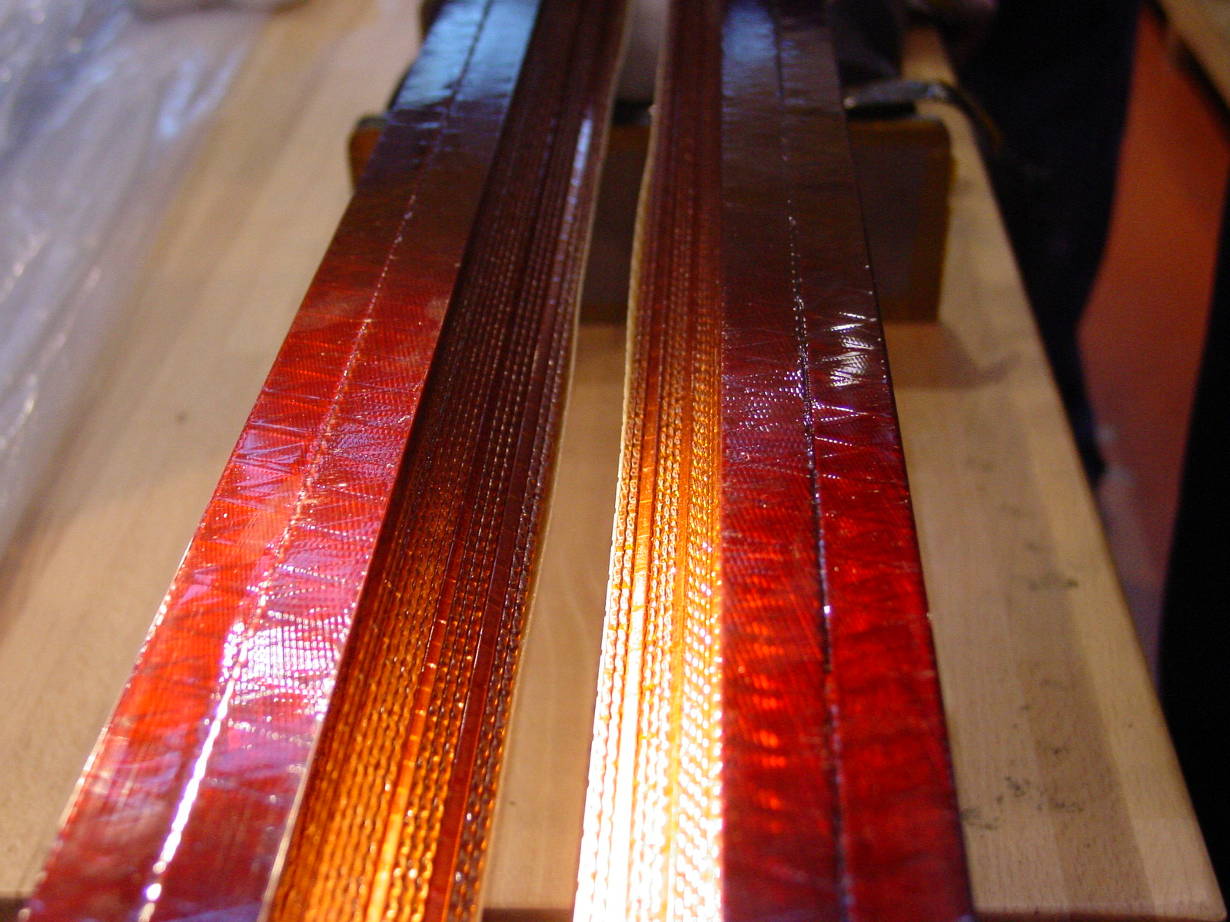
1/2 – I.L. n. 02I01215
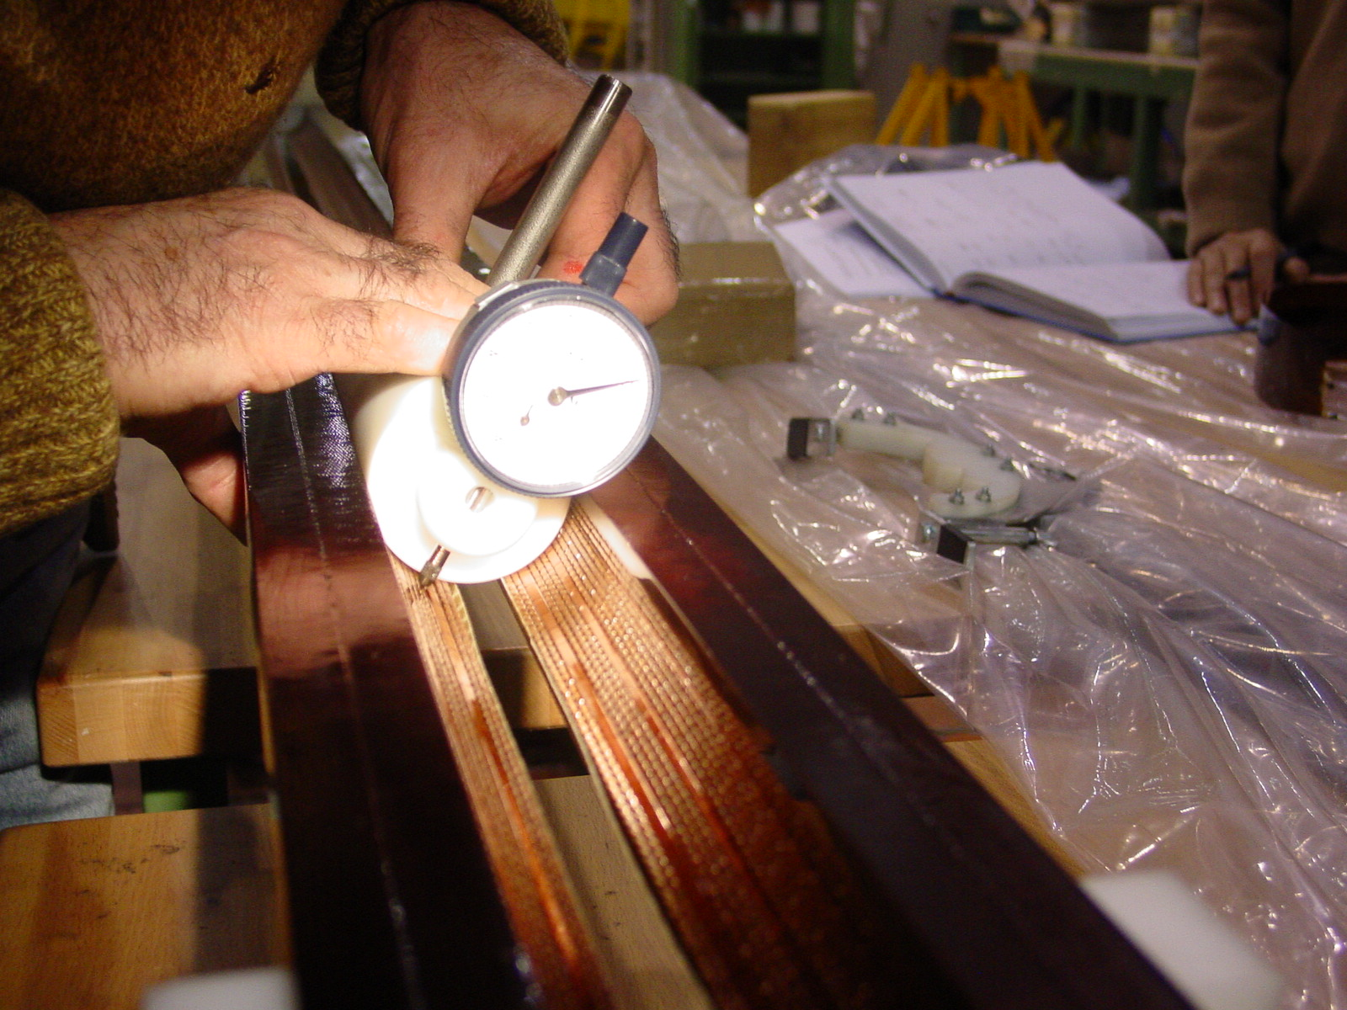
2/2 - Special tooling used to check the position of cables of inner layer

