–

Non conformity Report
IDENTIFICATION
1. Originator’s Name: B. Caserza – F. Terzi | 5. Date: 07-03-2006
2. Contractor/Supplier: Ansaldo Superconduttori S.p.A. | 6. Part description: HCMB__A100-MAL00765
3. Contract No: F462/LHC/LHC | 7. Qty: 1
4. Project Engineer: F. Savary, M. Bajko | 8. Dwg No: LHCMB__A0100 rev. C

9. Found during what activity:
☑ Incoming inspection | □ Final inspection
□ In-process inspection | □ Other:

10. Description of non conformity (use continuation page if necessary)
A dimensional check of collars A type 2 regarding batch nr. MAL00765 has been performed.
We found non-conforming values about the thickness of the laminations near the punching zone.
Measured value: 0.31 mm (nom. value = 0.2 ± 0.03 mm)
See also attached pictures on continuation pages.
This creates dimensional problems during assembling of collars pack.

11. Action taken to prevent misuse (use continuation page if necessary)

IMPORTANCE
12. | □ Non critical | □ Critical

DISPOSITION
13. | □ Use-as-is | □ Repair | □ Reject | □ Rework | □ Return to supplier
Description of proposed action (use continuation page if necessary)
ASG is proposing to sent back to Malvestiti all the collars regarding batch nr. MAL00765 .

CORRECTIVE/PREVENTIVE ACTION
14. Description of proposed action (use continuation page if necessary)

APPROVAL OF NON CRITICAL NON CONFORMITIES
15 | Project Engineer: | Date:

APPROVAL OF CRITICAL NON CONFORMITIES
16 | Project Management: | Date:

CLOSURE OF THE NON CONFORMITY
Planned actions have been completed and corrective/preventive actions have been initiated
 | For non critical non conformities  Quality Manager or Project Engineer | For critical non conformities  Project Engineer
17 | Name:  Date: | Name:  Date:

10. Description of non conformity (continuation page)

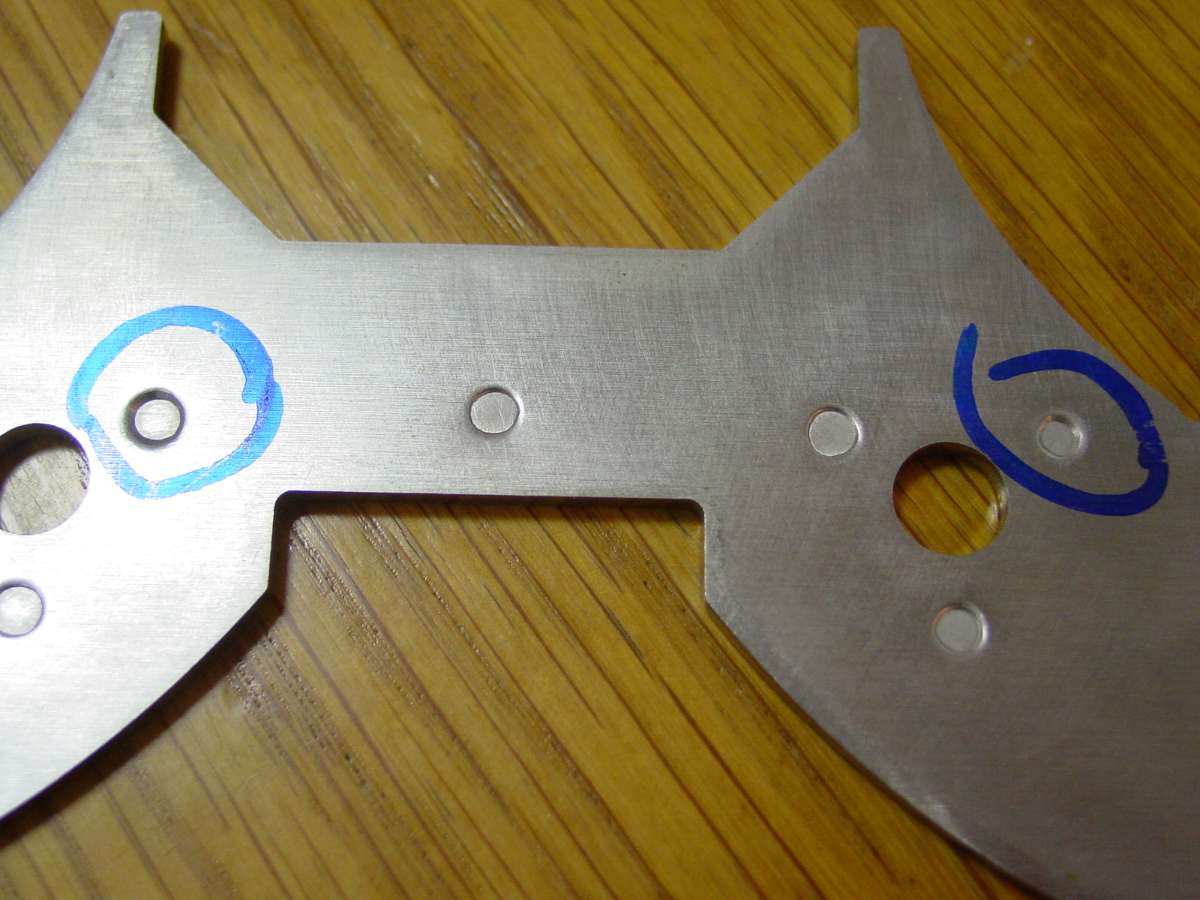
1/5

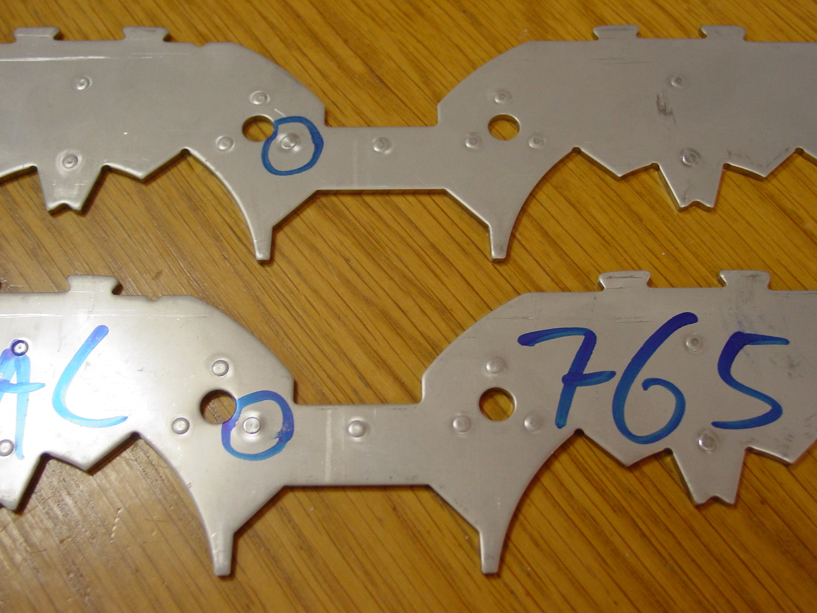
2/5

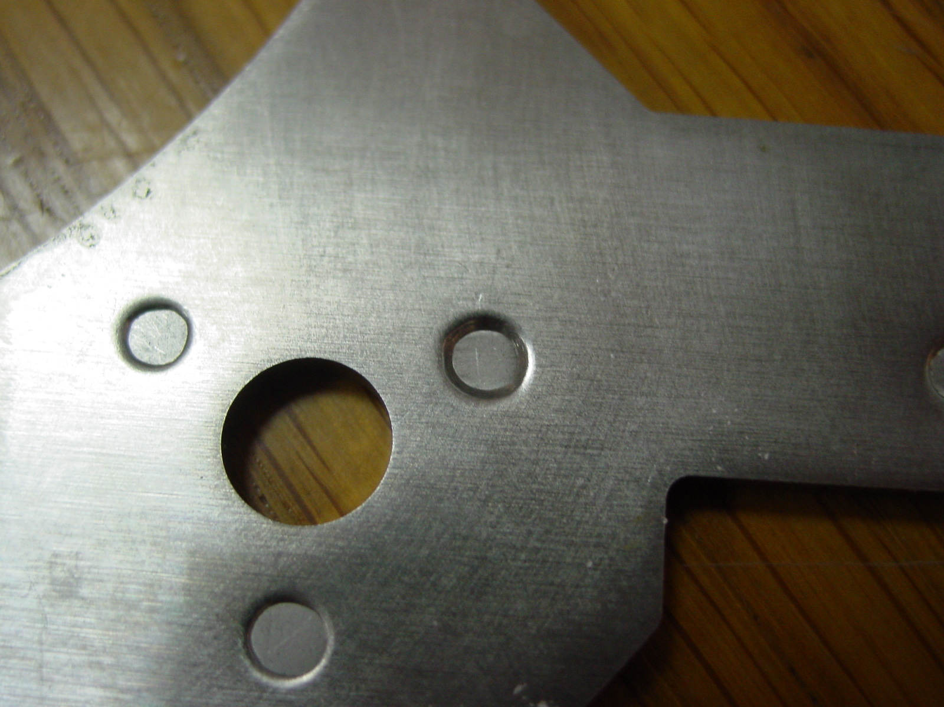
3/5

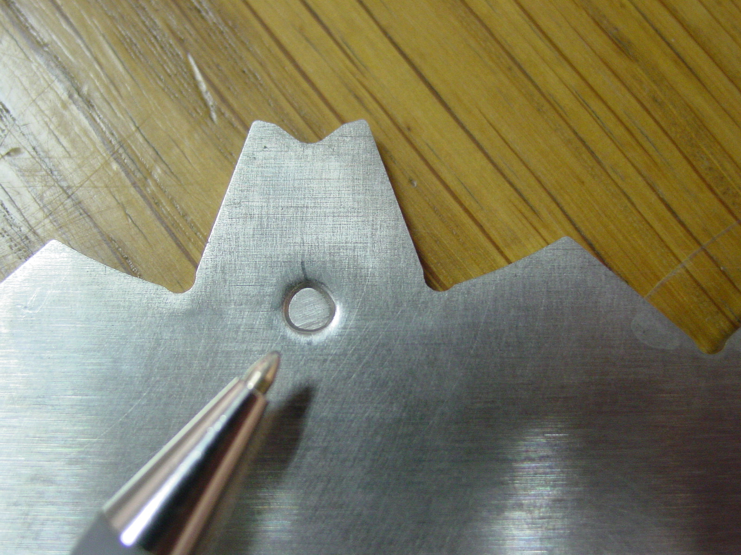
4/5

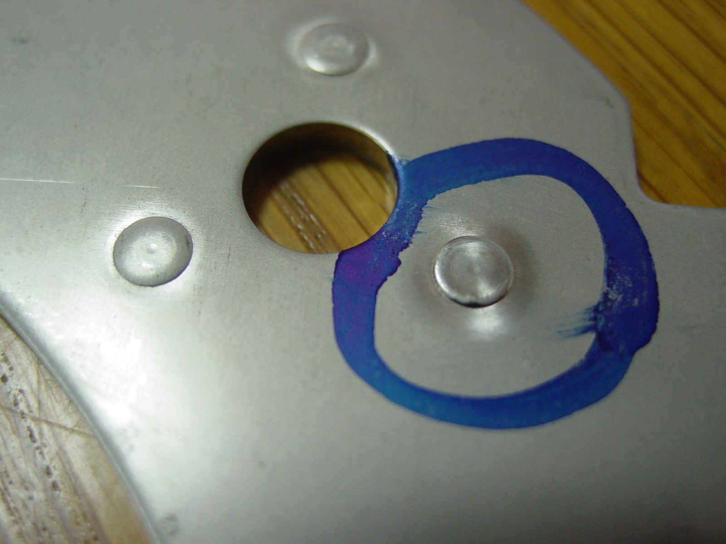
5/5

