–

Non conformity Report
IDENTIFICATION
1. Originator’s Name: F. Terzi, B. Caserza | 5. Date: 20/03/2006
2. Contractor/Supplier: Ansaldo Superconduttori S.p.A. | 6. Part description: HCMB__A001-02000303
3. Contract No: F462/LHC/LHC | 7. Qty: 1
4. Project Engineer: F. Savary, M. Bajko | 8. Dwg No: LHCMB__A0001/G (620RM08234/L)

9. Found during what activity:
□ Incoming inspection | □Final inspection
☑ In-process inspection | □ Other:

10. Description of non conformity (use continuation page if necessary)
After re-collaring of CC 2303, high energy discharge test, at 850V, on QHs, showed anomalies of the discharge curve.
See attached pictures of results, the strange behaviour clearly indicated with a normal curve as reference added!!!!
CC has been de-collared, then a visual check showed a s.s. strip burnt near the "omega" piece connection on NCS.
Position: D1-UPPER, strip id. YT121+; QH id. nr. ASG-CICO-B01128)

11. Action taken to prevent misuse (use continuation page if necessary)

IMPORTANCE
12. | ☑ Non critical | □ Critical

DISPOSITION
13. | □ Use-as-is | □ Repair | □ Reject | ☑ Rework | □ Return to supplier
Description of proposed action (use continuation page if necessary)
ASG proceed to open the CC and change all the necessary components (quench heaters, coils protection sheets, ground insulation, cold bore tubes).

CORRECTIVE/PREVENTIVE ACTION
14. Description of proposed action (use continuation page if necessary)

APPROVAL OF NON CRITICAL NON CONFORMITIES
15 | Project Engineer: Marta Bajko | Date: 29th of March 2006

APPROVAL OF CRITICAL NON CONFORMITIES
16 | Project Management: | Date:

CLOSURE OF THE NON CONFORMITY
Planned actions have been completed and corrective/preventive actions have been initiated
Cold bore tubes (MB-CBT-2062 & MB-CBT-2058) have been changed with new ones (MB-CBT-0817 & MB-CBT-0813)
Re-collaring and acceptance tests completed successfully.
 | For non critical non conformities  Quality Manager or Project Engineer | For critical non conformities  Project Engineer
17 | Name: F. Terzi  Date: 20/04/2006 | Name:  Date:

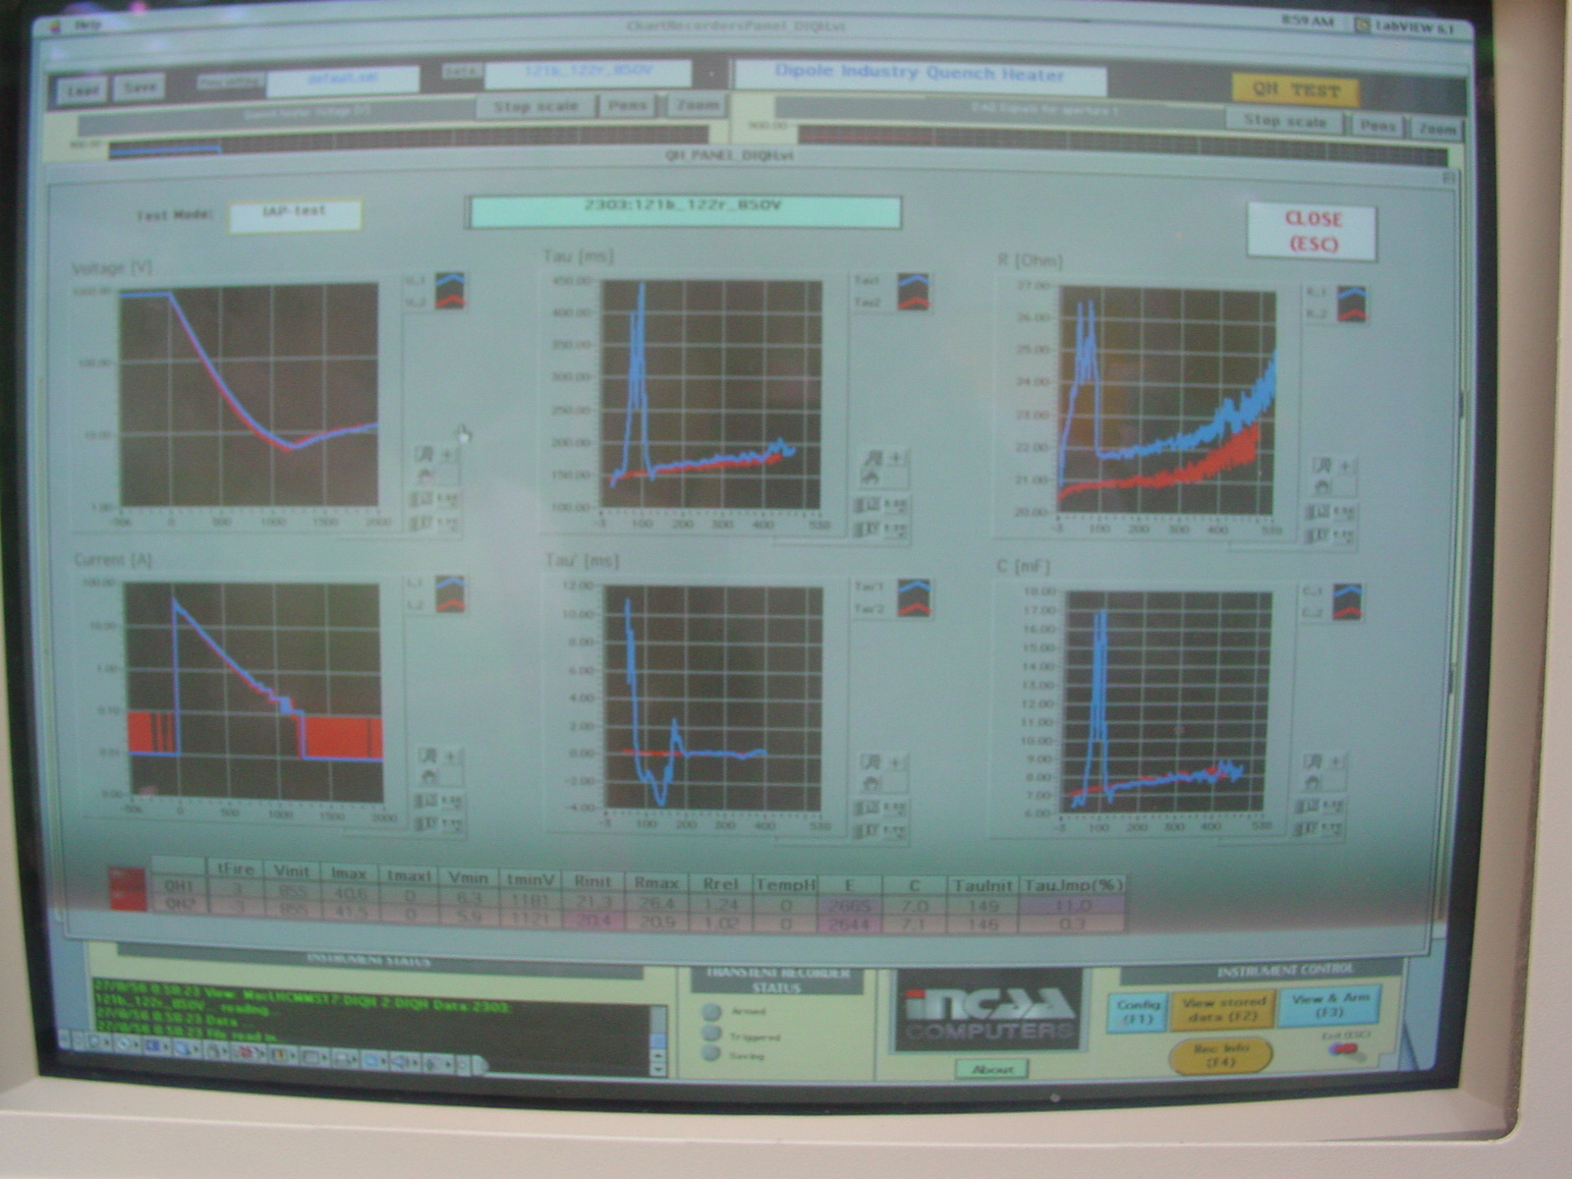
Figure 1/2. Results obtained : red one OK , blue one with error

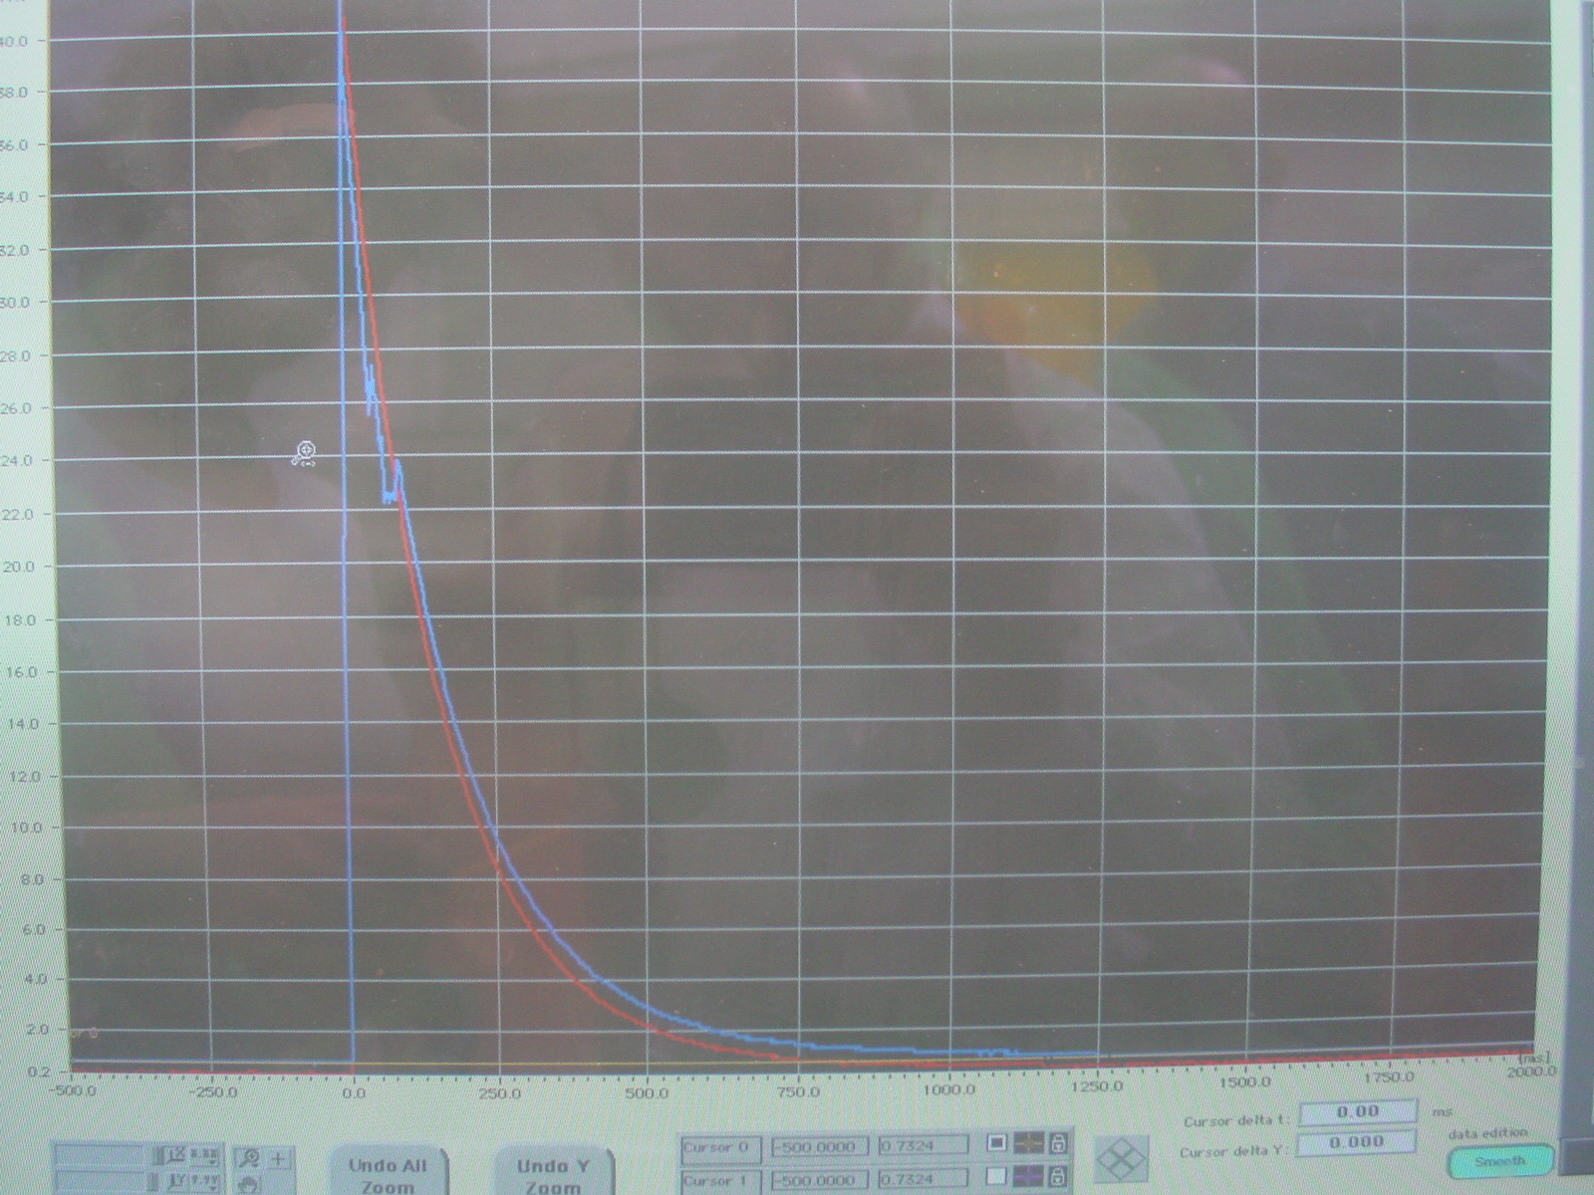
Figure 2/2. Results obtained: red one OK , blue one with error

