–

Non conformity Report
IDENTIFICATION
1. Originator’s Name: B.Caserza, F. Terzi | 5. Date: 24/03/2006
2. Contractor/Supplier: Ansaldo Superconduttori S.p.A. | 6. Part description: HCMBARA001-02000314
3. Contract No: F462/LHC/LHC | 7. Qty: 1
4. Project Engineer: F. Savary, M. Bajko | 8. Dwg No: LHCMBB_A0002/F (683RM08451)

9. Found during what activity:
□ Incoming inspection | □ Final inspection
◻ In-process inspection | ☑ Other: shipping operation

10. Description of non conformity (use continuation page if necessary)
During handling of CM 2314, its diode container and relevant components have been damaged.
See annexed photos.

11. Action taken to prevent misuse (use continuation page if necessary)

IMPORTANCE
12. | ☑ Non critical | □ Critical

DISPOSITION
13. | □ Use-as-is | □ Repair | □ Reject | ☑ Rework | □ Return to supplier
Description of proposed action (use continuation page if necessary)
ASG will proceed with dismantle of the diode container.
Diode container, "T" connecting piece and all other damaged components will be rejected and changed with new ones or repaired with a slightly different geometry in order to compensate the length of the cut pieces. ( see attached picture 4-6/6 showing the piece as is ordered. This will be then adapted to the real dimensions on site). The diode will be dismantled and sent back to CERN for inspection. Geometrical check, electrical test and leak detection will be performed again after the rework. ASG will keep informed CERN about re-assembling operations.

CORRECTIVE/PREVENTIVE ACTION
14. Description of proposed action (use continuation page if necessary)

APPROVAL OF NON CRITICAL NON CONFORMITIES
15 | Project Engineer: Marta Bajko | Date:29th of March 2006

APPROVAL OF CRITICAL NON CONFORMITIES
16 | Project Management: | Date:

CLOSURE OF THE NON CONFORMITY
Planned actions have been completed and corrective/preventive actions have been initiated
Rework completed: modified "T" piece and new diode container installed.
Final electrical measurements performed again, leak test completed successfully.
 | For non critical non conformities  Quality Manager or Project Engineer | For critical non conformities  Project Engineer
17 | Name: F. Terzi  Date: 11/04/2006 | Name:  Date:

10. Description of non conformity (continuation page)
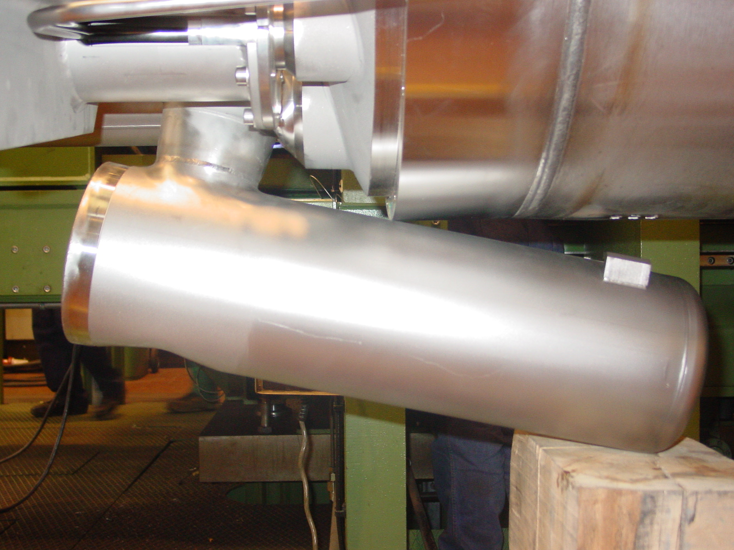
Figure 1/6. Diode container after accident before being cut from the cold mass
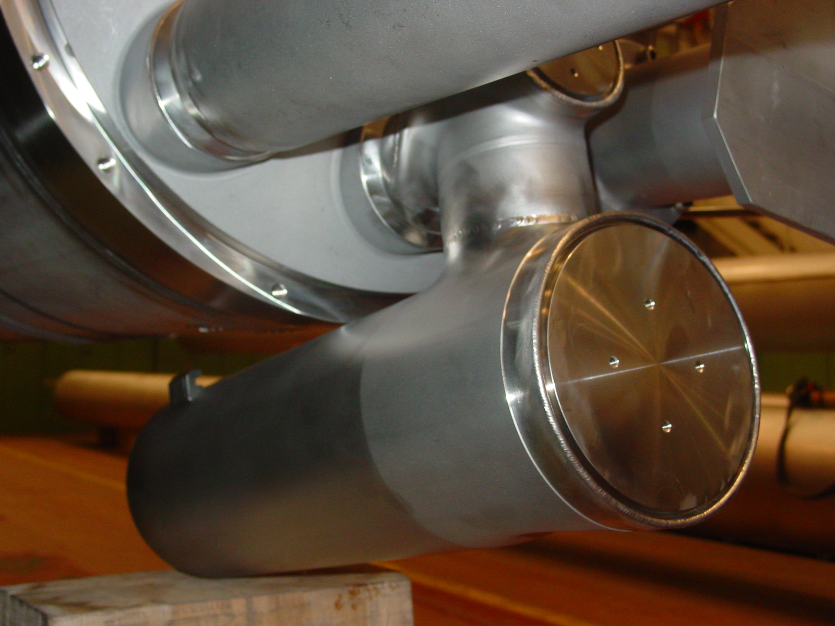
Figure 2/6. Diode Container after the accident
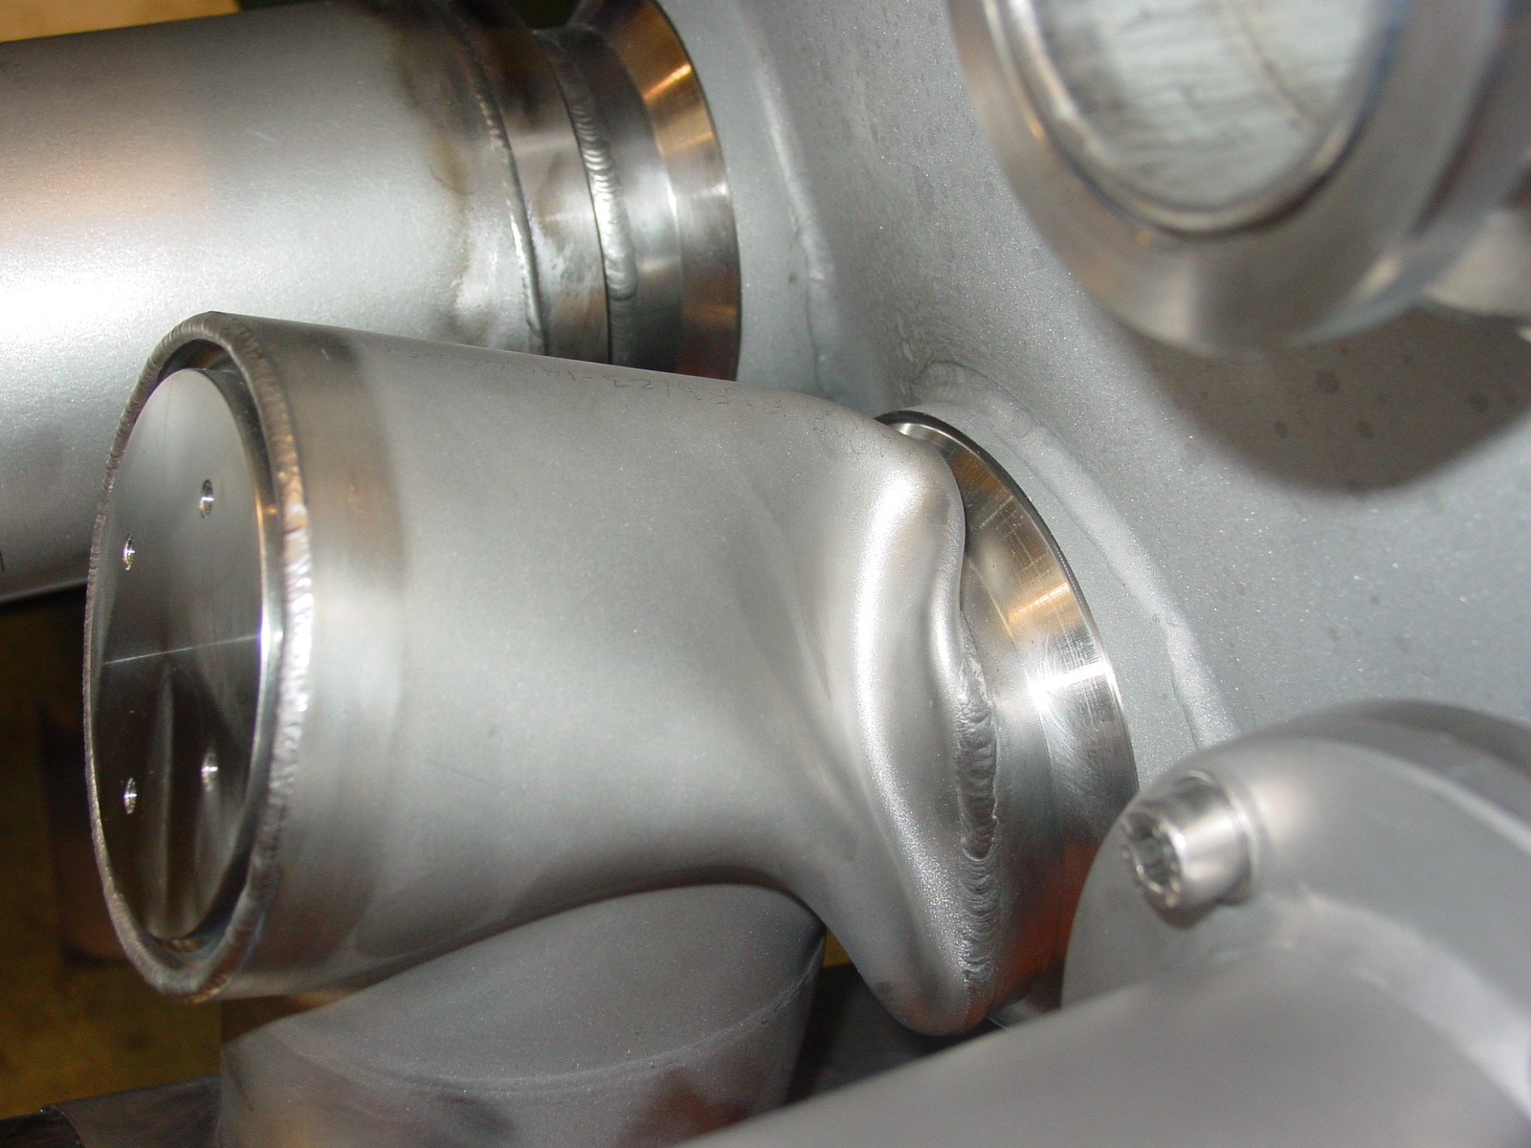
Figure 3/6. The damaged "T" seen from outside

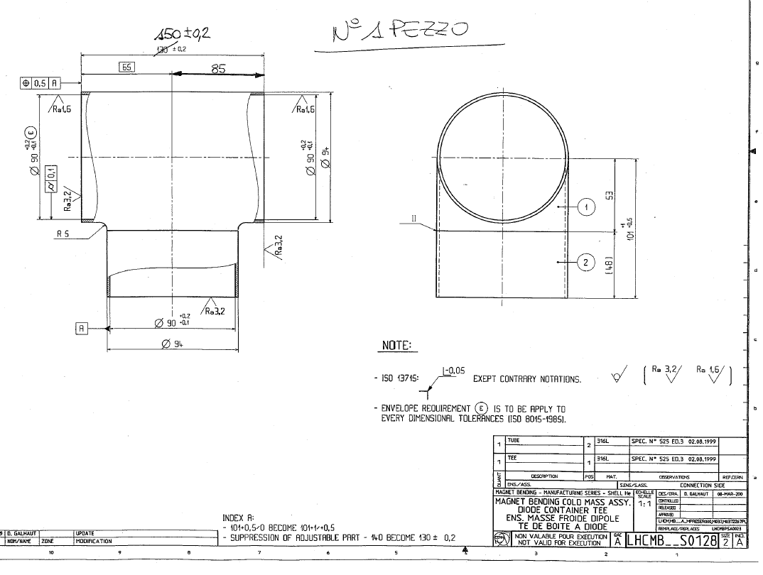

Figure 4/6. New piece with slightly different geometry, as ordered. This will be adapted onsite.
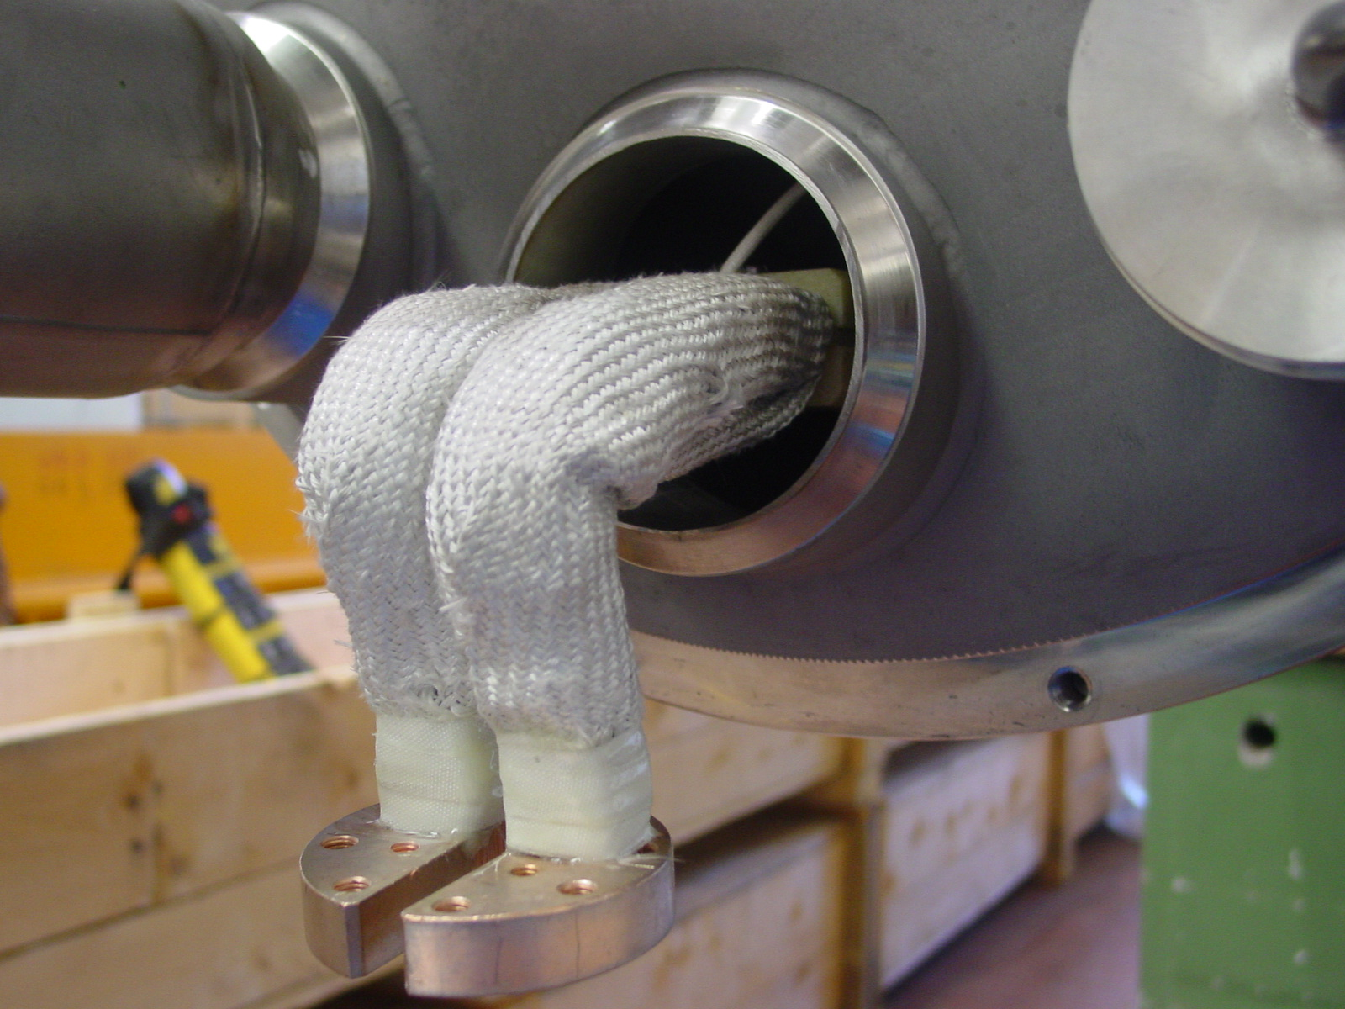
Figure 5/6. Reworked end cover

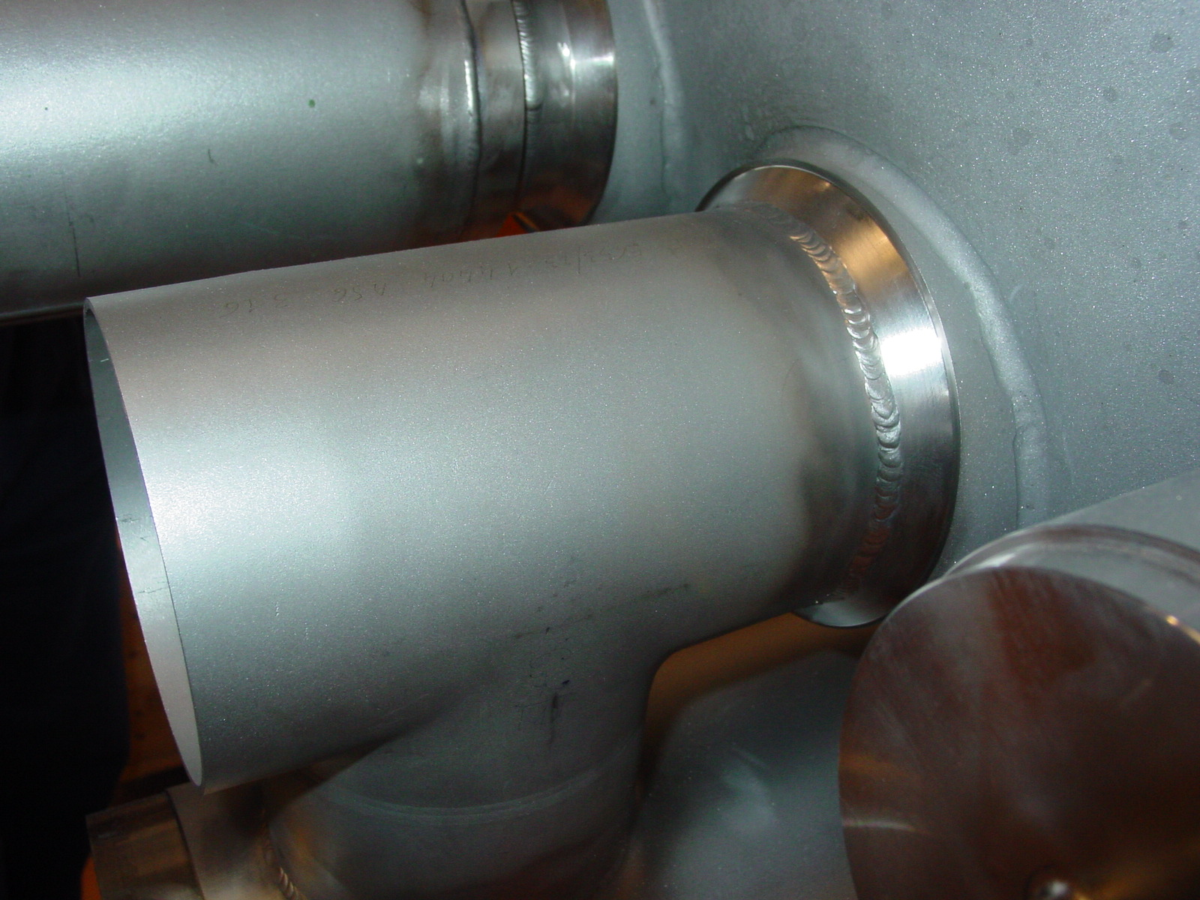
Figure 6/6.: new "T" piece after rework

