–

Non conformity Report
IDENTIFICATION
1. Originator’s Name: F. Terzi | 5. Date: 14/04/2006
2. Contractor/Supplier: Ansaldo Superconduttori S.p.A. | 6. Part description: HCMBARA001-02000320
3. Contract No: F462/LHC/LHC | 7. Qty: 1
4. Project Engineer: F. Savary, M. Bajko | 8. Dwg No: LHCMBB_A0002/F (683RM08451)

9. Found during what activity:
□ Incoming inspection | ☑ Final inspection
□ In-process inspection | □ Other:

10. Description of non conformity (use continuation page if necessary)
During the He leak test on CM 2320, pressurized to 26 bar, a leak has been detected on the internal bellow of heat exchanger.
Leak rate Q=1.2 E-5 mbar l/s (nom. value 1.0E-9 mbarl/s max.)

11. Action taken to prevent misuse (use continuation page if necessary)

IMPORTANCE
12. |  ☑ Non critical | □ Critical

DISPOSITION
13. | □ Use-as-is | ☑ Repair | □ Reject | ◻ Rework | □ Return to supplier
Description of proposed action (use continuation page if necessary)
ASG will leave the cold mass concerned pending
- until CERN can organize a visit to repeat the test with CERN experts in vacuum
OR
- until CERN authorization to proceed with the repairing procedure already applied on previous magnets with the same problem.
See details of the procedure on continuation page.

The defective X-line internal bellow (id. nr. XS0398 B) will be changed with a new one. He leak test will be repeated.

CORRECTIVE/PREVENTIVE ACTION
14. Description of proposed action (use continuation page if necessary)

APPROVAL OF NON CRITICAL NON CONFORMITIES
15 | Project Engineer: | Date:

APPROVAL OF CRITICAL NON CONFORMITIES
16 | Project Management: | Date:

CLOSURE OF THE NON CONFORMITY
Planned actions have been completed and corrective/preventive actions have been initiated

 | For non critical non conformities  Quality Manager or Project Engineer | For critical non conformities  Project Engineer
17 | Name:  Date: | Name:  Date:

Leak detection

Leak test has been performed using the LD in "sniffer mode".
The leak has been detected on the bellow and, according to our experience, maybe it is on the weld between the bellow and the "right adaptor" ring diam. 64/100 (CERN dwg. LHCMB__A0087).
As usual the defective bellow will be sent to CERN for further investigation.

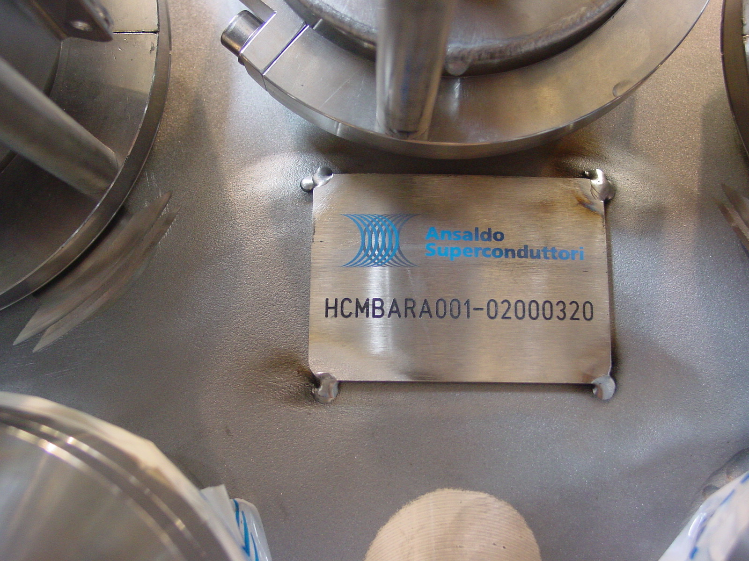
Fig. 1/2 – Cold mass identification tag

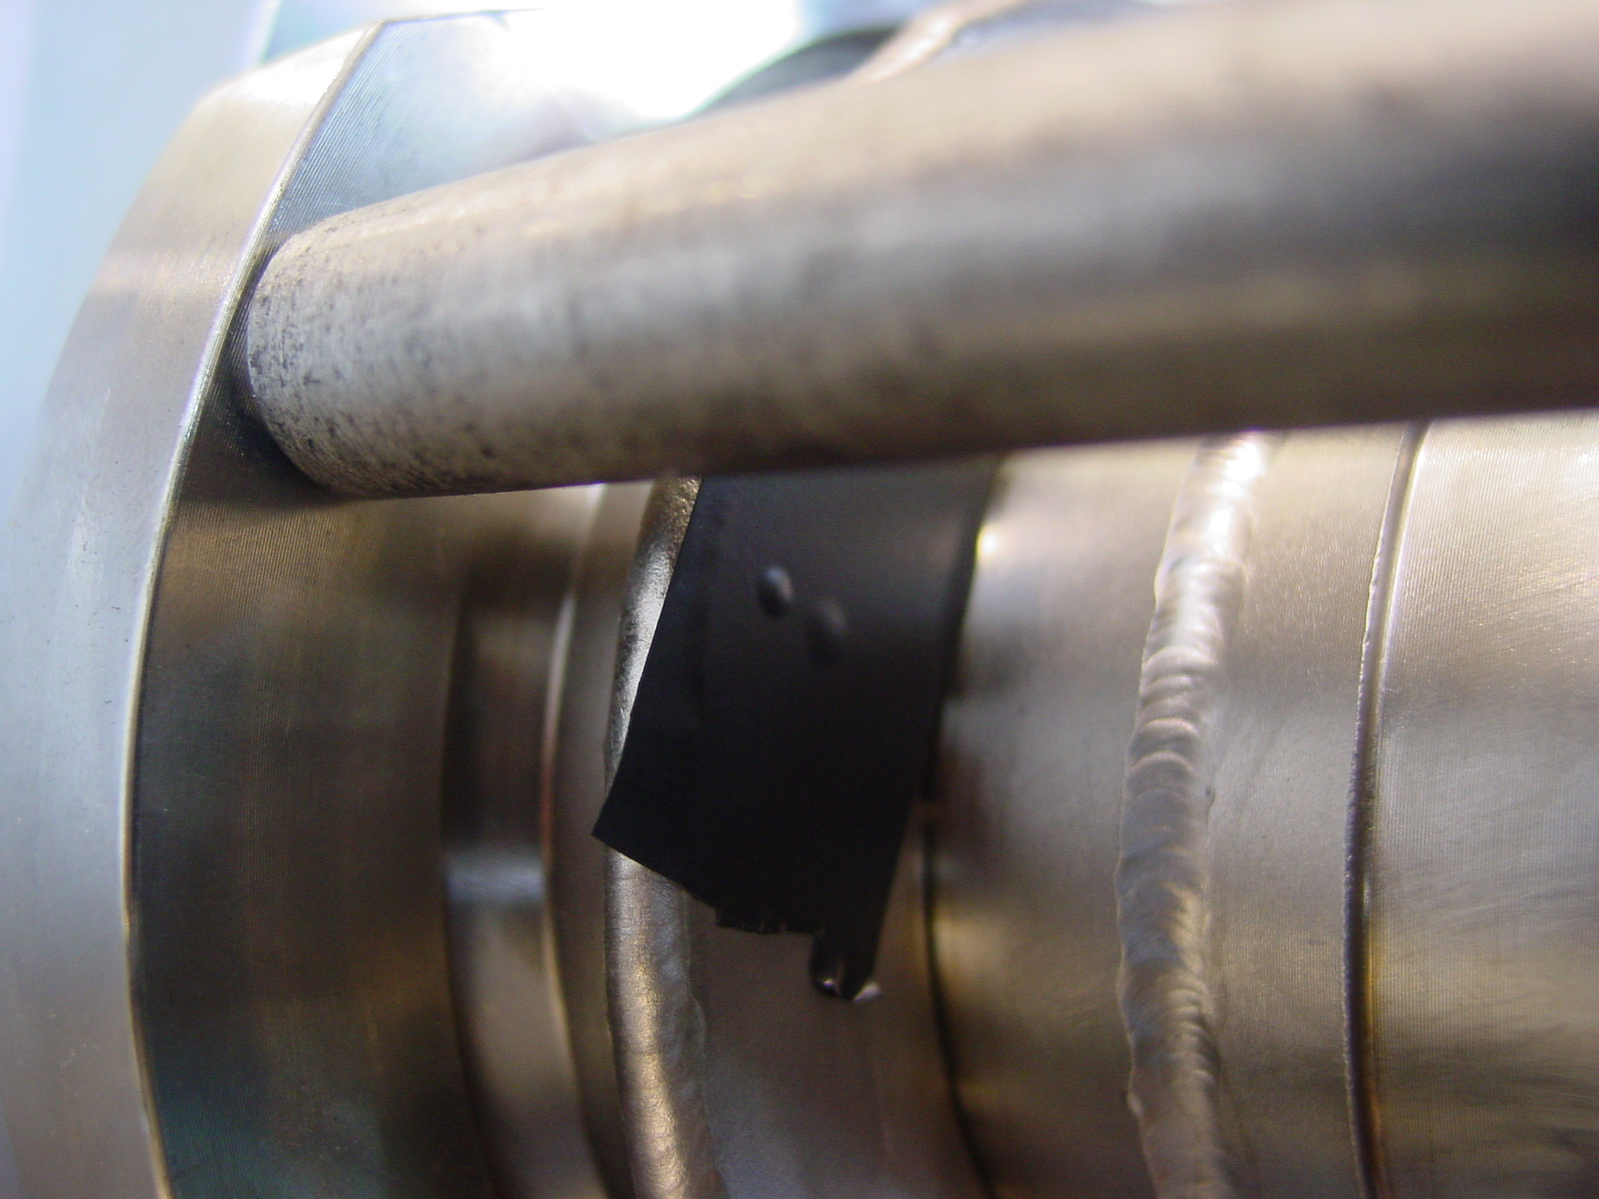
Fig.2/2 – Leak on side bellow ring base material showed by a bubble on the black tape

Repairing Procedure

1) Cutting of the weld between the X-line bellow and the end cover nozzle with a grinding/cutting disk (on the two sides, lyre and connection).
This operation must be done manually with great care in order not to damage the nozzle of the end cover.
2) Then, use an orbital cutting machine to cut the fillet weld between the bellow sleeve and the heat exchanger tube (once again with great care).
To do this, the heat exchanger tube is partially removed from the cold mass assembly.
3) Leaving then the heat exchanger tube in the cold mass assembly, restore the surfaces and chamfers wherever necessary.
4) Then, install a new bellow and re-weld the heat exchanger tube with its new bellow to the cold mass assembly.
All these operation shall be carried out with great care.

