–

Non conformity Report
IDENTIFICATION
1. Originator’s Name: F. Terzi | 5. Date: 02/05/2006 (updated on 08/05/06) ^{(*)}
2. Contractor/Supplier: Ansaldo Superconduttori S.p.A. | 6. Part description: HCMB__A133-FSG00485 HCMB__A133-FSG00494  HCMB__A133-FSG00497 ^{(*)}  HCMB__A133-FSG00500 ^{(*)}
3. Contract No: F462/LHC/LHC | 7. Qty:
4. Project Engineer: F. Savary, M. Bajko | 8. Dwg No:

9. Found during what activity:
☑ Incoming inspection | □ Final inspection
□ In-process inspection | □ Other:

10. Description of non conformity (use continuation page if necessary)
Yoke laminations regarding different batches received at ORMET from FSG, showed oxidation on the punched surface (bathes id nr. FSG00485 – FSG00494 - FSG00497^{(*)} - FSG00500^{(*)}).
Please find some pictures on continuation page.
(*) Updating of 08/05/06

11. Action taken to prevent misuse (use continuation page if necessary)

IMPORTANCE
12. | ☑ Non critical | □ Critical

DISPOSITION
13. | ☑ Use-as-is | □ Repair | □ Reject | □ Rework | □ Return to supplier
Description of proposed action (use continuation page if necessary)
We shall proceed as we did in the past, i.e. clean off the rust at the latest stage (from e-mail dated 28/04/2006 by Mr. F. Savary)

This means that the laminations, not yet stacked, shall be assembled “as is” and the outer surfaces cleaned at the final stage of assembly at ASG works when the packs are put together to make the ½ yokes.
All the lamination packs shall be cleaned in such a way the corrosion is totally removed from the visible/accessible surfaces (with Scotch-Brite and vacuum cleaning).

CORRECTIVE/PREVENTIVE ACTION
14. Description of proposed action (use continuation page if necessary)

APPROVAL OF NON CRITICAL NON CONFORMITIES
15 | Project Engineer: F. Savary | Date: April 28th, 2006

APPROVAL OF CRITICAL NON CONFORMITIES
16 | Project Management: | Date:

CLOSURE OF THE NON CONFORMITY
Planned actions have been completed and corrective/preventive actions have been initiated
 | For non critical non conformities  Quality Manager or Project Engineer | For critical non conformities  Project Engineer
17 | Name: F. Terzi  Date: 08/05/2006 | Name:  Date:

IDENTIFICATION
10. Description of non conformity (continuation page)

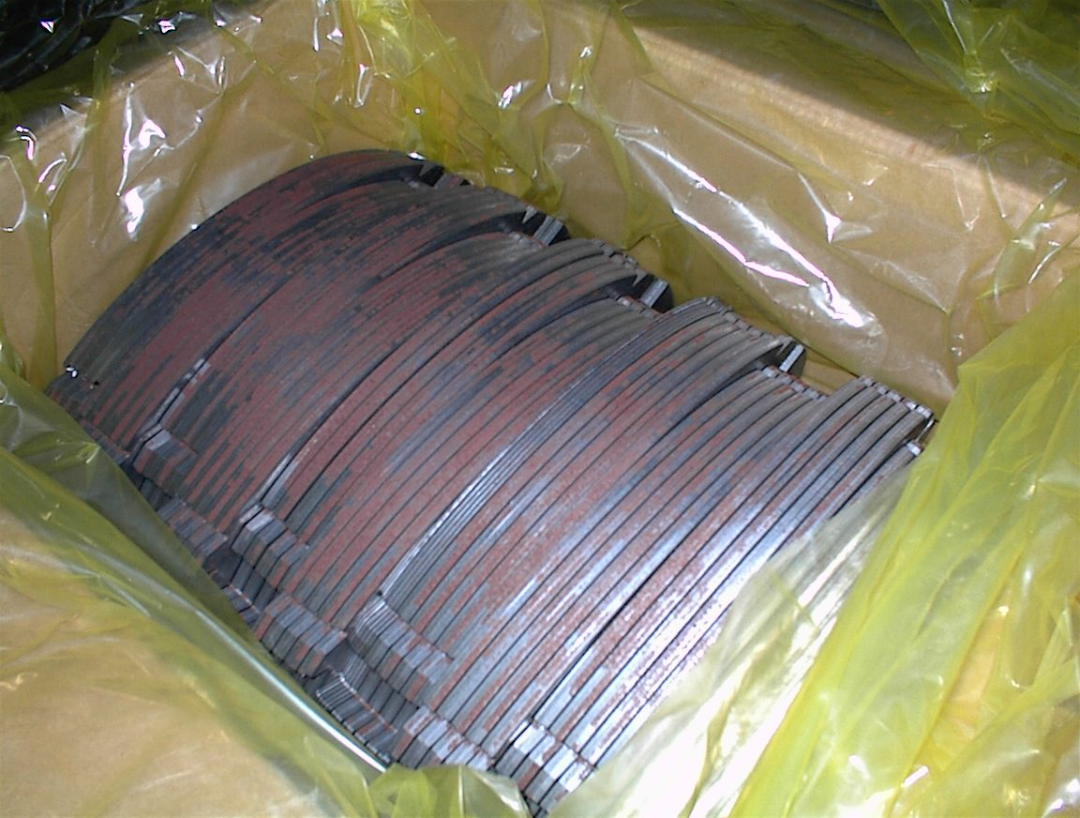
1/4 - Batch FSG00485

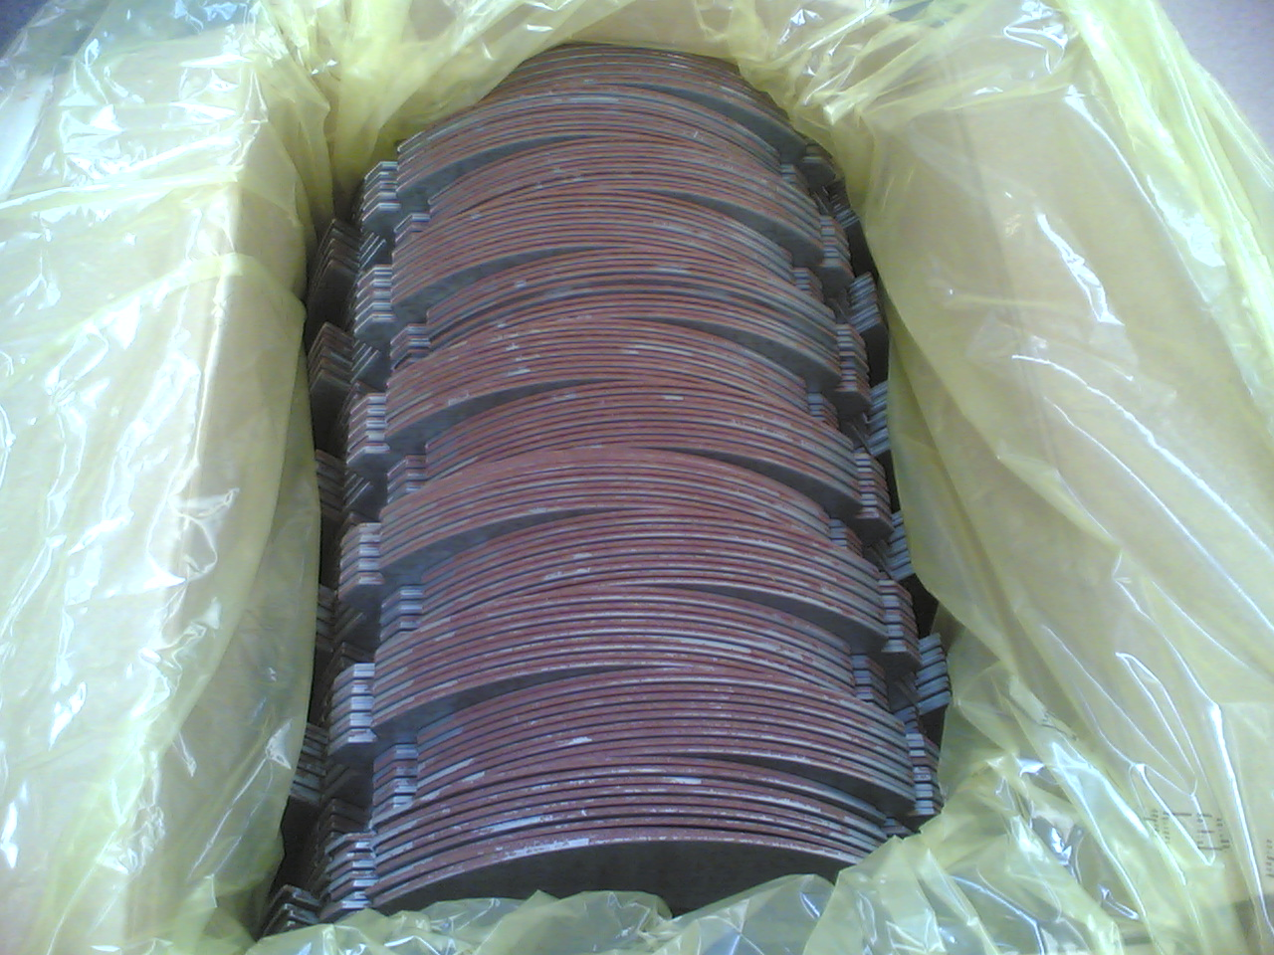
2/4 - Batch FSG00494

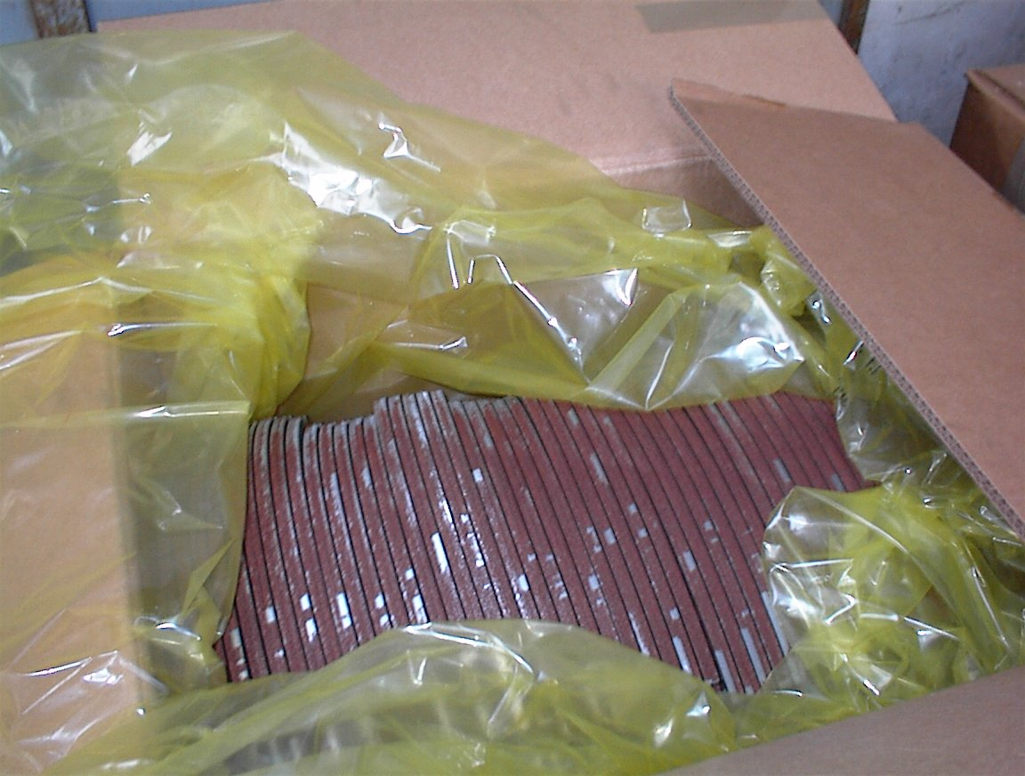
3/4 -FSG00497

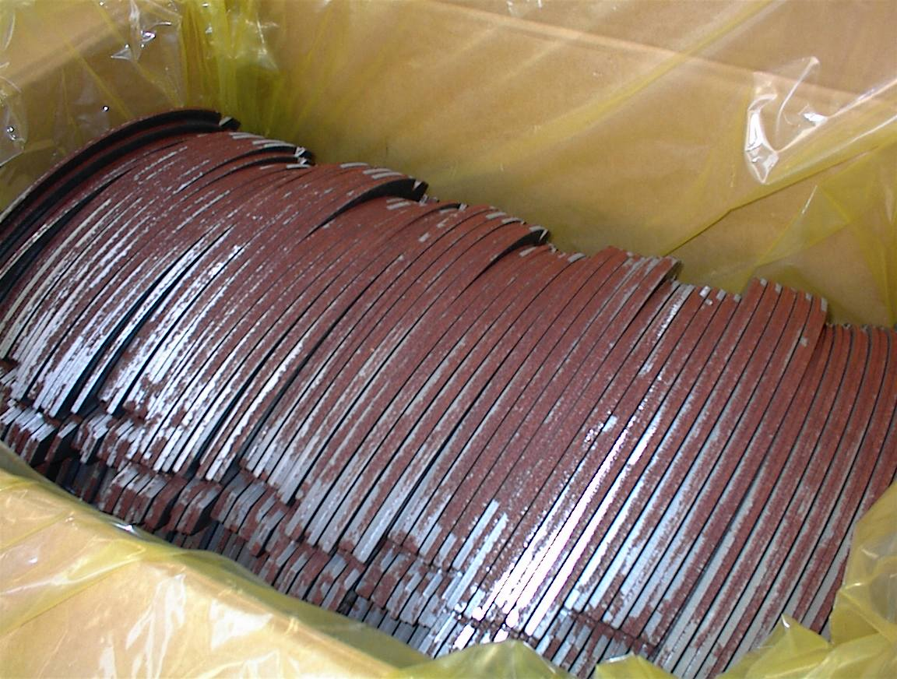
4/4 - FSG00500

