–

Non conformity Report
IDENTIFICATION
1. Originator’s Name: F. Terzi | 5. Date: 12-06-2006
2. Contractor/Supplier: Ansaldo Superconduttori S.p.A. | 6. Part description: HCMB__A001-02000363
3. Contract No: F462/LHC/LHC | 7. Qty: 1
4. Project Engineer: F. Savary, M. Bajko | 8. Dwg No: LHCMB__A0012/E (620RM08202/F)

9. Found during what activity:
□ Incoming inspection | □ Final inspection
☑ In-process inspection | □ Other:

10. Description of non conformity (use continuation page if necessary)
After collaring of CC 2363, electrical test at high voltage (V=4 kV) showed an interturn short circuit on Upper pole id. nr. 02P01452 of Aperture 2 (D2 – Upper).

11. Action taken to prevent misuse (use continuation page if necessary)

IMPORTANCE
12. | ☑ Non critical | □ Critical

DISPOSITION
13. | □ Use-as-is | □ Repair | □ Reject | ☑ Rework | □ Return to supplier
Description of proposed action (use continuation page if necessary)
The responsibility of the long term electrical integrity of the coil is of ASG Superconduttori.

CORRECTIVE/PREVENTIVE ACTION
14. Description of proposed action (use continuation page if necessary)

APPROVAL OF NON CRITICAL NON CONFORMITIES
15 | Project Engineer: Marta Bajko | Date: 02.10.2006

APPROVAL OF CRITICAL NON CONFORMITIES
16 | Project Management: | Date:

CLOSURE OF THE NON CONFORMITY
Planned actions have been completed and corrective/preventive actions have been initiated
CC 2363 has been de-collared and the short circuit has been detected between 5ht and 6th turn.

C.b.t. (MB-CBT-2431 & MB-CBT-2422) have been changed with new ones (MB-CBT -2485 & MB-CBT-2488)

Interturn insulation has been restored. Electrical test performed successfully.
See annexed picture about repair.
 | For non critical non conformities  Quality Manager or Project Engineer | For critical non conformities  Project Engineer
17 | Name: F. Terzi  Date: 02/10/2006 | Name:  Date:

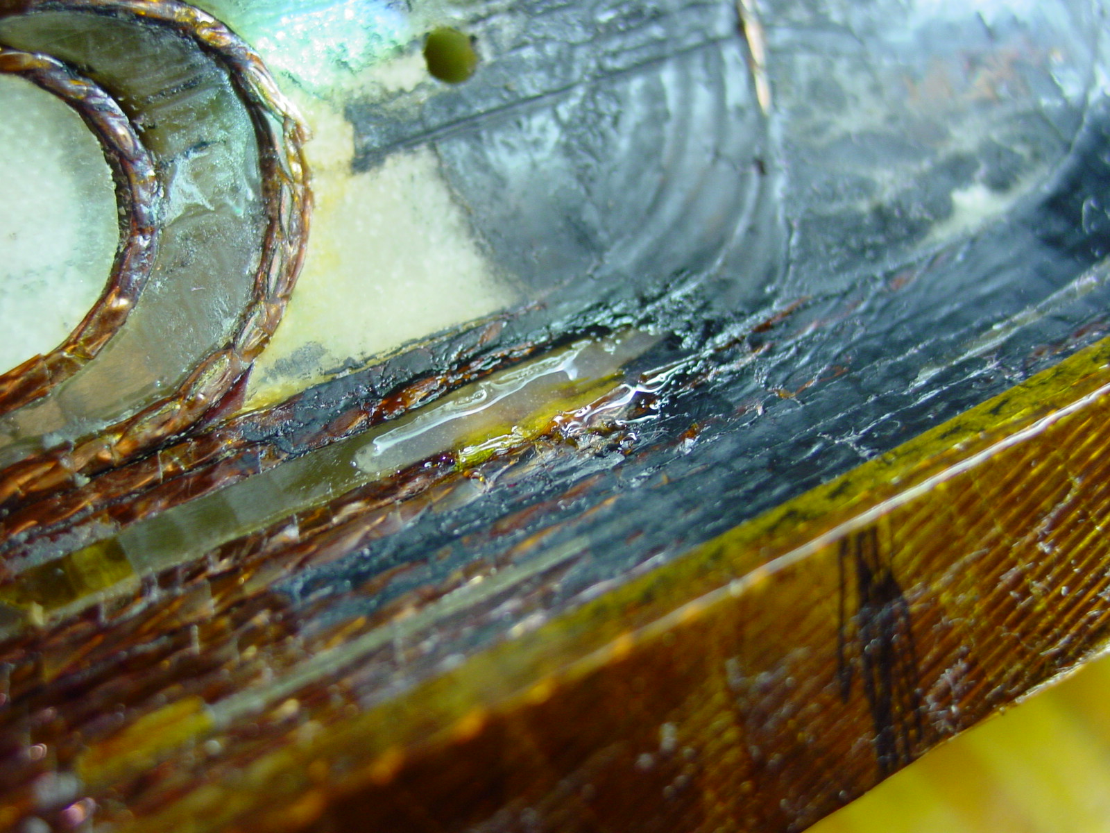
CC 2363: inner layer 02I01455 after repair

