–

Non conformity Report
IDENTIFICATION
1. Originator’s Name: F. Terzi | 5. Date: 12/07/2006
2. Contractor/Supplier: Ansaldo Superconduttori S.p.A. | 6. Part description: HCMBALA001-02000336
3. Contract No: F462/LHC/LHC | 7. Qty: 1
4. Project Engineer: F. Savary, M. Bajko | 8. Dwg No: LHCMBB_A0002/F (683RM08451)

9. Found during what activity:
□ Incoming inspection | ☑ Final inspection
□ In-process inspection | □ Other:

10. Description of non conformity (use continuation page if necessary)
During the He leak test on CM 2336, pressurized to 26 bar, a leak has been detected.
Further test, on the CM out of the vacuum vessel, showed that the leak was near the weld of the N-line tube to the flexible line end (N.C.S.).
The exact position of the leak is on heat affected zone (HAZ ) of base material of the N-line tube.
N-line tube id. nr. DM000844
ASG proceeded with the repair of the weld.
Please find here after some pictures.
ASG will perform mechanical test and chemical analysis on a sample (base material + HAZ) regarding this N-line tube to check its properties.

11. Action taken to prevent misuse (use continuation page if necessary)

IMPORTANCE
12. |  □ Non critical | □ Critical

DISPOSITION
13. | □ Use-as-is | □ Repair | □ Reject | ◻ Rework | □ Return to supplier
Description of proposed action (use continuation page if necessary)

CORRECTIVE/PREVENTIVE ACTION
14. Description of proposed action (use continuation page if necessary)

APPROVAL OF NON CRITICAL NON CONFORMITIES
15 | Project Engineer: | Date:

APPROVAL OF CRITICAL NON CONFORMITIES
16 | Project Management: | Date:

CLOSURE OF THE NON CONFORMITY
Planned actions have been completed and corrective/preventive actions have been initiated

 | For non critical non conformities  Quality Manager or Project Engineer | For critical non conformities  Project Engineer
17 | Name:  Date: | Name:  Date:

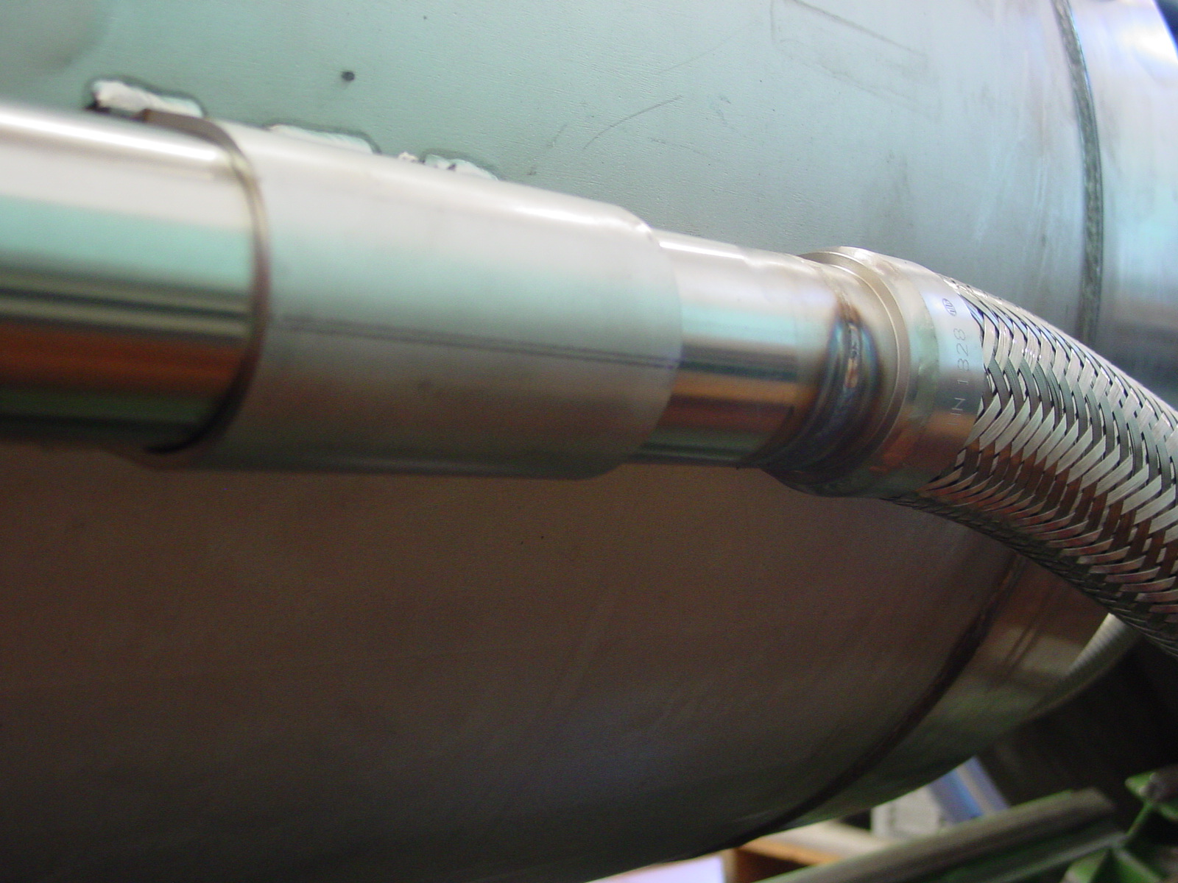
1/2

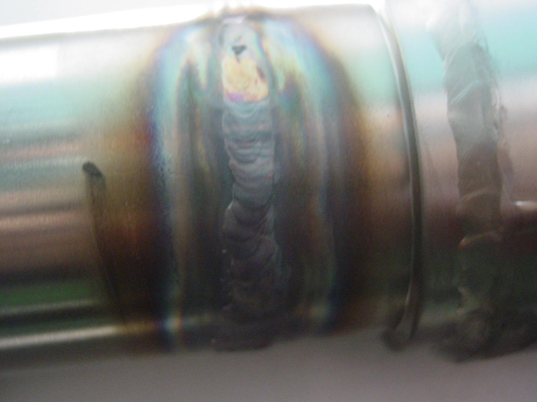
2/2

