–

Non conformity Report
IDENTIFICATION
1. Originator’s Name: F. Terzi | 5. Date: 27.11.2006
2. Contractor/Supplier: ASG Superconductors S.p.A. | 6. Part description: HCMB__A001-02000431
3. Contract No: F462/LHC/LHC Amendment n.4 | 7. Qty: 1
4. Project Engineer: M. Bajko | 8. Dwg No: LHCMB__A0012/E (620RM08202/F)

9. Found during what activity:
☑ Incoming inspection | □ Final inspection
□ In-process inspection | □ Other:

10. Description of non conformity (use continuation page if necessary)
During winding of the last turn of inner layer nr. 02I01725 (sc cable nr. 01E11029E) for CM 2431, a malfunctioning of the winding machine Spirex 1500 caused a damage of the sc cable (see annexed picture on continuation page).
This damage has been probably caused by a failure of the sensor of the tension of the cable.

11. Action taken to prevent misuse (use continuation page if necessary)

IMPORTANCE
12. | ☑ Non critical | □ Critical

DISPOSITION
13. | □ Use-as-is | □ Repair | ☑ Reject | □ Rework | □ Return to supplier
Description of proposed action (use continuation page if necessary)
Inner layer 02I01725 shall be rejected.
ASG is asking CERN a new inner layer cable on ASG expense.

CORRECTIVE/PREVENTIVE ACTION
14. Description of proposed action (use continuation page if necessary)

APPROVAL OF NON CRITICAL NON CONFORMITIES
15 | Project Engineer: | Date:

APPROVAL OF CRITICAL NON CONFORMITIES
16 | Project Management: | Date:

CLOSURE OF THE NON CONFORMITY
Planned actions have been completed and corrective/preventive actions have been initiated

 | For non critical non conformities  Quality Manager or Project Engineer | For critical non conformities  Project Engineer
17 | Name:  Date: | Name:  Date:

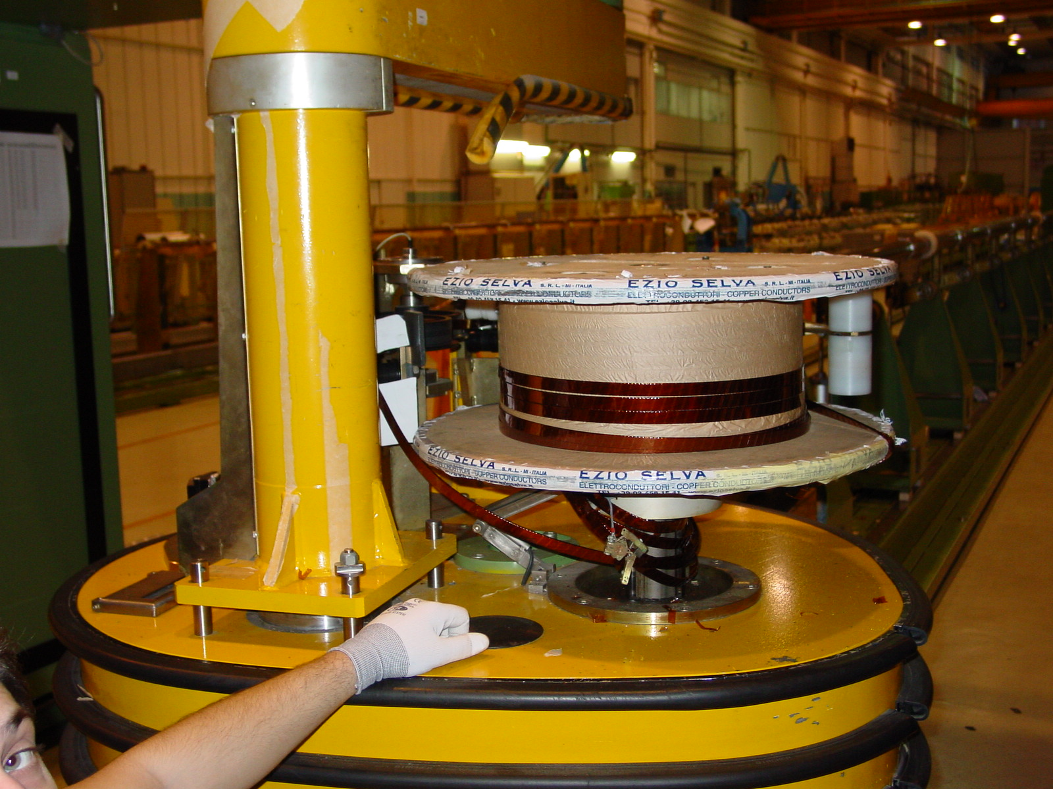
1/4

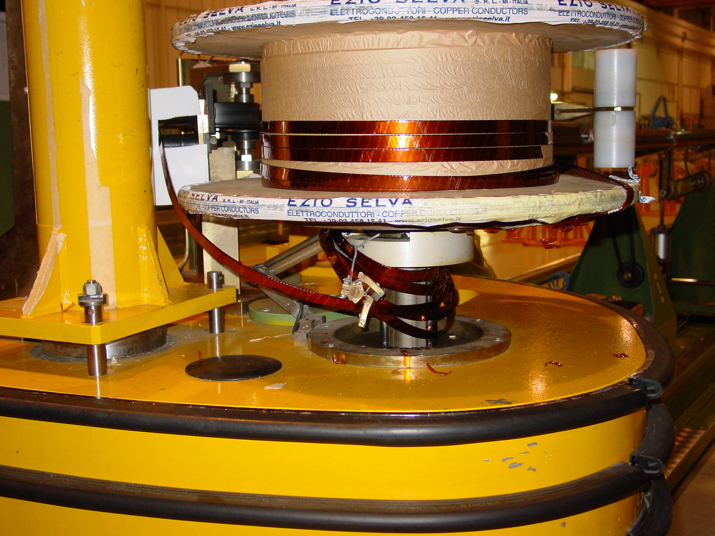
2/4

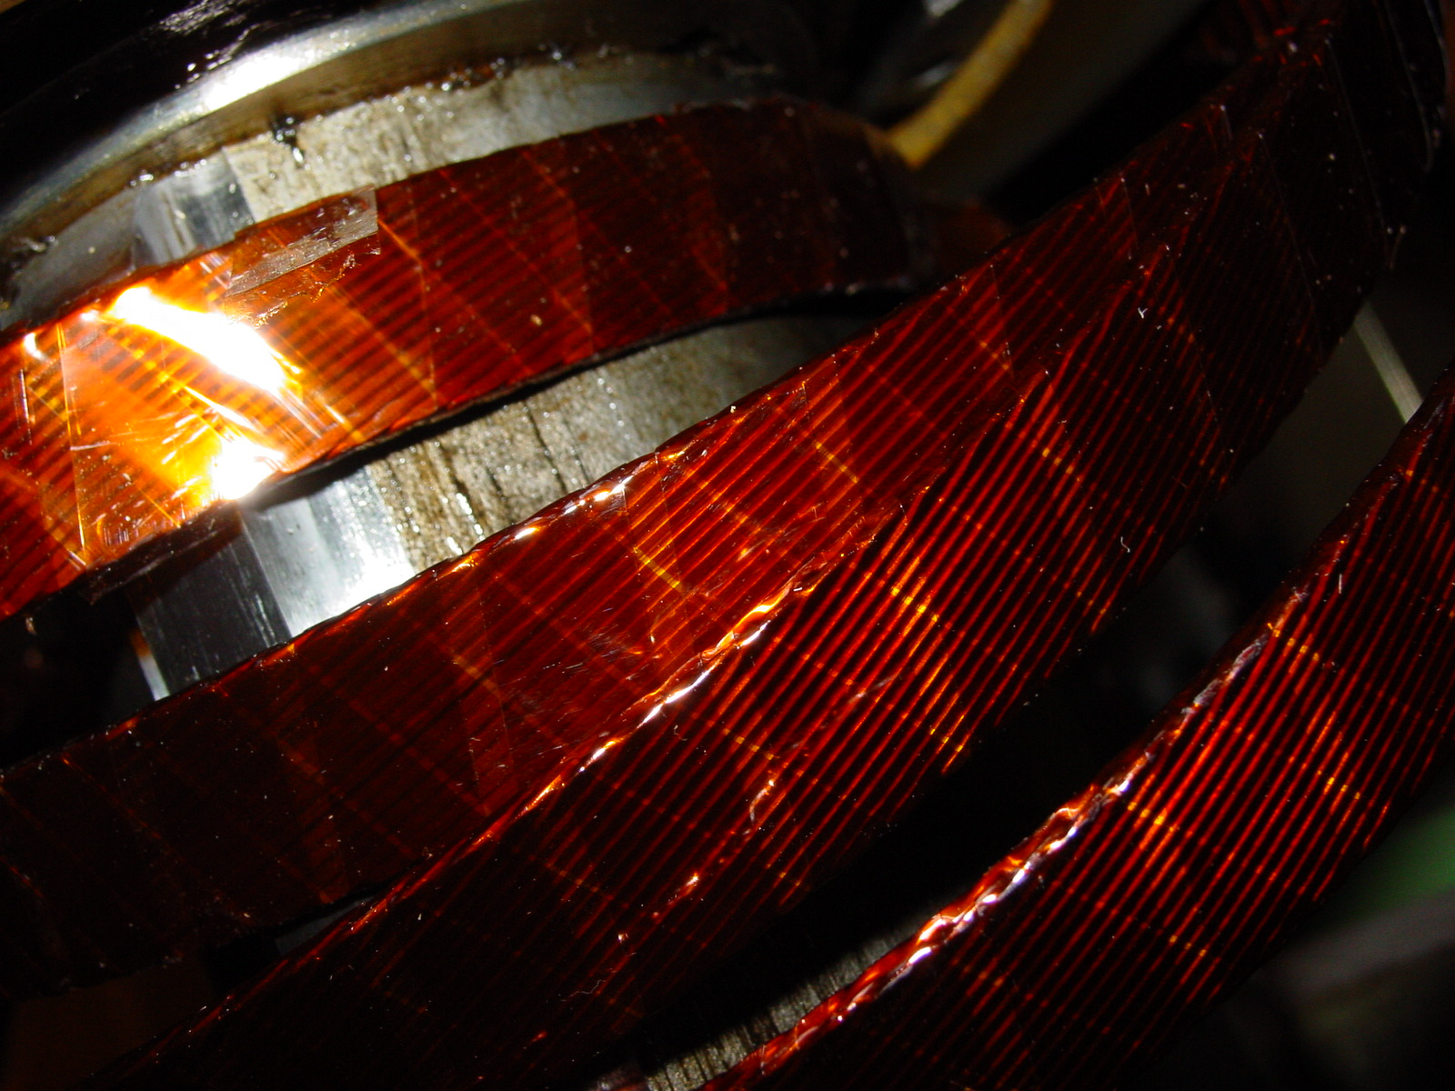
3/4

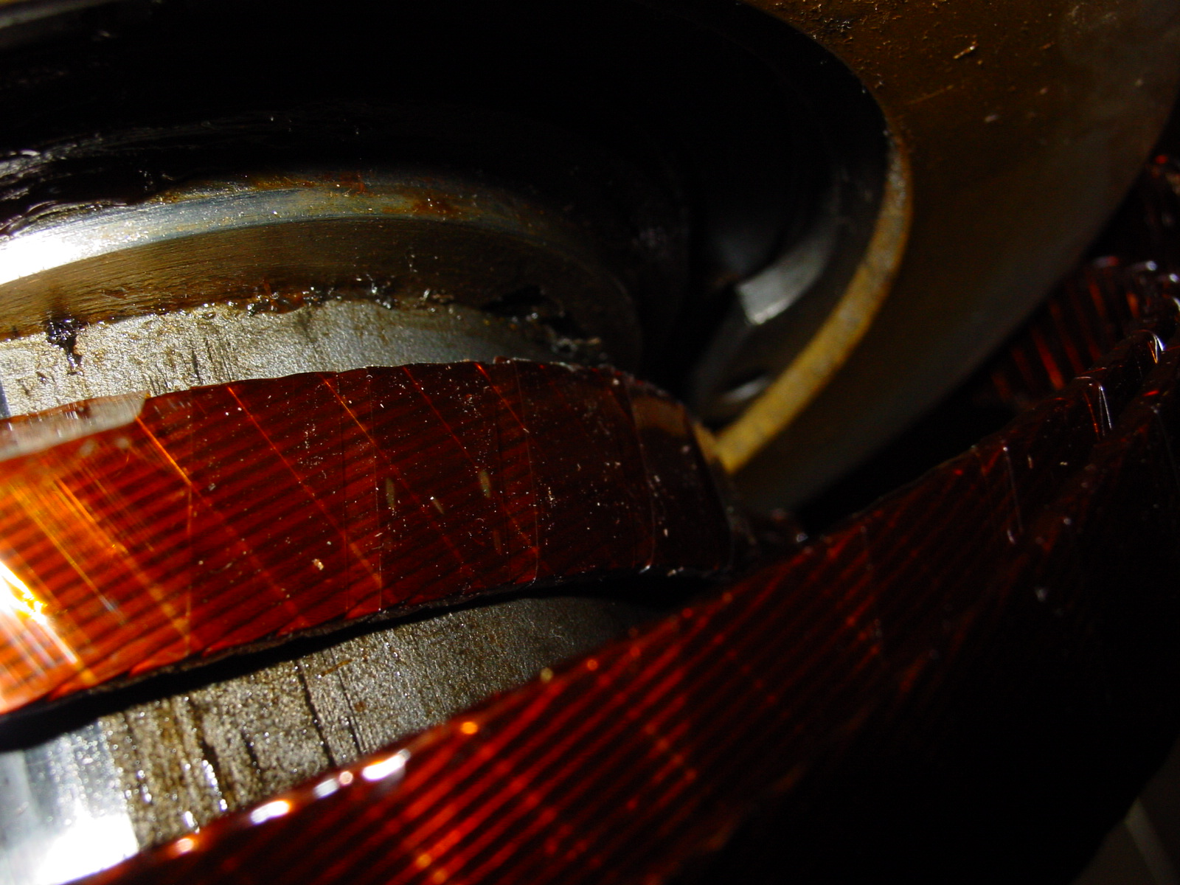
4/4

