–

Non conformity Report
IDENTIFICATION
1. Originator’s Name: F. Terzi | 5. Date: 29.11.2006
2. Contractor/Supplier: ASG Superconductors S.p.A. | 6. Part description: HCMB__A001-02000421
3. Contract No: F462/LHC/LHC Amendment n.4 | 7. Qty: 1
4. Project Engineer: F. Savary | 8. Dwg No: LHCMB__A0001/G (620RM08234/L)

9. Found during what activity:
□ Incoming inspection | □ Final inspection
☑ In-process inspection | □ Other:

10. Description of non conformity (use continuation page if necessary)
Warm magnetic measurements carried out on the collared coils 2421 showed anomalies of 10-15 units in multipoles a2, a3 and b3 on all positions of the straigth part in Aperture 1.
(ref. test report nr. HCMB__A001-02000421_CC.xls)

11. Action taken to prevent misuse (use continuation page if necessary)

IMPORTANCE
12. | ☑ Non critical | □ Critical

DISPOSITION
13. | □ Use-as-is | □ Repair | ☑Reject | □ Rework | □ Return to supplier
Description of proposed action (use continuation page if necessary)
CERN personnel (Mr. E. Todesco and Ms. C. Vollinger) made further data analysis that indicated these anomalies on Aperture 1 – Upper Pole – 1st quadrant (0-90 deg. from CS view) caused by a movement of the inner layer of about 0.5 mm.
Then CERN asked ASG to open the collared coil.
The collared coil has been opened on November 28th under the witness of CERN people (Ms. Bajko and Mr. Todesco).
After dismantling of collared coils, a visual inspection showed that during winding of inner layer 02I01685 a wrong Cu wedge type 4-5 has been used instead of type 3-4. This damage is only on one side of the layer as you can see on annexed pictures
ASG is asking CERN for a replacement cable.

CORRECTIVE/PREVENTIVE ACTION
14. Description of proposed action (use continuation page if necessary)
Coil cannot be used as it is. Inner layer 02I01685 is rejected (sc cable 01B11021A)

APPROVAL OF NON CRITICAL NON CONFORMITIES
15 | Project Engineer: | Date:

APPROVAL OF CRITICAL NON CONFORMITIES
16 | Project Management: | Date:

CLOSURE OF THE NON CONFORMITY
Planned actions have been completed and corrective/preventive actions have been initiated

 | For non critical non conformities  Quality Manager or Project Engineer | For critical non conformities  Project Engineer
17 | Name:  Date: | Name:  Date:

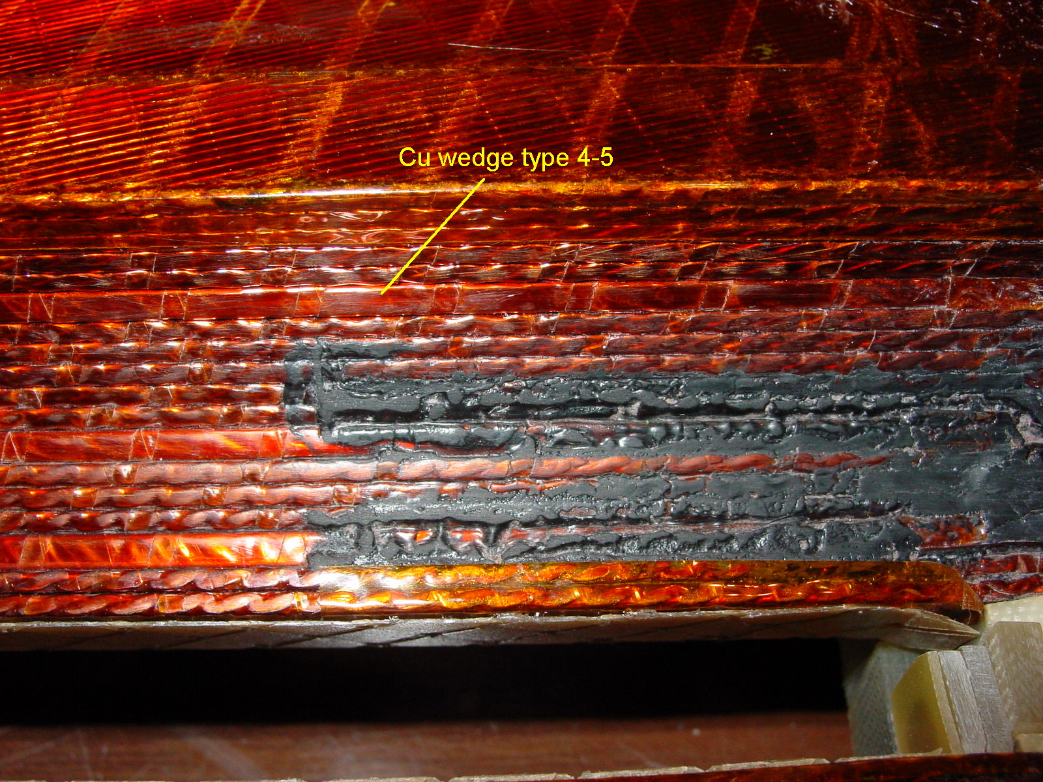
1/2 – Wrong Cu wedge (type 4-5 instead of type 3-4)

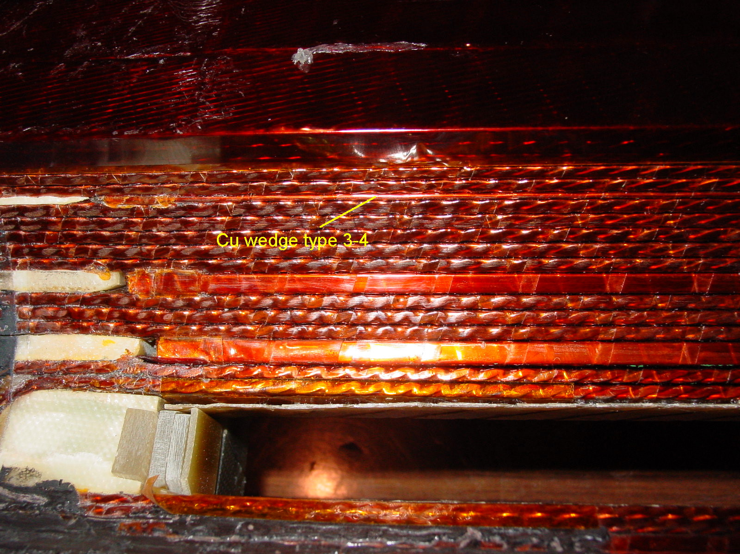
2/2 – On this side Cu wedge are right

