–

Non conformity Report
IDENTIFICATION
1. Originator’s Name: B.Caserza | 5. Date: 24/01/2003
2. Contractor/Supplier: Ansaldo Superconduttori S.p.A. | 6. Part description: HCMB__A001-02000020
3. Contract No: F302/LHC/LHC | 7. Qty: 1
4. Project Engineer: F. Savary | 8. Dwg No: LHCMBB_A0002/F (683RM08451)

9. Found during what activity:
□ Incoming inspection | □ Final inspection
☑ In-process inspection | □ Other:

10. Description of non conformity (use continuation page if necessary)
During assembling of CM nr.2020, the sc cable on CS has been cut at wrong length.
Real length of the cables are 1150 mm and 520 mm. (please ref. to e–mail sent by Mr.Drago on 24/01/03)

11. Action taken to prevent misuse (use continuation page if necessary)

IMPORTANCE
12. |  Non critical | □ Critical

DISPOSITION
13. | □ Use-as-is |  Repair | □ Reject | □ Rework | □ Return to supplier
Description of proposed action (use continuation page if necessary)
Exceptionally, we could accept having an additional junction for the coil outlet of c.m.2020.
From the information you gave us, including the photo (reproduced on next page), we understood that the coil outlet as shown on CERN drawing LHCMBA_E0005 (3-D view of the collared coils' end at the bottom right corner of the drawing) is concerned. See continuation page

CORRECTIVE/PREVENTIVE ACTION
14. Description of proposed action (use continuation page if necessary)
Ansaldo shall check more carefully the preparation of the coils’ terminals according to the type of cold mass considered.

APPROVAL OF NON CRITICAL NON CONFORMITIES
15 | Project Engineer: F.Savary | Date: 28th January 2003

APPROVAL OF CRITICAL NON CONFORMITIES
16 | Project Management: | Date:

CLOSURE OF THE NON CONFORMITY
Planned actions have been completed and corrective/preventive actions have been initiated See continuation page
 | For non critical non conformities  Quality Manager or Project Engineer | For critical non conformities  Project Engineer
17 | Name: F. Terzi  Date: 03/03/2003 | Name:  Date:

NON CONFORMITY CONTINUATION PAGE

DISPOSITION
Continuation of Section 13
Description of proposed action (use continuation page if necessary)
CERN recommends making the additional junction with a piece of superconducting cable (ideally of the same cable-length) taking care of having a minimum overlap of a transposition pitch, i.e. min. 125 mm.
Ansaldo shall submit to CERN a drawing showing the proposed arrangement and a dummy assembly for qualification before proceeding to repairing on the cold mass itself.

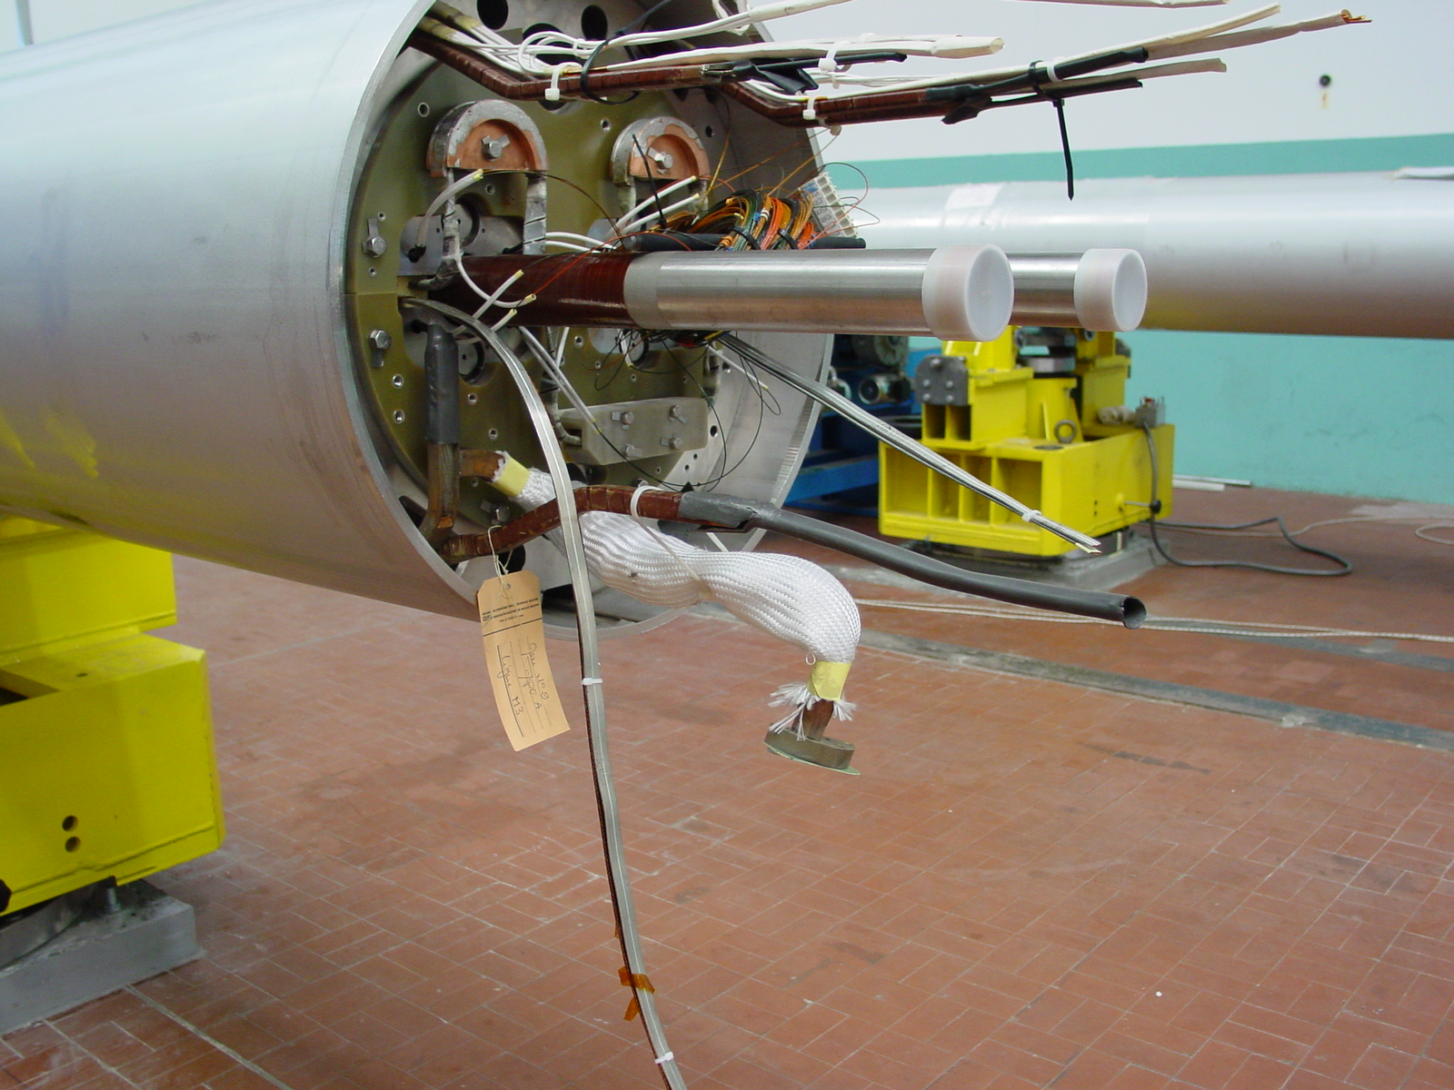

CLOSURE OF THE NON CONFORMITY
Continuation of Section 17
Description of planned actions
ASG applied the following procedure to repair cold mass:
- design of the arrangement for the manufacturing of the proposed additional junction: a datailed drawing has been issued (ref. to dwg. RNC 030124 here below) and sent to CERN for approval before proceeding to repair the cold mass
- manufacturing of a dummy assembly for qualification of the process. Main step and parameters are:
- manufacturing of the components
- cleaning of the components with Scotch Brite and alcool
- assembling of the components (sc cables and Cu piece)
- soldering of sc cables and Cu piece using Sn95-Ag5 brasing alloy and fluxant KESTER 135
- monitoring of brazing temperature T=230 ± 10 °C
- removal of excess brazing alloy and final cleaning of components
- check of dummy assembly: the dummy assembly has been sent to CERN for visual inspection and criogenic test for approval of the repairing procedure
- repairing on cold mass: after CERN approval, ASG applied to the cold mass the same procedure used for the manufaturing of the dummy assembly
F. Terzi
