–

Non conformity Report
IDENTIFICATION
1. Originator’s Name: B.Caserza – F. Terzi | 5. Date: 21/03/2003
2. Contractor/Supplier: Ansaldo Superconduttori S.p.A. | 6. Part description: HCMBBRA001-02000005
3. Contract No: F302/LHC/LHC | 7. Qty: 1
4. Project Engineer: F. Savary | 8. Dwg No: LHCMBB_A0002/F (683RM08451)

9. Found during what activity:
□ Incoming inspection | □ Final inspection
☑ In-process inspection | □ Other:

10. Description of non conformity (use continuation page if necessary)
see next pages

11. Action taken to prevent misuse (use continuation page if necessary)

IMPORTANCE
12. |  ☑ Non critical | □ Critical

DISPOSITION
13. | □ Use-as-is | ☑ Repair | □ Reject | □ Rework | □ Return to supplier
Description of proposed action (use continuation page if necessary)
Because the superconducting cable (at the level of the electrical connections between the poles, mainly) had to be heated up several times during the disassembling operations (following q.h. failure and defects in longitudinal welds, please refer to NC CERN 51), CERN Project Engineers have to make reserves until the results of the cold tests are known.
Regarding the broken strand, the repair proposed by Ansaldo, which is described in page 4 of this document, can be accepted with reserves until the results of the cold tests are known.
Ansaldo must take responsibility for the above mentioned dispositions.

CORRECTIVE/PREVENTIVE ACTION
14. Description of proposed action (use continuation page if necessary)

APPROVAL OF NON CRITICAL NON CONFORMITIES
15 | Project Engineer: F.Savary | Date: 4th June 2003

APPROVAL OF CRITICAL NON CONFORMITIES
16 | Project Management: | Date:

CLOSURE OF THE NON CONFORMITY
Planned actions have been completed and corrective/preventive actions have been initiated
 | For non critical non conformities  Quality Manager or Project Engineer | For critical non conformities  Project Engineer
17 | Name: F. Terzi  Date: 04/06/2003 | Name:  Date:

10. Description of non conformity
During disassembling activities on cold mass nr. 2005, a strand of sc cable on electrical connection nr.4 on CS, has been damaged.
Please refer also to nr.2 e-mail sent you on 13/02/2003 about difficulties we had during this work.
Here is a detailed description of the sequence (see next 3 pictures) of the activities performed on 13/02/2003 and the damage occurred:
- starting from connection end, we cut the Cu piece in different parts (4 pieces), using a small grinding wheel
- de-soldering of Cu pieces and sc cable by heating the 4 different parts (1 part each time) up to reach T=250°C in 10 min., in order to remove the Cu pieces from the sc cable: this means that the sc cable has been heated 4 times in 4 different parts during the removal of the Cu piece
- during the removal of the last Cu piece, a strand has been damaged at about 90 mm from end plate
F. Terzi (21/03/2003)

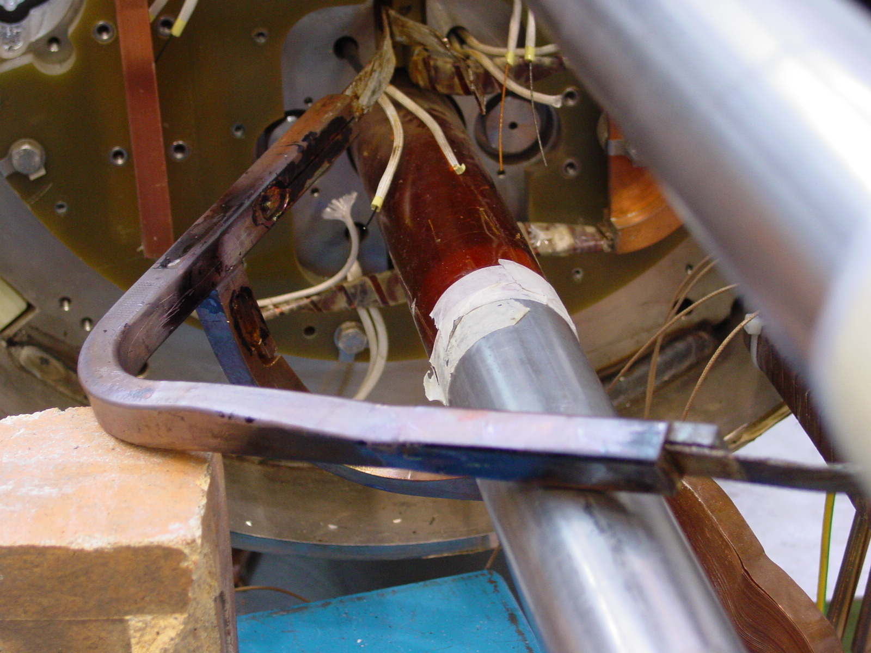
1/3
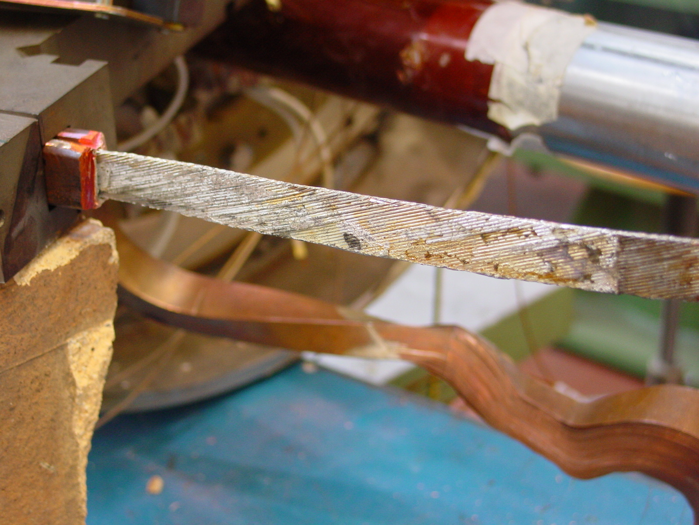
2/3
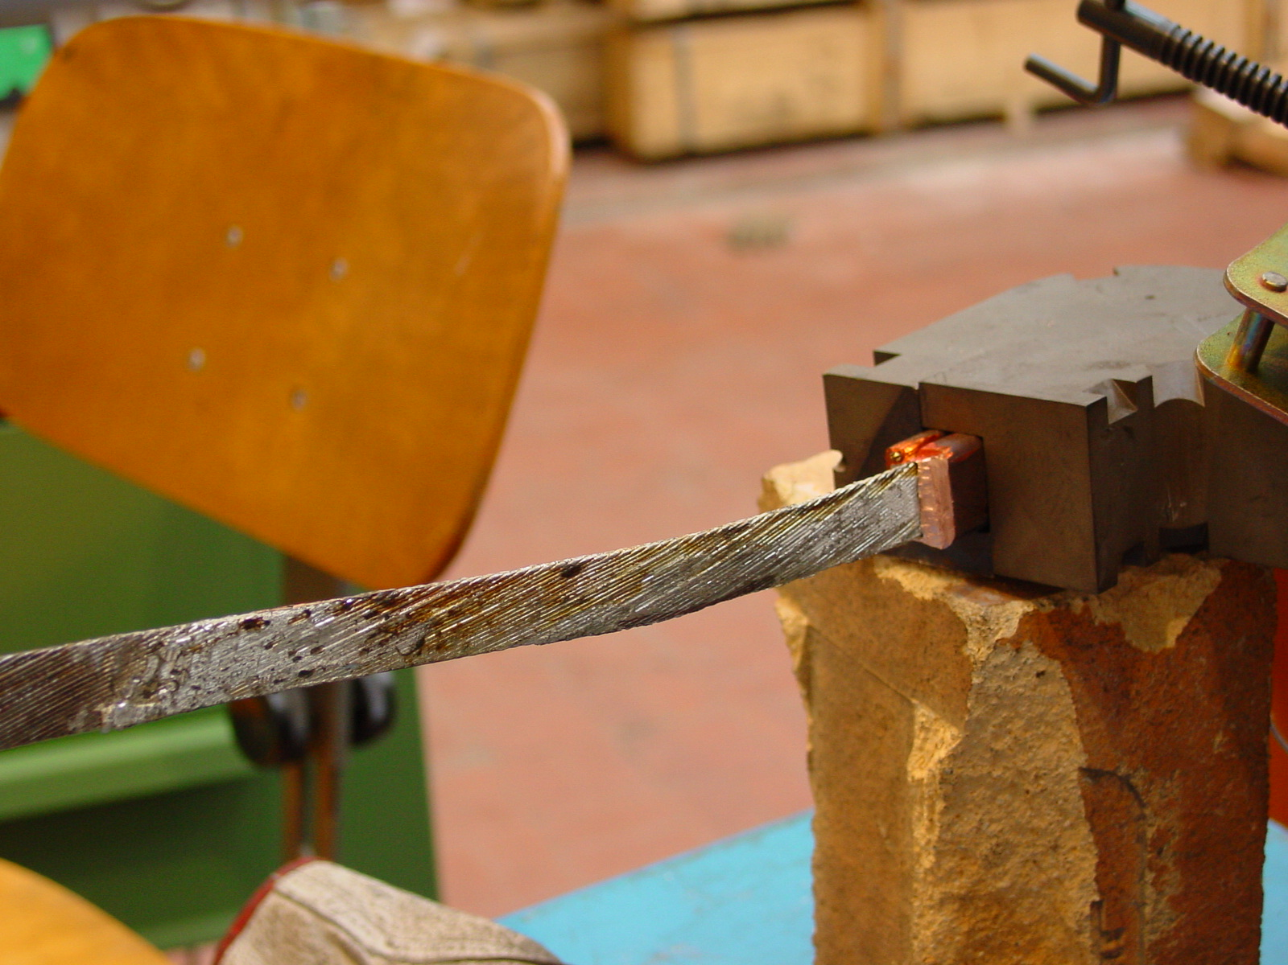
3/3

Repairing procedure
Here is a description of the repair of the sc cable (id. nr. 02C00023A) regarding outer layer E023 on cold mass 2005.
We proceeded with soldering an extra length of cable starting just 25 mm under the end spacer, in order to have 130mm of overlapping: this condition will give us a good situation to do a proper shaping of the electrical connection after collaring.
Main parameters are:
- soldering temperature: 230 ±10 °C
- brasing alloy = Sn95-Ag5
- fluxant = KESTER 135
F. Terzi (05/05/2003)

