Grant Agreement No: 284404

HILUMI LHC

FP7 High Luminosity Large Hadron Collider Design Study

Seventh Framework Programme, Capacities Specific Programme, Research Infrastructures, Collaborative Project, Design Study

MILESTONE report

Study of the Superfluid He Cooling

MILESTONE: MS41

|  |  |
| --- | --- |
| Document identifier: | HILUMILHC-Mil-MS41_rev0.11 |
| Due date of deliverable: | End of Month 36 (November 2014) |
| Report release date: | Xx/xx/2014 |
| Work package: | WP3: Magnets |
| Lead beneficiary: | CERN |
| Document status: | Draft [Final when fully approved] |

Abstract:

This report addresses the issues related to the baseline option for cooling of the inner triplets by means of superfluid helium. The cooling method is based on a transfer of the proven superfluid helium cooling method, as used in the present LHC, to the HiLumi inner triplet magnets. The overall cryogenic infrastructure needed is considered similar, but easily scalable from the existing configuration. The focus of the report is therefore primarily on the cryogenic requirements to be imposed on the magnet cold masses, which are of a new type and which have to handle higher heat loads than accustomed. It is shown that the requirements are reasonable and within the scope of integration in the magnet and cryostat design. Areas of further study are identified.

Copyright notice:

Copyright © HiLumi LHC Consortium, 2014

For more information on HiLumi LHC, its partners and contributors please see [www.cern.ch/HiLumiLHC](http://www.cern.ch/HiLumiLHC)

The HiLumi LHC Design Study is included in the High Luminosity LHC project and is partly funded by the European Commission within the Framework Programme 7 Capacities Specific Programme, Grant Agreement 284404. HiLumi LHC began in November 2011 and will run for 4 years.

The information herein only reflects the views of its authors and not those of the European Commission and no warranty expressed or implied is made with regard to such information or its use.

Delivery Slip

|  |  |  |  |
| --- | --- | --- | --- |
|  | Name | Partner | Date |
| Authored by | R. van Weelderen, G. Bozza | CERN | 07/11/2014 |
| Edited by | R. van Weelderen | CERN | 07/11/2014 |
| Reviewed by | L. Tavian, S. Claudet, L. Rossi, E. Todesco | CERN | xx/11/2014 |
| Approved by | Steering Committee |  | dd/mm/yy |

TABLE OF CONTENTS

1. Introduction 3

2. Description of the Inner triplet magnets 3

3. Cooling by superfluid helium: MAIN - longitudinal -Heat extraction 4

4. Cooling by superfluid helium: radial extraction 5

5. Conclusions 8

6. References 8

# Introduction

The final focusing magnets for the High Luminosity upgrade of the LHC (HL-LHC [1]) will receive a heat load due to debris coming from the adjacent particle interaction points: the computed peak heat deposition in the coil is of the order 1-2.5 mW/cm3 [2]. Superconducting magnets based on Nb3Sn cable technology and operating in superfluid helium at temperatures below 2 K are the objective of current magnet R&D and constitute the baseline for the project [3]. This report addresses the issues related to the baseline option for cooling of the inner triplets by means of superfluid helium. The cooling method is based on a transfer of the proven superfluid helium cooling method, as used in the present LHC, to the HiLumi inner triplet magnets. The overall cryogenic infrastructure needed is considered similar, but easily scalable from the existing configuration. The focus is therefore primarily on the cryogenic requirements to be imposed on the magnet cold masses, which are of a new type and which have to handle higher heat loads than accustomed. A backup cooling method using supercritical helium, but at higher temperatures and thus penalising the magnet performance, is reported in [4].

# Description of the Inner triplet magnets

The magnets have one beam pipe protruding over the full length through which the accelerated particles travel. Separated from it by an annular gap, filled with He, are the superconducting coils, usually two layers, embedded in an iron structure to maintain all the forces and to guide and shape the magnetic field. This whole, so-called cold-mass, is enclosed in a vessel, to be kept at the chosen operating temperature and supported in a vacuum insulated cryostat. In the following we will discuss the cooling channels and their configuration specific to the cold masses only.

The Inner Triplet magnets are installed on both sides of the interaction points IP1 and IP5. They consist of two sets of six cryostats: four inner triplet quadrupoles (Q1, Q2a, Q2b, and Q3), one corrector package (CP) and one dipole (D1). The quadrupoles will be made using Nb3Sn coils whereas the CP and D1 will use Nb-Ti coils. The cryostats are about 4 m to 7 m in length each, with up to 3 m of cold interconnects. One set together forms a continuous cryostat with a total length of 57 m.

The heat loads due to debris from the adjacent particle interaction point are intercepted at two distinct magnet locations and temperature levels. A first heat intercept is on tungsten absorbers which are placed inside the beam pipe vacuum and which will be cooled in the 40 K to 60 K range. This heat intercept is outside of the scope of this report. The remaining heat load will fall on the cold mass volume comprised of the yoke, collars and coils, referred to as “cold masses” for the remainder of this article. The heat loads for only one set of 6 magnets are used for calculation. For the purpose of the evaluation of the cooling, the heat load to the cold masses is taken at 700 W for a luminosity of 5∙1034 cm-1 s-1 with provision to be taken for an ultimate luminosity of 7.5∙1034 cm-1 s-1, giving rise to 1050 W heat load.

# Cooling by superfluid helium: MAIN - longitudinal -Heat extraction

The cooling principle is an evolution of the one proposed for the LHC-Phase-I Upgrade [5] (Figure 1). The cold masses will be cooled in a pressurized static superfluid helium bath at 1.3 bar and at a temperature of about 1.9 K. The heat generated in the magnets will be extracted by vaporization of superfluid helium which travels as a low pressure two-phase flow in two parallel bayonet heat exchangers (HX) [6], protruding the magnet yokes (depicted as one bold line in Figure 1). The low vapour pressure inside the heat exchanger is maintained by a cold compressor system, with a suction pressure of 15 mbar, corresponding to the saturation temperature of 1.776 K.

Due to constraints on magnet design, the bayonet heat exchanger can be made to be continuous only through the quadrupole magnets or through the corrector package and dipole. The size and number of heat exchangers is determined by the maximum vapour velocity of 7 m/s above which the heat exchangers do not function anymore and the total available heat exchange area, when they are wetted over their full length. For the quadrupole heat exchangers, the vapour velocity limit is the more stringent condition and is met if the inner diameter of the two parallel heat exchangers is greater than 68 mm and an additional low pressure pumping is added between Q2a and Q2b. Figure 2 shows schematically the placement of external interfaces needed for the cryogenic services over the extend of the magnet chain. The heat exchangers are to be made of copper to assure proper heat conduction across the walls. A wall thickness of about 3 mm is required to sustain the external design pressures of 20 bar. With, in addition, an annular space of 1.5 mm between the HX and the yoke to allow contact area of the pressurized superfluid helium on the coil-side, the yoke hole size required is 77 mm minimum. With this configuration about 800 W can be safely extracted. The 77 mm yoke hole size is compatible with the mechanical design of the magnet, but should not be increased otherwise one would need to increase as well the overall diameter of the cold mass. Coping with the remaining 250 W is to be done via active cooling of the other magnets, D1 and CP. Two parallel bayonet heat exchangers of 51 mm ID through D1 and CP are foreseen, requiring yoke holes of 60 mm diameter.

For the proper functioning of the two-phase heat exchanger configuration, heat must be given some freedom to redistribute along the length of the cold-masses. This is no hard criterium, and a free longitudinal area of ≥ 150 cm2 through the Q1, Q2a, Q2b, Q3, and their interconnections and ≥ 100 cm2 through D1, CP and their interconnections are deemed sufficient.



Figure 1: architecture of the cooling by using superfluid helium

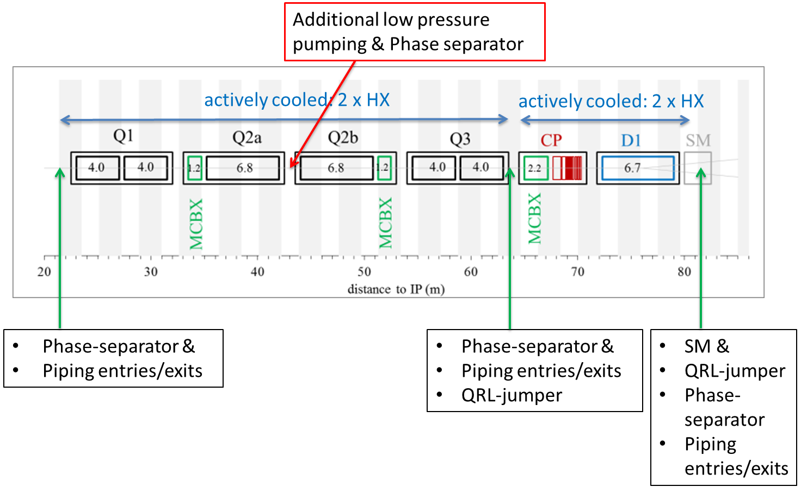

Figure 2: schematic placement of external interfaces over the magnet chain needed for the cryogenic services

# Cooling by superfluid helium: radial extraction

The Nb3Sn quadrupole coils are fully impregnated, without any helium penetration. The heat loads from the coils and the beam-pipe area can only evacuate to the two heat exchangers by means of the pressurized HeII. To this end the cold mass design shall incorporate the necessary radial helium passages. Figure 2 shows the typical heat flow path: out from the coil areas, through the annular spacing between cold bore and inner coil-block, and subsequently via free passages through the titanium insert and G10-alignment key. The annular space between cold bore and inner coil block is set at 1.5 mm and the free passage needed through the titanium insert and G10-alignment key is given by 8 mm holes repeated every 40 mm - 50 mm along the length of the magnet. The exact repetition rate and size of the radial passages need further refinement in order to find a compromise between the cooling margin obtainable and the mechanical feasibility of integrating these holes. To have freedom to install the two heat exchangers in any two of the four available cooling channel holes in the yoke and to limit asymmetric cooling conditions, some free helium paths interconnecting these four cooling channel holes are to be implemented in the cold mass design.

Initial thermal model calculations have shown that aforementioned values, given a source at 1.9 K, will provide sufficient cooling at 5×1034 cm-2 s-1 luminosity to keep the coils at temperatures at 2.0 K in the high field region, and below 2.7 K everywhere (Figure 4). This translates into a minimum temperature margin of  2.4 K (Figure 5 ) However these studies have to be updated and detailed to take into account the demand to sustain 7.5×1034 cm-2 s-1 luminosity and the requirements for extra quench heaters in the inner layer, which are located on the critical path for heat extraction. The whole configuration must be sized such as to avoid any bottlenecks in the heat extraction paths, in particular showing only marginal dependence on cold-source temperature. A dedicated thermal validation study of the heat extraction pathways from superconducting cable towards the heat-exchanger as function of the related magnet construction features for the quadrupoles as well as D1 is mandatory.

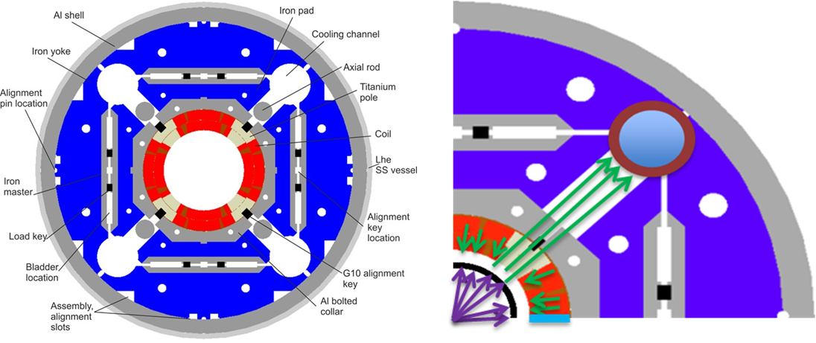

Figure 3: heat flow paths from coil to one of the two-phase heat exchangers located in the upper right quadrant

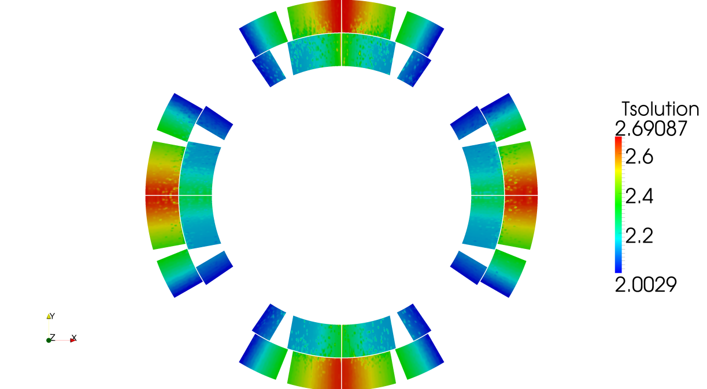

Figure 4: calculated temperature distribution for heat loads corresponding to L=5∙1034 cm-1 s-1 and cold source at 1.9 K, no quench heaters on inner layer

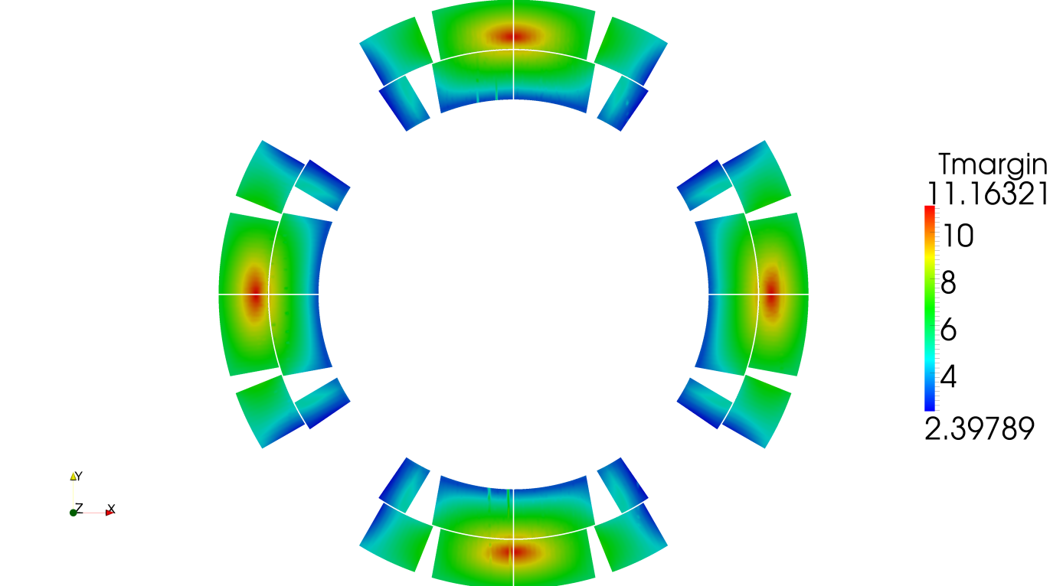

Figure 5: calculated resulting temperature margin due to heat loads corresponding to L=5∙1034 cm-1 s-1 and cold source at 1.9 K, no quench heaters on inner layer

Table 1 summarizes the cold mass, heat extraction specific sizing requirements, as known up to now. The radial passage requirements are subject to further detailing pending the validation studies for ultimate luminosity conditions and chosen quench heater implementation.



Table 1: Cold mass, heat extraction specific, sizing requirements.

# Conclusions

The requirements to be imposed on the cold mass design to enable cooling the inner triplets by superfluid helium have been integrated in the magnet design since the early stage of the design study. With the present baseline, they fall within the scope of integration in the magnet and cryostat design. Considering that the cryogenic infrastructure needed is similar to a proven LHC configuration, the superfluid helium cooled option constitutes a viable solution. Areas of further cold mass specific study are identified, specifically related to take into account the demand to sustain 7.5×1034 cm-2 s-1 luminosity and the requirements for extra quench heaters in the heat extraction path. The whole configuration must be sized such as to assure absence of any bottlenecks in the heat extraction paths, in particular showing only marginal dependence on cold-source temperature.

# References

[1] *High Luminosity Large Hadron Collider A description for the European Strategy Preparatory Group*, Rossi, L.; Brüning, O., CERN-ATS-2012-236

[2] *Fluka Energy Deposition Studies for The HL-LHC*, Esposito L.S.; Cerutti F.; Todesco, E., 2013 International Particle Accelerator Conference (IPAC'13), May 13-17, 2013, Shanghai, China

[3] *Design Studies for the Low-Beta Quadrupoles for the LHC Luminosity Upgrade*, Todesco E., Allain H., Ambrosio G., Borgnolutti F., Cerutti F., Diedtrich D., Esposito L., Felice H., Ferracin P., Sabbi G., Wanderer P., van Weelderen R., Applied Superconductivity, IEEE, Volume 23 (2013)

[4] *Study of the Supercritical He Cooling: MS41*

[5] *The Cryogenic Design of the Phase I Upgrade Inner Triplet Magnets for LHC*, van Weelderen, R.; Vullierme, B.; Peterson, T., 23rd International Cryogenic Engineering Conference, Wroclaw, Poland, 19 - 23 Jul 2010

[6] *Cooling Strings of Superconducting Devices below 2 K: The Helium II Bayonet Heat Exchanger*, Lebrun Ph.; Serio L.; Tavian L.; van Weelderen, R., Adv. Cryog. Eng., A: 43 (1998)