 | AT-MAS Technical Note  30 July 2026  Elena.Wildner@cern.ch

Proposal for the implementation of an automatic holding point procedure for the magnetic and geometric measurements of the LHC Dipole
E. Wildner, G Bevillard / MAS
Keywords: Holding point, data base, magnetic measurements, geometric measurements

Summary

The holding point for the magnetic measurements implies today a certain number of manual manipulations of files, data, mailing, mailing lists etc. With the increasing production rate this becomes more and more difficult to handle and the risk of making mistakes is increasing. This is a proposal to implement a system using modern and secure programming techniques to make the system as automatic as possible. The proposal is made in such a way that it can be implemented in a modular way and in parallel with the present system for testing and smooth change. The ideas could be adapted for other measurements like geometry or quadrupole data.

Introduction
The holding point for the magnetic field measurements is now a working procedure including analysis [Ref. 1], data base upload, mail sending etc. However the administrative part takes most of our time and is perfectly possible to automate completely which would give us more time for our analysis and statistics. To be fully automatic, integrated and possible to run from a web application the data analysis program and data upload program should also be revised.
This note describes a proposal for a possible solution to automize the holding point procedure almost completely. The idea of the work is to provide a web based interface in a way such that the user only needs an internet browser and no specific software like for example Excel or Java (the program runs remotely in a CERN server). This is important if we want to do this analysis outside CERN. It is also important that the software can be run on any computer system (PC, MAC, UNIX etc.). The solution we propose here is based on java/jsp. One of the important things for us is that we get support for the java server from IT since we have very limited expertise and manpower for the maintenance of the software and hardware environment. The choice of programming environment was made from the following criteria: web supported, data/code separation (not the case for excel, very important for maintenance), object oriented, relatively easy to maintain and learn, supported by CERN, supported by EDMS, ORACLE-interface supported by CERN, a modern but well anchored language adapted to web technology.

In a meeting held in May 2003 it was agreed that a proposal should be made to make this holding point procedure as automatic as possible. This note is trying to formalize this proposal that has also been presented in a meeting within the MAS/MA section in July 2003. The proposal is not detailed, but just a basis for discussion and a way to permit the start of a prototype implementation. However, no important items should be omitted in the description. The aim is to make the system very modular to avoid blocking when ideas develop.

What is to be done for the holding point?
The holding point is a procedure by which a set of measurement data for a dipole is sent from industry to the MAS group, analysed by MAS/MA, classified (acceptable or not) and stored in a database. The result of the analysis is communicated to project engineers who take decisions and propose actions, by considering the analysis results, via mail to industry. The problems we have with this is that many manual manipulations have to be done, writing mails (these have to contain clear information for retrieval, they have to be classified, be sent to the right people etc.), database manipulations, file manipulation, data sheet updating with risk to forget or mistype, update of repositories with the risk of being incompatible with MTF data and so on.

With a new technology it is proposed to develop a small number of programs that force the user to think of all information necessary to include in the mail, send the mails to responsible people listed in the database, formulate the mails to contain all information in a clear way, store important information in the data base and on the server for use by analysis programs and statistics programs, store all mails in the EDMS. In this way we believe that we can reduce mistakes to a minimum and optimize the time spent for the holding point procedure.
The aim is to implement these programs in a generic way, so that they can be used for different similar problem classes. The magnetic and the geometric data reception and analysis (dipole) are different but the general scheme should be possible to adapt to different situations. It is not necessary to include all steps either.

General Layout
The general layout of the proposal is shown in figure 1. It applies to the holding point for the magnetic measurements of the collared coil and the cold mass of the dipole. The aim is that it can be applied also for geometric measurements or magnetic measurements for the quadrupole with minor changes if this is needed in the future.

When a magnetic measurement is finished in industry it has to be controlled by CERN. The AT/MAS/MA section analyses the data and gives an opinion on the measurement result to the AT/MAS/MD section, with suggestions about possible origins of the problem, if any. AT/MAS/MD takes the decision if the magnet assembly can be continued or if some actions have to be taken. This procedure is today performed using Excel and text files sent by electronic mail to the concerned people, analysed using an Excel program, the information is uploaded from Excel to the Oracle database. All mails concerning this process have to be kept by many people for reference. The MTF repository has to be updated with the same information as the database, which is for the moment not evident. There is a repository of Excel files to update and maintain in addition to the data base. This repository is used for accessing the original Excel data and the results of the analysis (these data exist also in the database). All mails have to be edited manually and sent to the correct people. The problem with all this is the number of manual checks and actions, which, with increasing production speed, already has shown a risk for making mistakes.

Figure 1: General layout of the information flow for the holding point of the magnetic measurements.

It is suggested to make the procedure automatic using programming techniques conceived for this kind of problems. Here is a list of the basic ideas.
All mails exchanged should be registered. The mails should have a strict format. Mailing lists and classification of comments (also a free comment possible if information not foreseen in our lists of predefined comments) will be stored in our database for future programmatic treatment. The mails should be constructed from a web program using the database and sent and registered when the user gives the ok to execute.
The procedure should force all steps in the procedure so that nothing is forgotten, that magnet numbering/naming, dates and similar things can not be manipulated (filled in by hand) and this should be carefully checked automatically as far as possible.
The analysis program is written in Excel and this has a number of disadvantages when production speed increases. Converting the analysis to a non interactive language would be an advantage.
To be able to execute the necessary actions from anywhere in the world via the web, it is necessary to replace the Excel programs for the analysis and upload procedures with programs written in a more adapted programming language.
Our Excel repository will not be updated any more (it was originally foreseen as a temporary storage only). We will not throw away the original file coming from the industry but keep them since intermediate storage is also part of the automatic procedure. They can be browsed if necessary and no wild manipulation of files is possible. There is in addition always a document in the EDMS, containing the source file, (a file in the MTF).
All the programs (mail creators, analysis programs, data base uploads, analysis) should have web interfaces and be accessible from anywhere (with correct access checks).
When programs are updated all users should immediately profit of the modifications without any manipulation (with our present system this is not guaranteed). Only one way of update and maintenance will be possible.
With the new proposal all programs reside in the same server, maintained by IT. This server also holds parts of the EDMS system for the main dipole and is therefore maintained at highest priority. All programs should be data driven and use information stored in the Oracle database (mailing lists, information about measurements etc.). Some information may be stored temporarily in the server waiting for an entry in the data base, additional laminations needed is an example.

Description of the different steps in the proposed holding point implementation
In the following I shall go though all the boxes on the layout. They are all numbered and I shall refer to these numbers (box 1, box 2 etc.).

The measurement result
The measurements are available in a text file (box 1 in figure 1). Not all firms send the information in the text file, but in an Excel file. However the text file is always available. Today the operator can check the result by running the Excel analysis program at the site which is an interesting option that should be kept. However he has to be aware that he has to update his local Excel version manually if we make modifications. In the new proposal there should be a possibility to do this analysis via the same web based program as the one used by the analysis team. This is represented by the arrow going to box 5.
Then the measurement should be sent to CERN.
The prerequisites at the premise are an internet connection and that the measurement file is accessible on the connected computer.

Sending the measurement to CERN
The measurement file should be available locally on a computer in the industry that is connected to internet. The program (box 2) should read the file from this computer via a file browser. Then the file should be transferred to a special repository on the server at CERN. The program should then construct a mail. By knowing from which firm the mail comes, the corresponding list of recipients should be constructed.

The program prompts for:
The name of sender
Magnet number
Stage (collared coil or cold mass)
If cc it prompts for additional shims (figure 2)
If cm it prompts for left or right dipole (L or R) and type of dipole (A or B)
Also a free comment is possible to submit.

The program checks the magnet number with information stored in the text file.

Shims
Aperture 1 |  |  |  |  | Aperture 2
Left |  | Right |  |  | Left |  | Right
Outer | Inner | Inner | Outer |  | Outer | Inner | Inner | Outer
0.850 | 0.200 | 0.200 | 0.850 | Up | 0.850 | 0.200 | 0.200 | 0.850
0.850 | 0.200 | 0.200 | 0.850 | Down | 0.850 | 0.200 | 0.200 | 0.850
Seen from connection side
Figure 2: Shim information for collared coil

The program should store on the server (box 3):
Date of sending
Login name and IP address of sender
Additional shims (collared coil) and laminations (cold mass)
The data file in standard CERN file system (the data file should be kept after the analysis but transferred to another place for “treated” files).

Transfer of information holding point information to the database should be done when the analysis is finished.
It should be checked in an efficient way that the user has the permission to send the information and write to the server. This should be done in a way similar to the EDMS system for example.
Mailing lists should be stored in the data base and a web interface to maintain these lists should be available. This applies of course to all the mail sending modules.
See figure 3, 4 and 5.

Reception by analysts and analysis
When the result is sent to CERN, the responsible analysts get the mail and start the analysis program. This program is foreseen to run in the server and be accessible via the web. The program should have at least the same functionality as the present excel version of the analysis program. It should always be possible to check a measurement result with the existing Excel version for checks, testing, and backup. The measurement file will not be sent together with the mail, but be sent to the server. The analyst has to take the file from the server (the file will be accessible from a web page) if he wants to use the Excel program for the analysis. In this way we can ensure a progressive way of implementation. There will be no other backup at this stage, but since the server will be the EDMS server [Ref. 2] it will have high priority. The files can also be stored in the data base. The txt files should be sent to the EDMS system for backup security.

The analysis program should prompt for the magnet number and the stage (collared coil or cold mass), prompt for the name of the analyst, check access rights, and look for the corresponding measurement file in the server. When the analysis is finished the program should construct a complete file (box 6) with original data, date of analysis, name of analyst and with the analysis results.
The analysis program has access to information like additional shims, laminations and such things, that are stored in the server, and uses this for the analysis. When the analysis of the collared coil is finished the information about the possible need of additional laminations should be stored.
The program for checking the identity of the magnet (this program is already written in java, runs presently in the server and can be accessible from our program web page) has to be invoked.
There will be a possibility to inspect the information via a display program (web access) by just giving the magnet number and the stage (collared coil or cold mass). This will work directly on the database information.

There should be a list of standard comments in the database that will be shown in a multiple choice selection box. The aim of this is to facilitate classification and treatment of analysis results, retrieval of similar errors and the like. All comments can not be expressed from simplified classification and a free comment should always be available. To make the system compatible with the present log program, a summary comment should be supplied using this free comment, as before. This comment should then be used by the log.

When the old Excel analysis program is used, the file can be downloaded from the server using the interface shown in figure 6.

Data base upload
For the upload (box 7), the date of the analysis is stored together with the results in a file and this date is stored in the database. Also the date of upload should be stored. The procedure is not compatible with the presently existing Excel program. If the analysis is done using Excel, the upload has to be done via the presently existing Excel upload program, and cannot be done via the web.

Analyst’s reply
When the analysis and upload is finished, the result is going to be communicated to the MAS/MD section. The program to do this is started (box 9) and the user is prompted for his name and the magnet number and the stage (collared coil or cold mass). The comments are automatically displayed in the interface (the “free comment”). The date of the sending is sent to the data base. In the case of collared coil the need for extra yoke laminations has to be communicated. The program checks access rights and according to lists in the database (the magnet number identifies the firm) and the responsible engineers will be notified with a mail.
See figure 7 and 8.

Project engineer’s reply
There is also a program accessible via the web for the project engineers to send the holding point result to industry. The user should be prompted for his name, the magnet number and the stage (collared coil or cold mass). The comment from the analysis should be displayed so that the project engineer can see what the comment was from the analysis. A possibility to send this comment should exist. A free comment should be possible to enter in addition to this comment or alone. Mailing lists should be in the data base. Access rights etc. should be checked. The date of the sent mail should be uploaded into the data base. The comment should be stored.

A collection of example figures
The examples are generated from a software prototype already running on the server in the target environment.
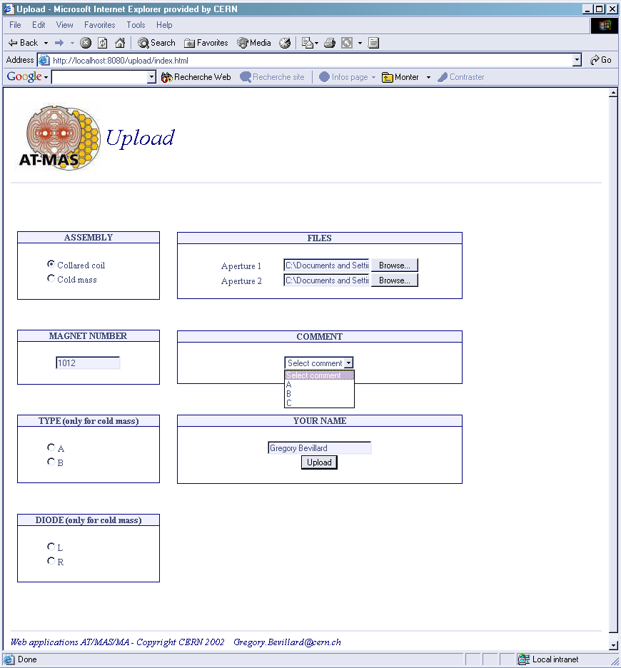
Figure 3: Prototype interface for industry to send measurement

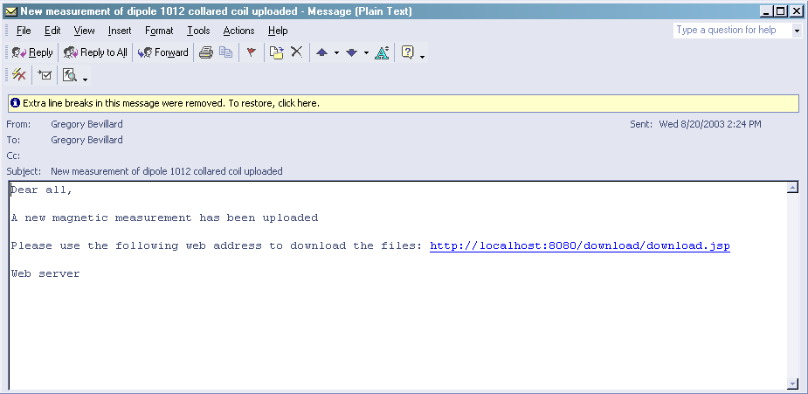
Figure 4: Example of mail automatically received from industry

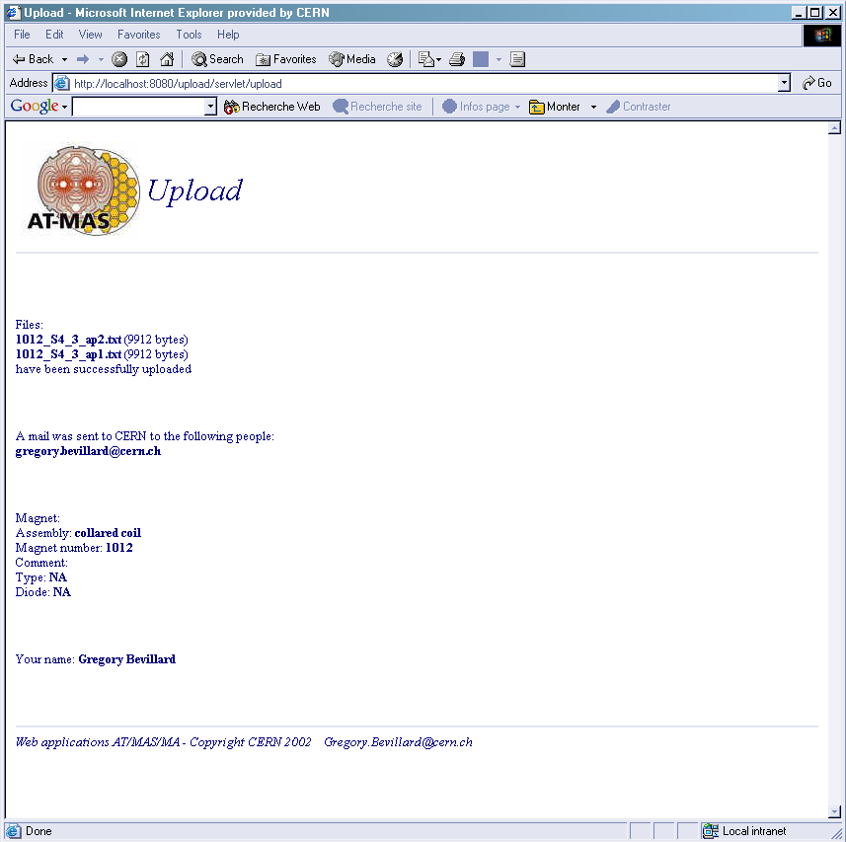
Figure 5: Example of confirmation at the premise of mail automatically sent to CERN

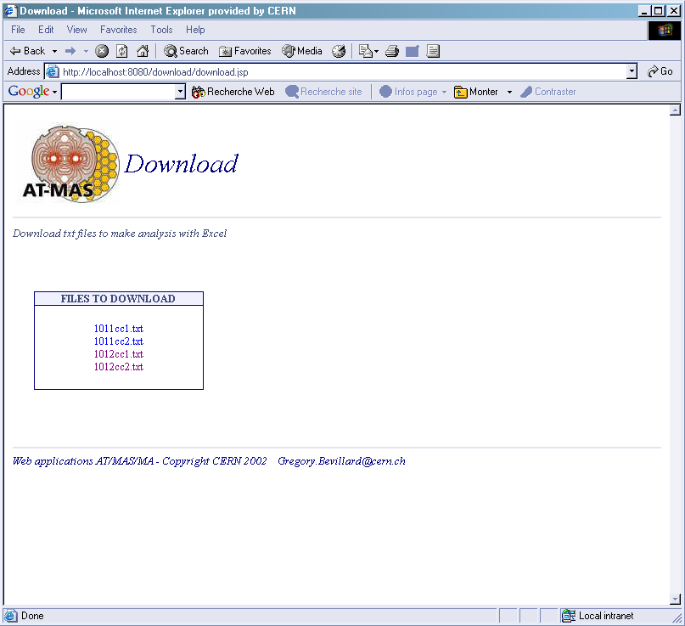
Figure 6: Example of interface to download files to be manually analyzed by the Excel analysis program

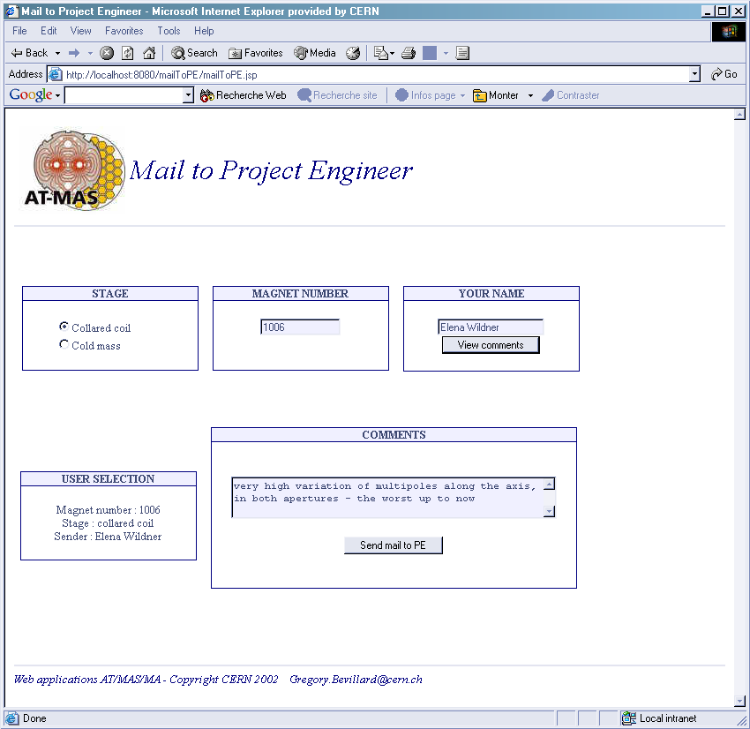
Figure 7: Example mail automatically sent to project engineers after analysis. The comment comes from the database and can be modified if necessary.

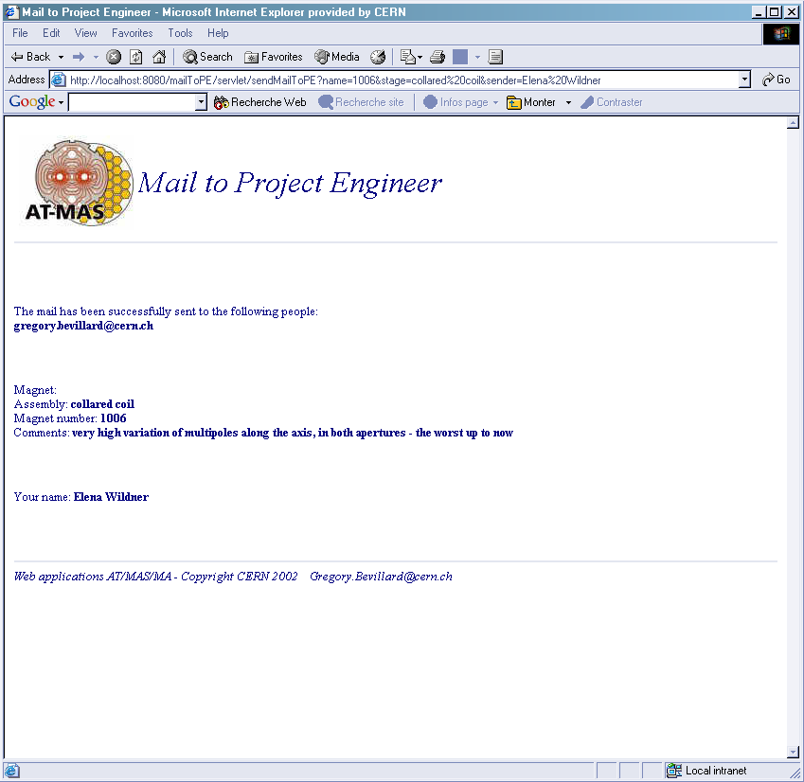
Figure 8: Confirmation of contents of the mail sent to project engineers

The MTF
The data files stored in the MTF are today Excel files that can be directly inspected. With this new proposal the text file would be stored. For inspection of the contents one would need the analysis program either the Excel program or the new analysis program.

The MTF already has infrastructure for sending mails, storing documents (files) and for keeping track of workpackages to be done in the acceptance procedure of the dipole. This possibility should also be considered as an option. With the prototype we have developed we are more independent and can more easily change our filosophy, on the other hand we have less generality.

The EDMS
The EDMS system facilities can be a useful help to register all mails and to store the text files sent from industry. This is an essential backup necessity. Maybe the storage of the text files can be the standard EDMS registry so that the storage of the text files does not have to be duplicated see section 4.7. This is illustrated with boxes 13, 14 and 15.

Planning
The programming of the proposal can now start using the new programming environment (java/jsp) using the server that the IT division has offered to us. The first phase will be to make the skeleton of mail sending and file handling. The analysis program will for the first phase still be the old Excel program, which implies that box 6 and box 7 will not be implemented. The estimation is that with one full time programmer this can be achieved for January 2004.

Acknowledgements
Considerable help for application program writing and integration using the software system (java, jsp), making this proposal possible, has been given to us by Bertrand Rousseau EST/ISS. Support for using a server in the IT division has also been given by Eric Grancher and Nilo Segura in the IT division.

References
- S.Pauletta, Field quality analysis to monitor the industrial series production of the dipole magnets for the Large Hadron Collider, Tesi di Laurea, Politecnico di Torino, 2002, report in progress
- E. Grancher, private communication, July 2003

