Introduction
The holding point for the magnetic field measurements is now a well established procedure that includes analysis [Ref. 1], data base upload, mail sending etc. However the administrative part takes most of our time and it is perfectly possible to automate this completely which would give us more time for our analysis and statistics. To be fully automatic, integrated and possible to run from a web application, the data analysis program and the data upload program also have to be revised.
This note describes a proposal for a possible solution to automate the holding point procedure almost completely. The idea of the work is to provide a web based interface in a way such that the user only needs an internet browser and no specific local software like for example Excel or Java (the program runs remotely in a CERN server). This is important if we want to do this analysis outside CERN. It is also important that the software can be run on any computer system (PC, MAC, UNIX etc.). The solution we propose here is based on java/jsp. One of the important things for us is that we get support for the java server from IT since we have very limited expertise and manpower for the maintenance of the software and the hardware environments. The choice of programming environment was made from the following criteria: web supported, data/code separation (not the case for excel, very important for maintenance), object oriented, relatively easy to maintain and learn, supported by CERN, supported by EDMS, ORACLE-interface supported by CERN, a modern but well anchored language adapted to web technology.

In a meeting held in May 2003 it was agreed that a proposal should be made to make this holding point procedure as automatic as possible. This note is trying to formalize this proposal that has also been presented in a meeting within the MAS/MA section in July 2003. The proposal is not detailed, but just a basis for discussion and a way to permit the start of a prototype implementation. However, no important items should be omitted in the description. The aim is to make the system very modular to permit easy modifications and stepwise increased functionality.

What is to be done for the holding point?
The holding point is a procedure by which a set of measurement data for a dipole is sent from industry to the MAS group, analysed by MAS/MA, classified (acceptable or not) and stored in a database. For the moment this is only applied for the magnetic measurements. The result of the analysis is communicated to project engineers who take decisions and propose actions, by considering the analysis results, via mail to industry. The problems we have with this is that many manual manipulations have to be done, writing mails (these have to contain clear information for retrieval, they have to be classified, be sent to the right people etc.), database manipulations, file manipulation, data sheet updating with risk to forget or mistype, update of repositories with the risk of being incompatible with MTF data and so on.

With a new technology it is proposed to develop a small number of programs that force the user to think of all information necessary to include in the mail, send the mails to responsible people listed in the database, formulate the mails to contain all information in a clear way, store important information including mails and original files in the data base and in the server for use by analysis programs and statistics programs. In this way we believe that we can reduce mistakes to a minimum and optimize the time spent for the holding point procedure.
The aim is to implement these programs in a generic way, so that they can be used for different similar problem classes. The magnetic and the geometric data reception and analysis (dipole) are different but the general scheme should be possible to adapt to different situations.

General Layout, magnetic measurements
The general layout of the proposal is shown in figure 1. It applies to the holding point for the magnetic measurements of the collared coil and the cold mass of the dipole. The aim is that it can be applied also for geometric measurements (see below) or magnetic measurements for the quadrupole with minor changes.

When a magnetic measurement is finished in industry it has to be controlled by CERN. The AT/MAS/MA section analyses the data and gives an opinion on the measurement result to the AT/MAS/MD section, with suggestions about possible origins of the problem, if any. AT/MAS/MD takes the decision if the magnet assembly can be continued or if some actions have to be taken. This procedure is today performed using Excel and text files sent by electronic mail to the concerned people, analysed using an Excel program, the information is uploaded from Excel to the Oracle database. All mails concerning this process have to be kept by many people for reference and retrieval. The MTF repository has to be updated with the same information as the database, which is for the moment not evident. There is a repository of Excel files to update and maintain in addition to the data base. This repository is used for accessing the original Excel data and the results of the analysis (these data exist also in the database). All mails have to be edited manually and sent to the correct people. The problem with all this is the number of manual checks and actions, which, with increasing production speed, already has shown a risk for making mistakes.

Figure 1: General layout of the information flow for the holding point of the magnetic measurements.

It is suggested to make the procedure automatic using programming techniques conceived for this kind of problems. Here is a list of the basic ideas.
All mails exchanged will be saved in the data base and accessible according to firm, date or other criteria if wanted. The mails should have a strict format and be easily readable from a web page. Mailing lists and lists of predefined comments that analysts or project engineers may want to give (also a free comment possible if information not foreseen in our lists of predefined comments) will be stored in our database for future programmatic treatment. The mails should be automatically constructed by a web program using the database and they should be sent and registered when the user gives the ok to execute.
The procedure should force all steps in the procedure so that nothing is forgotten, that magnet numbering/naming, dates and similar things can not be manipulated (filled in by hand) and this should be carefully checked automatically as far as possible.
The analysis program is written in Excel and this has a number of disadvantages when production speed increases. Converting the analysis to a non interactive language would be an advantage, but this will only be considered at a later stage of this development. To be able to execute the necessary actions (reception of mail, analysis and data base upload) from anywhere in the world via the web, it is necessary to replace the Excel programs for the analysis and upload procedures with programs written in a more adapted programming language.
Our Excel repository will not be updated any more (it was originally foreseen as a temporary storage only). The source data files coming from the premises will first be stored in the server and when analysis is finished they will be loaded into and accessible from the ORACLE data base. They can be browsed if necessary and no wild manipulation of files is possible. There is in addition always a document in the EDMS, containing the source file (a file in the MTF), which is considered being the official document.
All the programs (mail creators, analysis programs, data base uploads) should have web interfaces and be accessible from anywhere (with correct access checks).
When programs are updated all users will immediately profit of the modifications without any manipulation (with our present system this is not guaranteed). Only one way of updating and maintenance will be possible.
With the new proposal all programs reside in the same server, which is maintained by IT. This server also holds parts of the EDMS system for the main dipole and is therefore maintained at highest priority. All programs should be data driven and use information stored in the Oracle database (mailing lists, information about measurements etc.). Some information may be stored temporarily in the server waiting for an entry in the data base; proposed number of additional laminations is an example of this.

Description of the different steps in the proposed holding point implementation for the magnetic measurements
In the following we will go though all the boxes on the layout. They are all numbered and we will refer to these numbers (box 1, box 2, etc.).

The measurement result
The measurements are available in a text file (box 1 in figure 1). Not all firms send the information in the text file, but in an Excel file. However the text file is always available. Today the operator can check the result by running the Excel analysis program at the site which is an interesting option that should be kept. However he has to be aware that he has to update his local Excel version manually by downloading from our repository or by asking for a copy of the program and down load from a diskette, if we make modifications in the analysis program. In the new proposal there should be a possibility to do this analysis via the same web based program as the one used by the analysis team (a development that we will do as a second development phase if wanted). This is represented by the arrow going to from box 1 to box 5.
Then the measurement should be sent to CERN.
The prerequisites at the premise are an internet connection and that the measurement file is accessible on the connected computer.

Sending the magnetic measurement to CERN
The measurement file should be available locally on a computer in the industry that is connected to internet. The program (box 2) should read the file from this computer via a file browser. The operator is forced to send complete information and the text file will be sent directly to the server and will be automatically transferred to the database once the analysis is carried out. This way of storing the raw data will replace our present repository.
The program should then construct a mail. By knowing from which firm the mail comes (operator, IP address, magnet number), the corresponding list of recipients should be constructed. In this way we avoid making mistakes in the construction of mailing lists.

The program prompts for:
The name of sender
Magnet number
Stage (collared coil or cold mass)
If cc it prompts for additional shims (figure 2)
If cm it prompts for left or right dipole (L or R) and type of dipole (A or B)
Also a free comment is possible to submit.

The program checks the magnet number with information stored in the text file.

Shims
Aperture 1 |  |  |  |  | Aperture 2
Left |  | Right |  |  | Left |  | Right
Outer | Inner | Inner | Outer |  | Outer | Inner | Inner | Outer
0.850 | 0.200 | 0.200 | 0.850 | Up | 0.850 | 0.200 | 0.200 | 0.850
0.850 | 0.200 | 0.200 | 0.850 | Down | 0.850 | 0.200 | 0.200 | 0.850
Seen from connection side
Figure 2: Shim information for collared coil

The program should store the following on the server (box 3):
Date of sending
Login name and IP address of sender
Additional shims (collared coil) and laminations (cold mass)
The data file in standard CERN file system (the data file should be kept after the analysis but transferred to another place for “treated” files, this storage can be the data base for example).

Transfer of holding point information to the database should be done when the analysis is finished.
It should be checked in an efficient way that the user has the permission to send the information and to write to the server. We will use the database to administrate this (see below).
Mailing lists should be stored in the data base and a web interface to maintain these lists should be available. This applies of course to all the mail-sending modules. See figure 3, 4 and 5.

Reception by analysts and analysis
When the result is sent to CERN, the responsible analysts get the mail and start the analysis program. This program is also foreseen to run in the server and be accessible via the web (a second phase of development). The program should have at least the same functionality as the present Excel version of the analysis program. It should always be possible to check a measurement result with the existing Excel version for checks, testing, and backup. Since the measurement file will not be sent together with the mail, but will be sent to the server, the analyst has to take the file from the server (the file will be accessible from a web page) if he wants to use the Excel program for the analysis. When the web based analysis program is used the file will be automatically retrieved. In this way we can ensure a progressive way of implementation. There will be no backup of the original measurement file at this stage, but since the server will be the EDMS server [Ref. 2] it will have high priority. The source files will be stored in the data base after analysis.

The analysis program should prompt for the magnet number and the stage (collared coil or cold mass), prompt for the name of the analyst, check access rights, and look for the corresponding measurement file in the server. When the analysis is finished the program should construct a complete file (box 6) with original data, date of analysis, name of analyst and with the analysis results.
The analysis program should take care of the magnet numbering which is a parameter essentially used for easy plotting and similar.
The analysis program has access to information like additional shims, laminations and such things, that are stored in the server or in the data base, and uses this for the analysis.
The program for checking the identity of the magnet (this program is already written in java, runs presently in the server and can be accessible from our program web page, www.cern.ch/pdaindex) has to be invoked.
It is possible to develop a display program (web access) from which information can be accessed by just giving the magnet number and the stage (collared coil or cold mass). This module will work directly on the database information (later development).

There should be a list of standard comments in the database that will be shown in a multiple choice selection box. The aim of this is to facilitate classification and treatment of analysis results, retrieval of similar errors and the like. All comments can not be expressed from simplified classification and a free comment should always be available. To make the system compatible with the present log program, a summary comment should be supplied using this free comment, as before. This comment will then be used by the log. The free comment can also be taken from the classification list. Here we see the interest to formulate and register comments of general kind to make the log look nice, and show similar comments for similar errors.

When the old Excel analysis program is used, the file can be downloaded from the server using the interface shown in figure 6.

Data base upload
For the upload to the data base (box 7), the date of the analysis is stored together with the results in a file and this date is stored in the database. Also the date of upload should be stored. The proposed procedure is not compatible with the presently existing Excel program. If the analysis is done using Excel, the upload has to be done via the presently existing Excel upload program, and cannot be done via the web.
With a new upload procedure, the reloading of dipoles already existing in the database should be automatic which is not the case today.

Analyst’s reply
When the analysis and upload is finished, the result is going to be communicated to the MAS/MD section. The program to do this is started (box 9) and the user is prompted for his name and the magnet number and the stage (collared coil or cold mass). The comments are automatically displayed in the interface (the “free comment”). The date of the sending is sent to the data base. In the case of collared coil the need for extra yoke laminations has to be communicated via the automatic mail. The program checks access rights and according to lists in the database (the magnet number identifies the firm) and the responsible engineers will be notified with a mail.
See figure 7 and 8.

Project engineer’s reply
There is also a program accessible via the web for the project engineers to send the holding point result to industry. The user should be prompted for his name, the magnet number and the stage (collared coil or cold mass). The comment from the analysis should be displayed so that the project engineer can see what the comment was from the analysis. A possibility to send this comment should exist. A free comment should be possible to enter in addition to this comment or alone. Mailing lists should be in the data base. Access rights etc. should be checked. The date of the sent mail should be uploaded into the data base, which today has to be done manually and is time consuming. The comment should be stored. For the collared coil the project engineer should indicate if additional/less number of laminations for the cold mass is needed. This should be asked by the interface and stored on the server.

Access rights
It is very important that we manage the rights to access these web programs. This not only for the integrity of the measurement results from the firms and our answers. It is also important to ensure the consistency and the validity of data. Therefore different levels of access to this automatic holding point procedure have to be defined. Only authorized persons (with a login and a password) will have the right to transfer measurement files (responsible at the firm), upload data in the database (analyst) and to send mails (responsible at the firm, analyst and project engineer).
This automatic holding point procedure has to be flexible to guarantee that it can be used during the duration of the project. Thus an administrator level with all rights has to be defined. The administrator could change the mailing list, create new predefined comments and create new accounts for people who are recently implied in this procedure or in the project.
Accounts will be managed by the administrator and not by using CERN services (like a NICE or AIS account). In this way, it will be easier to react rapidly to any change or request from users, and also to guarantee confidentiality of data (firms may access only to their own data and not ones from others firms). This automatic holding point procedure is developed in parallel with data viewers, and access rights for this procedure can be coupled to access rights for the viewers.
Accounts will be managed via a web interface, and information will be stored in the database in a table with the following fields:
- name
- first name
- login [primary key]
- password
- e-mail [optional]
- type (project engineer, analyst, administrator, firm’s responsible)
- rights (upload, send mail, view data, read/write comments, read/write mailing list, create account)
- expiration date

Where “[…]“ means technical specification and “(…)“ means values taken by this field.

A collection of example figures for the magnetic holding point
The examples are generated from a software prototype already running on the server in the target environment.
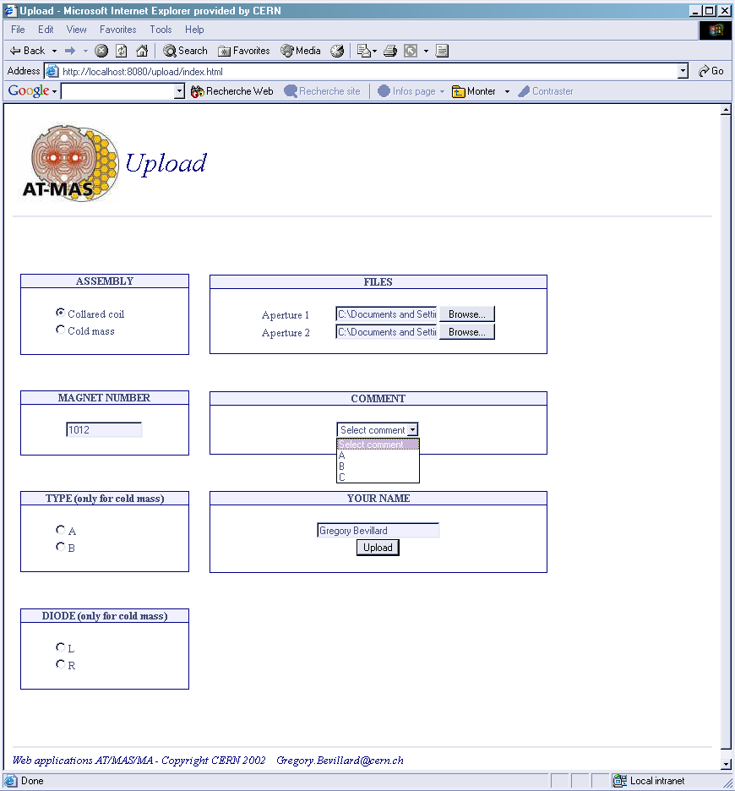
Figure 3: Prototype interface for industry to send measurement

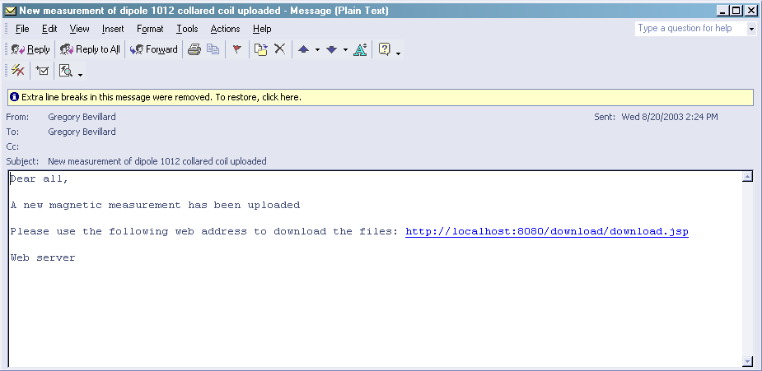
Figure 4: Example of mail automatically received from industry

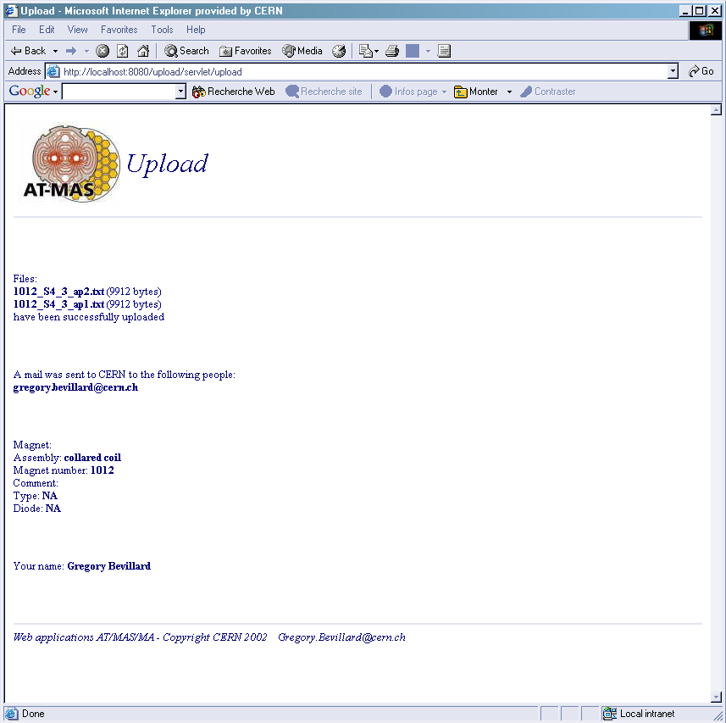
Figure 5: Example of confirmation at the premise of mail automatically sent to CERN

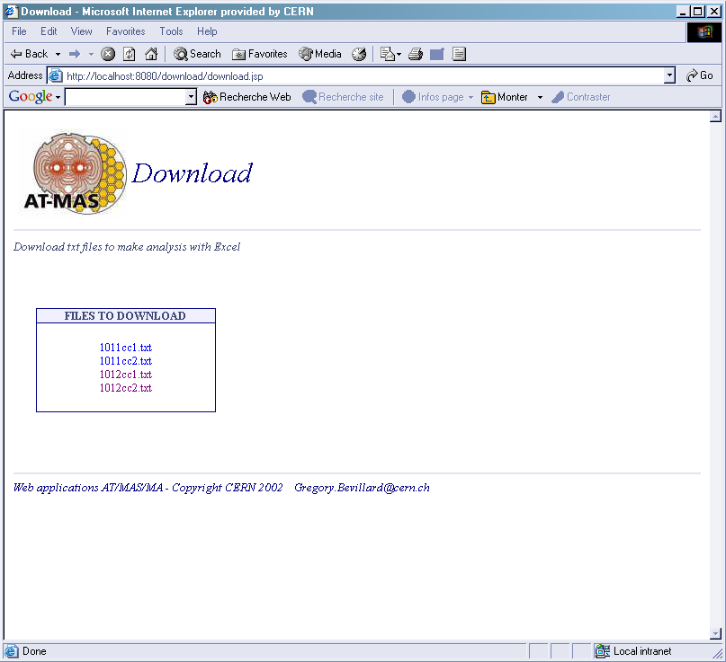
Figure 6: Example of interface to download files to be manually analyzed by the Excel analysis program

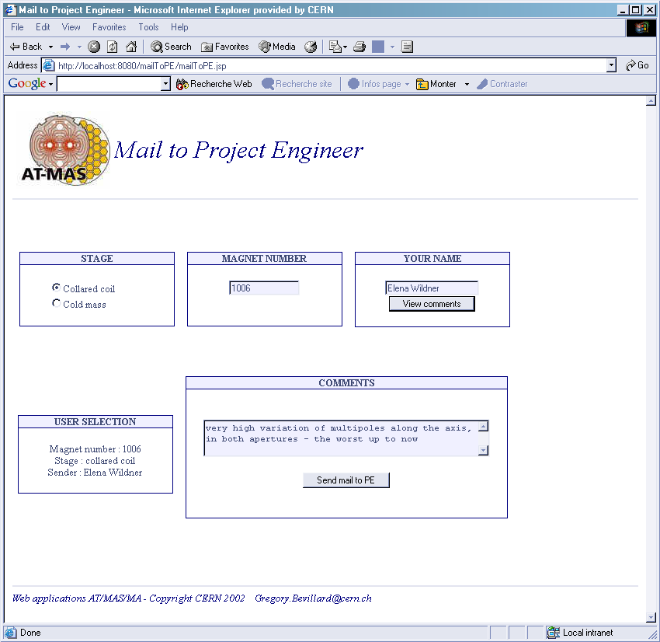
Figure 7: Example mail automatically sent to project engineers after analysis. The comment comes from the database and can be modified if necessary.

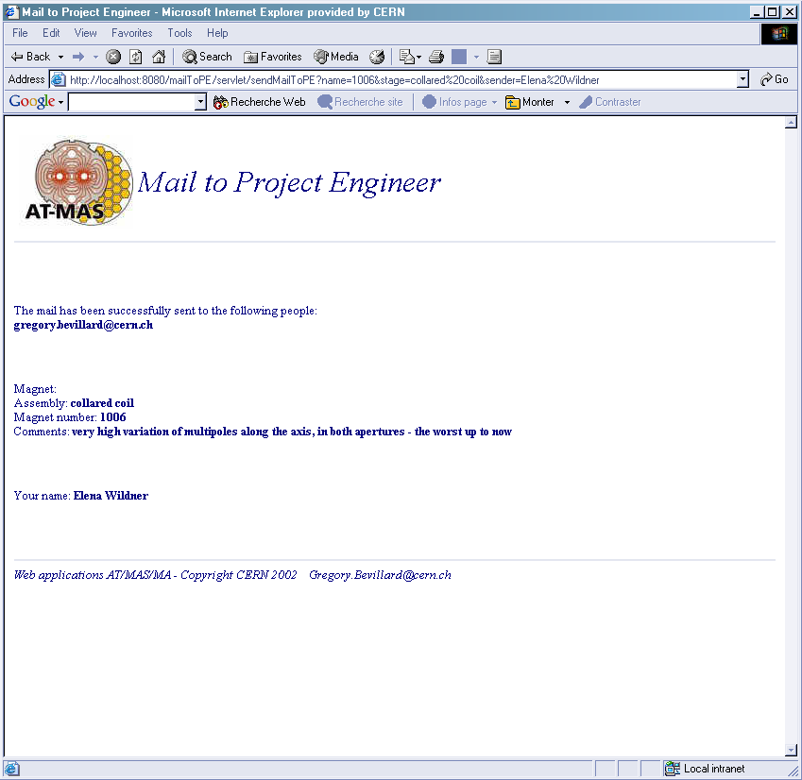
Figure 8: Confirmation of contents of the mail sent to project engineers

The MTF
The data files stored in the MTF are today Excel files that can be directly inspected. With this new proposal the text file would be stored. For inspection of the contents one would need the analysis program either the Excel program or the new analysis program.

The MTF already has infrastructure for sending mails, storing documents (files) and for keeping track of work packages to be done in the acceptance procedure of the dipole. This possibility should also be considered as an option. With the prototype we have developed we are more independent and can more easily change our philosophy, on the other hand we have less generality.

The geometric holding point
The geometric point holding does not exist for the moment. It is different from the magnetic holding point in the sense that there are hard tolerances on most of the parameters that need to be controlled. These are already checked in the industry. For additional checks and controls the files should be sent to CERN together with information concerning the assembly that may be relevant for the analysis geometry of the cold mass. The results of the analysis at CERN should be uploaded to the data base. Results of the analysis should be sent to the project engineers, as we do it for the magnetic holding point, and the project engineer should make the final descisions.

The measurement result
The DGM (Dipole Geometric Measurement) device [Ref. 3] produces a text file with pre-treated information on the geometry of the cold mass Box 1 in figure 8). Measurements may be done several times after the welding of the shrinking cylinder has been finished. The results we are interested in for the analysis at CERN are the measurement immediately after the welding (ITP15) and the final measurement (ITP20) which is represented in Box 5. What is also important for the analysis is a certain number of parameters describing the assembly procedure, see fig 9. These data should be collected and put on a text file (Box 6). Alternatively the operator can be prompted for the environmental information from the web program (Box 2) used for transferring the measurement data. There is a non considerable amount of data to collect and for this reason it may be easier to use a file prepared in advance.
Figure 8: General layout for the geometric holding point

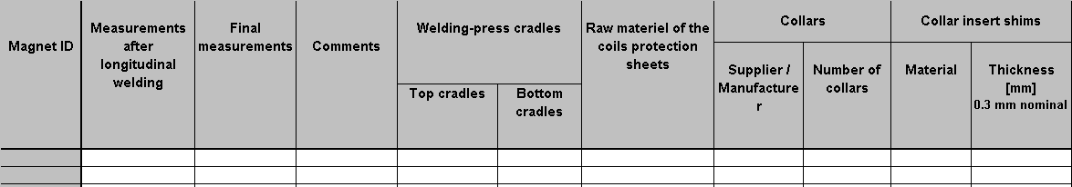
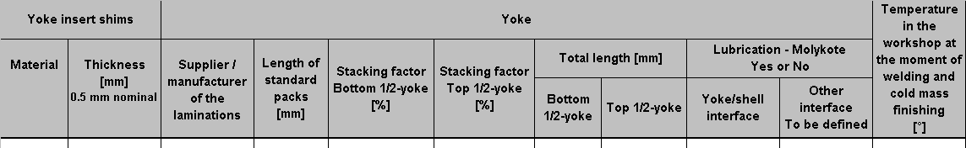

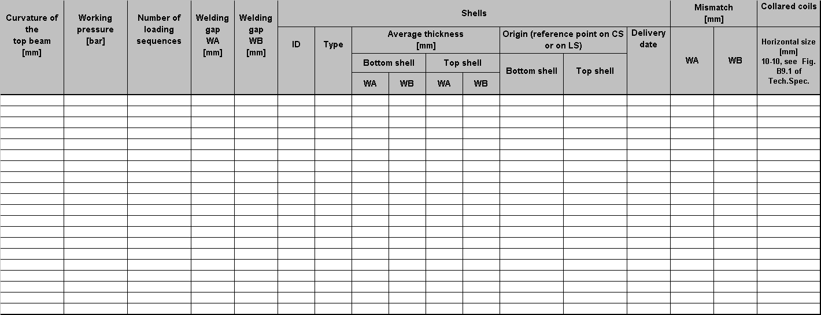

Figure 9: Example of additional assembly parameters, prepared by F.Savary (discussed in the first working group meeting on cold mass geometry)

Sending the geometric measurements to CERN
The program prompts for:
The name of sender
Magnet number
A free comment is possible to submit.

The program checks the magnet number with information stored in the text file.

The program should store on the server (box 3):
Date of sending
Login name and IP address of sender (to be checked together with the first digit of the magnet number)
The data files in the standard CERN file system (the data file should be kept after the analysis but transferred to another place for “treated” files, this can be the data base).

Transfer of holding point information to the database should be done when the analysis is finished.
It should be checked in an efficient way that the user has the permission to send the information and to write to the server. We will use the database to administrate this (see paragraph 4.7 on access rights).
Mailing lists should be stored in the data base and a web interface to maintain these lists should be available. This applies of course to all the mail-sending modules.
See figure 3, 4 and 5 for the magnetic measurements, the interface for the geometric data should look similar.

Reception of geometry data by analysts and analysis
When the result is sent to CERN, the responsible analysts get the mail and start the analysis program. This program is foreseen to run in the server and be accessible via the web. The measurement file will not be sent together with the mail, but be sent to the server. The analysis program automatically gets the files (ITP15, ITP20 and the assembly information) from the server and this is transparent to the user. The source files will also be stored in the data base after analysis.

The analysis program should prompt for the magnet number, prompt for the name of the analyst, check access rights, and look for the corresponding measurement files in the server. When the analysis is finished the program should construct a complete text file (box 11) with original data, date of analysis, name of analyst and with the analysis results. A comment should also be prompted for .
The analysis program has access to information that is stored in the server or in the data base, and uses this for the analysis. The analysis program would need statistical bounds for the parameters to check to be able to judge the new magnet compared to other produced magnets. In this way we control the production concerning the magnetic field and maybe this method can be applied also for geometric data.
There will be a possibility to inspect the information via a display program (web access) by just giving the magnet number. This will work directly on the database information. This is important for the users who need to look at the measurements and the results of the analysis. This display will be for one magnet at a time or for a specific parameter for several magnets (trends).
There should be a list of standard comments in the database used in a similar way as for the magnetic measurements.

The database upload of the geometric measurements will be done similarly as for the magnetic measurements.

The analysis program will produce information that will be used by a program for automatic generation of an overview of the results during a specified period of time (Box 9). This program will provide statistical information. This will be the basis for a bi-monthly report on the cold mass geometry. The report will be described in a separate note.

The reply of the analyst and the project engineer will be generated in a similar way as for the magnetic measurements.

Planning
The programming of the proposal can now start using the new programming environment (java/jsp) using the server that the IT division has offered to us. The first phase will be to make the skeleton of mail sending and file handling for the magnetic measurements. The analysis program will for the first phase still be the old Excel program, which implies that box 6 and box 7 will not be implemented. The estimation is that with one full time programmer this can be achieved for November 2004. Immediately after this, the geometric measurements will be treated as soon as the mechanisms for the magnetic measurements are working well and are well accepted by users. For the geometric measurements we will also start with the mail sending and file handling but also include new development for the data base upload, since more data is now uploaded (now we only upload the files from industry and no additional information). This can hopefully be completed before January 2004. In parallel the analysis program and the report generating program will be designed and implemented (another note will be written to explain the proposal). The time for a first version of the report is estimated to 3 full time months.

Acknowledgements
Considerable help for application program writing and integration using the software system (java, jsp), making this proposal possible, has been given to us by Bertrand Rousseau EST/ISS. Support for using a server in the IT division has also been given by Eric Grancher and Nilo Segura in the IT division.

References
- S.Pauletta, Field quality analysis to monitor the industrial series production of the dipole magnets for the Large Hadron Collider, Tesi di Laurea, Politecnico di Torino, 2002
- E. Grancher, private communication, July 2003
3. DGM

