POST-PROCESSOR FOR THE POLE MEASURING MACHINE
(CERN version)

USERS MANUAL

I.Vanenkov MMS/LHC

Coil size/E-modulus measurements standard procedure
A standard coil size/E-modulus measurements procedure to be used with the new Pole Measuring Machine (later PMM) is based on the requirements written in IT-2997/LHC/LHC Technical Specification. According to the Annex B9 of this document, the coils shall be measured in single layers and assembled pole configurations. A single coil layer shall be measured each meter in its straight part and the assembled pole at least in three sections. A maximum compressive stress should not exceed 120 MPa for the measurements in the straight part. A layers-jump/splice area is measured in two sections. All the measurements data shall be treated with post-processor and stored in the “Collared coil database”, which is a part of the traveller. For traceability, the names of the original raw data files shall be saved in the database and files should be attached to the traveller. Following to all this requirements a standard coil size/E-modulus measurements procedure is following:
- The individual coil layers are measured first. The measurements shell be taken at up to 18 longitudinal positions in the straight part of the coil. The PMM software predefines the exact longitudinal position for each of these sections. In case when a decision is taken to do the measurements with a reduced number of sections, they should always be performed at the standard positions.
- The assembled poles are measured at up to 20 longitudinal positions. Where 18 positions are in the straight part of the coil, and 2 sections are in the layers-jump/splice area. In case when a decision is taken to do the measurements with a reduced number of sections, they should be performed at least in three positions: (preferably at positions 3, 10 and 18).
The PMM calibration procedure, described in the manual of the machine, shall be performed after each startup and after each reconfiguring of the machine for the measurements on coil in different configuration (for example, switch from measurements on the layers to the measurements on poles).

Post-Processor User's Guide
The Post-processor application (CERNPP.vi, later PP) is written in LabVIEW 6.02 for Windows environment. To use it, a LabVIEW 6.02 full software package or at list a LabVIEW Run-Time Engine needs to be installed at the same computer first. The PP is off-line data analysis program and if it will be used at PMM computer, it might be executed at any time as it should not interfeare with the main software of PMM. Post-processor allows to exctract the relevant information from the raw data files created by the main sofware of the PMM, view strain-displasement graphs for each recorded measuring cycle, and treat data in a uniq approch for all measuring sections and all coils.

Data treatment method and output data files format
PMM, being measuring the coil at one particular section, produces a raw data file, which contains a header with the information about Date and Time of the test, Coil Identification number (Coil ID), User name and type of the machine (1.6MN or 3.2MN). After this header file contains the data from 4 LVDT and 4 pressing prisms (forces in kN and pressures in MPa) together with measuring cycle number and additional information about zero settings for pressure and displacement sensors. One raw data file could contain a data from many measuring cycles, performed at the same section. An example of the raw data file is given in annex 1. When the raw data file belongs to one coil, measured at particular longitudinal coil section, is loaded into PP, it can be re-viewed on the strain-displacement graph, cycle by cycle in the same order as it was recorded by the main software of PMM during measurements. At the same time, when the data is viewed, it is also post-processed. For each measuring cycle strain-displacement data set PP creates a fitting model (polynomial of the second order) and runs regression analysis for this data. For this analysis, only data from the loading branches of strain-displacement curves, as a more precise, is used. User of PP is free to view the original entire curves (loading and unloading branches) or fitted once together with the loading branches of original curves. The processed data about E-modulus and coil size is printed into the “Post-processed data” table of PP front panel. There are two steps in the saving procedure for processed data: first data for each longitudinal measuring position is saved into separate files, second, when all sections are being treated, all the files, belongs to the same coil, are collected into one excel file. When user saves the data, 3 types of output files are created or updated:
- The output file of first type contains the header of the original raw data file and a portion of measurements data from this file, which corresponds to the measurement cycle, was used for post-processing. Generated by PP, the name of this file consists from the Coil ID and longitudinal Section number: “coilIDsectionNN.ppr” and it is saved under C:\Post Processor\”Coil type”\Coil ID\ folder, (if it is not exists, PP creates this folder). “Coil type”- depends from the measured coil configuration and it could be one of three: /Inner layer/, /Outer layer/ or /Pole/. When measurements data, belongs to the same coil, was analyzed for all longitudinal sections, the corresponding to this coil the post-processed data folder contains up to 20 files (18 sections in the straight part and 2 sections in layer-jump-splice region of the coil). The format of these files is shown in annex 2. When user saves the data to the Database, all these files are grouped into one excel file (CoilID.xls), to be attached to the traveller. It should be noticed, that for traceability, the names of original raw data files are saved in the headers of “CoilIDSectionNN.ppr” files.
- The output file of second type contains the summary on processed data for particular coil. This file is a spreadsheet type ASCII-format file with a coil ID as a header and 20 rows of processed data: one row per one longitudinal measuring coil section. PP creates this file for a particular coil when the data from this coil was post-processed at least at one measuring section. The name of this file is “CoilIDsummary.ppr” This file is created under the C:\Post Processor\”Coil type”\Coil ID\ folder, where all output files of the first type are saved. When the summary file is just created for a new coil, it contains only the processed data in one row among 20. When another sections are treated by PP, the summary file is updated with new rows of data. In fact, user can retrieve the data for a particular coil at any times and re-process the data for one or all measured sections. In that case a corresponding summary file will be loaded into PP and updated. Finally, the summary file is copied into CoilID.xls file.
- The output file of third type, created by PP, contains the same data as the summary file, but the data is written in string-type file format. This file is used by CERNPP for an automatic data load into the Collared Coil Database.

Post-processor front panel
A front panel (screen) of the PP application is shown in Figure 1.
At the upper left corner of the screen there is a “Selected file info:” text-box, which contains the information taken from the header of the raw data file loaded into PP, such as Coil Identification number, User name, Date and Time of test. Below this text-box there are three string-indicators with the data re-created by PP from the raw data file header: a complete coil ID number, the longitudinal position in [m] the measurements were taken and measuring section number (a number from 1 to 20). At the right side of this text-box there are 3 control buttons: “Load new data”, “Save data”, “Save data into DB” and more to the right, two file-path indicators. When the PP application is launched for a first time all the file paths are empty and the user is asked to load the raw data file through the standard file browser window. Important: before proceeding a new file load, the coil configuration, such as “Outer layer”, ‘Inner layer” or “Pole” has to be selected with the coil type selector, placed at the right side of the “Stop” button. A new data file can be loaded or re-loaded without stopping the program by pressing “Load new data” button. When measurements data is loaded, PP first plotting the original data in the strain-displacement graphs in the upper right part of the PP screen. In this graph window user can view all measuring cycles one by one, selecting them with a “Measuring cycle” selector placed at the lower left corner of this graph. User has an option to use the graph window for viewing the original strain-displacement curves, or the loading branches of these curves together with their polynomial trend lines. In fact, PP treats the data from each measuring cycle at the same time as it is plotted. It calculates the E40, E80 and S100 parameters for each coil layer and each coil side and shows them in the “processed data table”, positioned at the left side of the screen. Before the “Save data” button is pressed, processed data is not saved yet and user can load a new raw data file or re-load the same file and observe the original curves if he wont. When user has decided to save post-processed data for a particular measuring cycle, he has to press a “Save data” button. At this time the “Section number” digital indicator and longitudinal position slider starts blinking and through a message window user will be asked to confirm if the longitudinal section number is correct. In case it is false he has to press a “Cancel” baton. The PP will react to this action with replacing the “Section number” digital indicator by “Section number input” control (also blinking for an easy guiding) and user would need to select a right number of the measuring section. After that, he has to press “Save data” button again. PP will create or update (in case they already exists), three output files under corresponding to the coil type and coil ID directories (see previous chapter for output file formats). After being saved, the data from the summary file is re-loaded back into the PP and plotted in the “Coil tolerances in longitudinal direction” graph window. At the upper right corner of this graph, there is a parameter selector, which allows user to view different coil parameters one by one. When he does so, the graph’s vertical scale, title and units are updated according to the chosen parameter format. User also can view all the coil sizes at the same graph window by moving the graph type switch to the “All coil sizes” position. This time, at the upper left corner of the graph the plots legends will appear.
When the data belongs to particular coil was processed for all measured sections, user can save the data from the summary data file into Collared Coil Database file by pressing the “Save into DB” button. PP will create a file named “CoilID_db.dat” under C:\Post Processor\”Coil type”\ folder. He will be prompted to save directly to the database and if he press button “yes”, PP will start automation with MS Access database (start Access application, open DB, open “new data form” and execute the macro which will do a data transfer into the DB). As a last step, PP will start automation with MS Excel and will create a multi-page sped-sheet excel file with all raw and processed data (CoilID.xls file). This file is a subject to be attached to the traveller.

Annex 1 IMMG PMM raw data file format

DE01#13300#1548-151.csv raw data file: containing data taken on outer layer measured at 13.3 m distance from NCS coil end (hear only a portion of more than 1000 rows of data are shown).
.

Annex 2 IMMG PMM Post-Processor output data files format
(3 types of files):

1. D01Section18.ppr file: a slice (third measuring cycle only) from the raw data file (see annex 1), containing data taken on outer layer measured at 13.3 m distance from NCS coil end (only a portion of 390 rows of data are shown).

2. D01Summary.ppr file: a summary file on the measurements performed at 6 longitudinal positions on the D01 outer coil layer.

3. D01_db.dat file: a summary file on the measurements performed at 6 longitudinal positions (out of 19) on the D01 outer coil layer written in database format (string file).

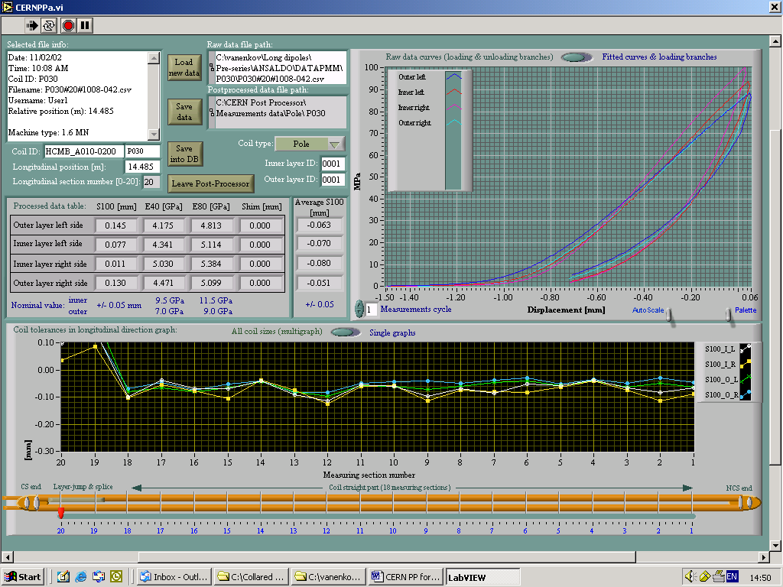

The LabVIEW Run-Time Engine includes the libraries and other files necessary to execute LabVIEW-built applications and shared libraries.
In fact, when PP loads a row data file and reads in its header the longitudinal position in [m], it calculates the corresponding section number, while some time, the result of this calculations could not be correct due to irregular step in longitudinal positions distances, that is why a manual option is kept as well.

