Collared Coil Database
Software package

(JEUMONT-ALSTOM Contractor’s version)

USERS MANUAL

I.Vanenkov AT/MAS 22.05.03
Introduction.

During each mechanical test on the layers and poles the measured values are recorded using Pole measuring machines, which produce sets of files containing the detailed measurement raw data. For monitoring the layers and the pole azimuthal length, the raw data need to be treated and normalized in standard format. CERN supplied the Contractor with Collared Coil Database software package, which includes the Collared Coil Database (Database), PPJEUMONTv4.vi application (Post-Processor) and the View&Analyse JEUMONT data.vi application (Data Viewer).
The Database is a core of this package and it used to store the treated data and exchange the data between JEUMONT, ALSTOM and CERN. It was designed using MS Access (MS Office 2000). The database includes also the retrieve forms with the possibilities to export stored data into the Excel format files and the main parameters summary reports, which can be used as traveller pages.
The Post-Processor application is written in LabView and it is used to treat the raw data files on coil size measurements (.ref type format) and do an automatic upload of treated data into the Database.
The Data Viewer application is written in LabView and it is used to view the stored in the database data in graphical presentation, do some pre-analysis on coil size trends, coils statistical profiles and perform the poles set pairings, targeting minimum a2 multipole field component and with on-line collaring shims computations.

Coil size measurements data treatment at JEUMONT.

1. Post-processing of raw data.

The PPJEUMONTv4.vi is used to treat the raw data file with the coil size measurements data and to store treated data into the database. When operator starts the program by pressing an arrow button in the upper left corner of the screen (see fig. 1). A file browser window is open and operator is requested to select a raw data file (xxx .ref) file, which he wants to treat. Depending from the position of the processing mode switch (by default it stays in Auto mode and operator, if he wants to do data treatment for particular coil sections only, have to toggle it into Manual mode before executing the program), the raw data can be processed for all longitudinal sections of coil at ones or one by one. The raw data strain-displacement curves are plotted in the upper graph. At the same time, when the data is viewed, it is also post-processed. For each measuring cycle strain-displacement data set PP creates a fitting model (polynomial of the second order) and runs regression analysis for this data. For this analysis, only data from the loading branches of strain-displacement curves, as a more precise, is used. User of PP is free to view the original entire curves (loading and unloading branches) or fitted once together with the loading branches of original curves. The processed data is printed into the table at the bottom of the screen an also shown on the longitudinal graph. With longitudinal graph selector above this graph, operator can select to see different processed coil parameters on this graph. The post-processor calculates the average coil sizes and also the shims thickness, required to reach the target pre-stress value (70 MPa). These shims are calculated following the standard ALSTOM procedure. These values are shown in the middle of the screen. The shims indicators starts to blink when their value are out of the allowed range (on inner layer 0.1-0.3 and on the outer layer 0.7-0.9). As a reference, the shims thickness, that were used during the coil size measurements are also shown on the left side of the screen. The dimensions of these shims are taken into account for the coil size and collaring shims thickness computations done by Post-processor. Once the data is processed, it can be saved by pressing the button “Save Data”. This invokes two steps saving procedure of processed data:
First step: the treated data is saved into an Excel format file, which is named as the raw data .ref file adding a t (treated). The Post-processor writes this file into the directory of the .ref file.
Second step: the operator is asked to save or not the data into the database and if he answers yes, the post-processor uploads the data into the Collared Coil Database. Notice: the data on particular coil, once been saved into the database, cannot be overwritten by the Post-processor. From two consecutive post-processing of data about the same coil, the treated data saved during the first run will be kept in the database, see chapter Database for instructions how to overwrite it).
The excel format output file contains two pages: first page is just a copy of the original raw data file (a back-up), and the second page contains the processed data. The processed data page has a header with coil IDs, dates of the test and 17 rows of processed data: one row per one longitudinal measuring coil section. The rows 16 and 17 are concerns the measurements done on the layer jump/splice area and they are ignored for straight part averages calculations.
At the bottom the values of the coil size averages, standard variation and computed shims thickness are written.

2. Viewing and analyzing of processed data.

The View&Analyse JEUMONT data.vi application is a viewer, which reads the data from the database and allows doing pre-analysis of data on coils. When operator starts the program by pressing an arrow button in the upper left corner of the screen (see fig. 2). Before starting the program (if the location of the database was changed), with the browser window in the upper left side of the screen, operator has to point the viewer to the new location of the database (by default, the path is C:\Collared Coil Database\Contractor\Collared coil database at Contractor (JEUMONT).mdb). In case of JEUMONT, were the measurements on coil sizes are taken only for coils in pole configuration, the Coil type control in the left upper corner of the screen should stay always as Pole.
The upper part of the screen has graphs, which can be switched to plot the trends on any of coil parameters for whole population of measured coils stored in the database or to plot the statistical longitudinal coil profile. The statistical coil profile plot is a variation of a coil parameter (for example coil size) along the coil length. In this plot each point is an average of data for a number of coils (batch of coils). The batch of coils is selected by mouse in the table on the left side of the screen (the selected rows of data are changing the color). Up to 4 trend graphs on different coil parameters can be selected with the P1-P4 controls at the left side of the graph. The zoom view can be made by un-checking the auto-scale option on the X-axes with the mouse right button first and then selecting with the cursor the wonted number of coils. The coils ID number is associated with the progressive number and can be found in the table window.
The graph at the lower part of the screen also can be used for two purposes: first to see the longitudinal coil profile for up to 4 coils selected with Plot 1- Plot 4 controls (the graph switch is in position “individual coils”); or to see the combined coil size for a chosen magnet’s set of coils (the graph switch is in position “paired poles”). Notice: only the data on new coils (not signed and send yet to CERN and ALSTOM) can be seen on this graph. When the switch is turned to the position “paired poles”, the table on the left side of the screen is replaced by the magnet cross-section picture were 4 poles are marked with different colors, associated with the colors of Plot 1- Plot 4 controls (see figure 3). Above theis picture there are the indicators of shims thickness, required to reach the target coil pre-stress value (70 MPa on both layers). The shims are calculated as the average of shims values stored in the database for each pole, which were computed during the post-processing stage. If the thickness of shims is out of the allowed range (nominal shims +/- 0.1 mm) then the shim indicators start to blink. At the same time with shims computations, the viewer checks the up/down coil size asymmetry in each magnet aperture and calculate from this asymmetry the expected skew quadrupole field components (a2). The 4 poles, if it is possible (there are constrains coming from different cable mix) can be re-arranged to have the minimum a2 field component in the magnet assembly. When the pairing is done, the data on shims can be saved by pressing the “Save” button. In the pop-up window, operator will be asked to give a magnet number, and press OK button. Then the viewer will create an Excel format file about the poles pairing, including the shims thickness for each pole and average shims. This output file can be saved in the directory specified by operator and it is a subject to be send to ALSTOM and CERN.

3. Data approval and transfer to ALSTOM and CERN.

Once the data on poles set is treated and analyzed, it has to be formally approved and send to ALSTOM and CERN for their databases update. This step is done via the “Check new data on poles” form of the Collared Coil Database. The procedure is following:
- Open the Collared Coil database, the start-up window will appears (fig. 4).
- Press the button “New data check and approval”, the “Check new data on poles” form will appears (fig. 5).
- Operator has to sign, put the date and press “Validate” button. This action will run the MS Access macro, which will move the data on this pole from the “Pole_assembly_table” into the “Approved_poles_t”within the same database first. Then it will send the data on this pole to the pre-defined e-mail addresses (the addresses cab be changed by editing the “Check the pole“ macro), as an attachment (see figure 6).
- Repeat the same procedure for the rest 3 poles.

When the approval is done for a poles set, the excel file with the data on coil poles pairings and shims (created by viewer), should be send as well to ALSTOM and CERN.
The approved data can be retrieved via the “Data on poles retrieve” form (fig. 7). In this form by pressing the button export data, the all data on poles will be saved into an Excel file in the same directory with the database, named as Data on poles. xls. This file can be used for deep analysis.

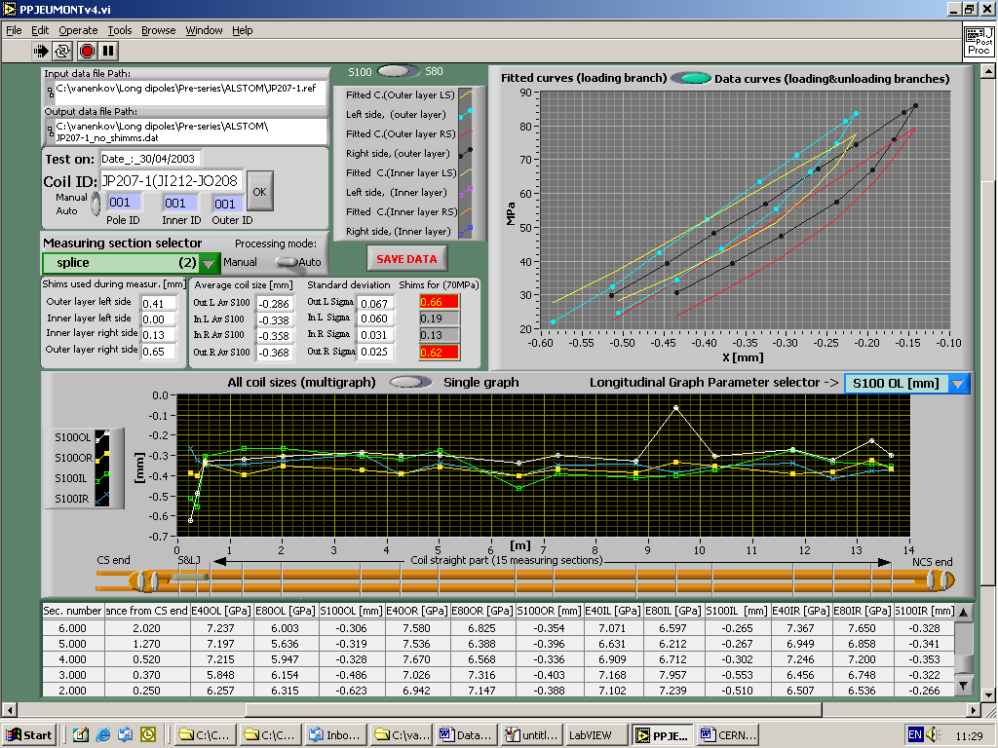

Figure 1 (Post-processor)
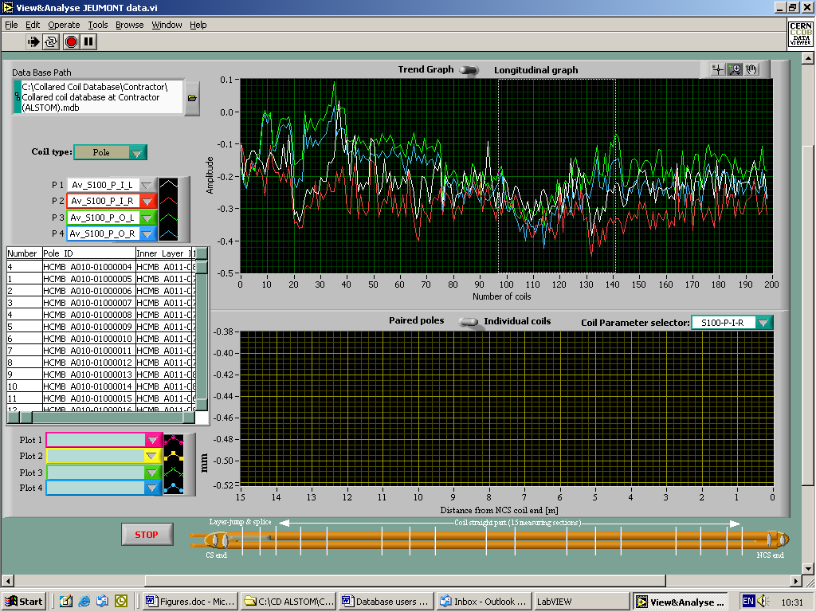
Figure 2 (Viewer, analyzing trends)
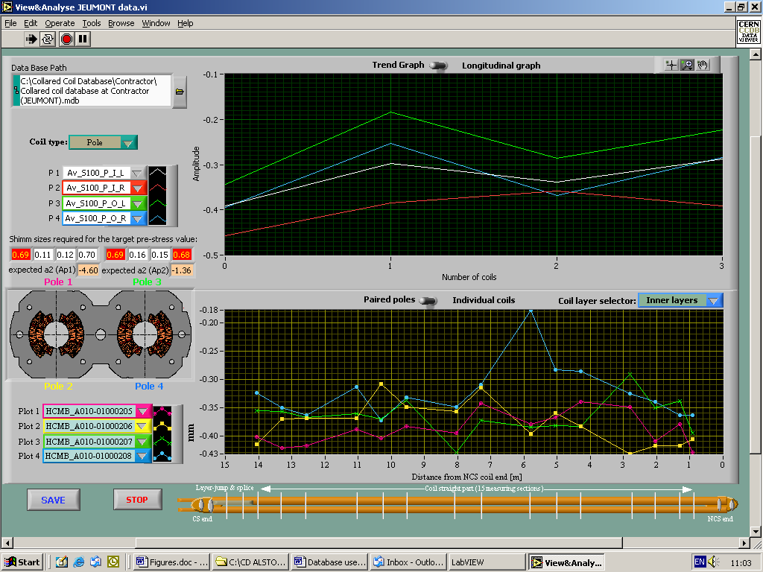

Figure 3 (Viewer, pairing the pols)
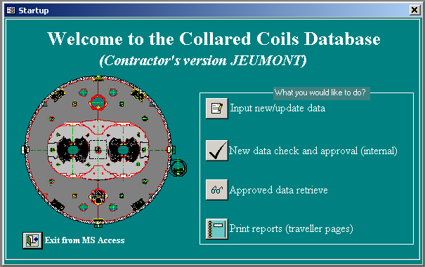

Figure 4 (Collared Coil Database start-up window)

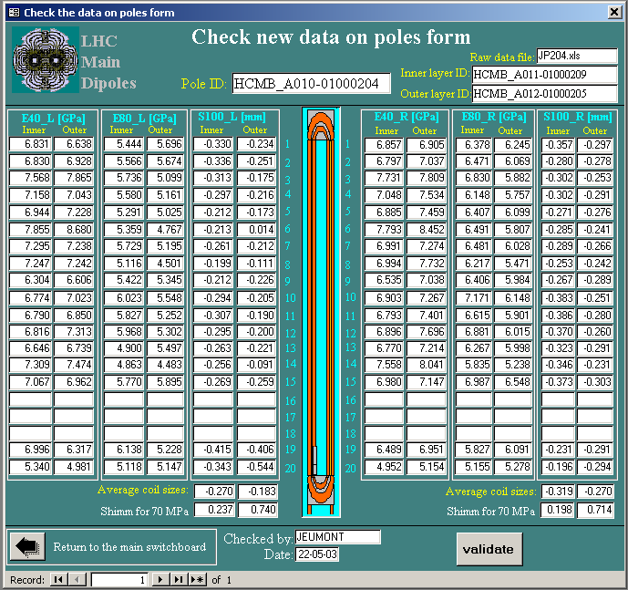

Figure 5 “Check new data on poles” form.

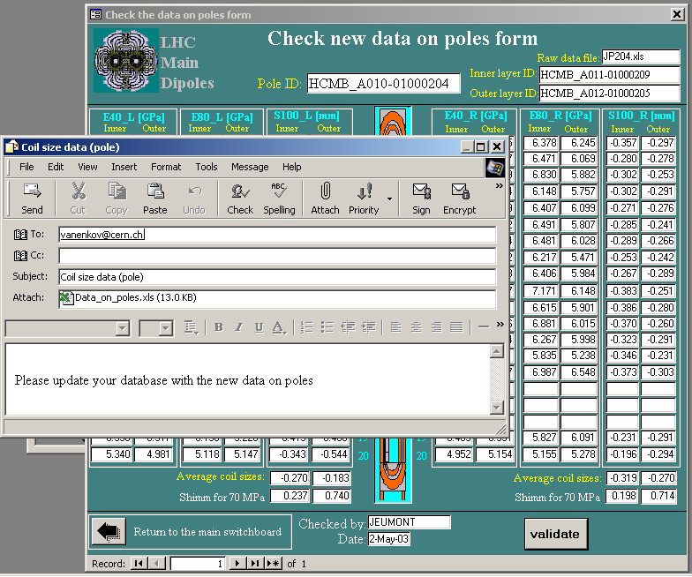

Figure 6. E-mail with data file attachment is send after pressing “Validate” button.

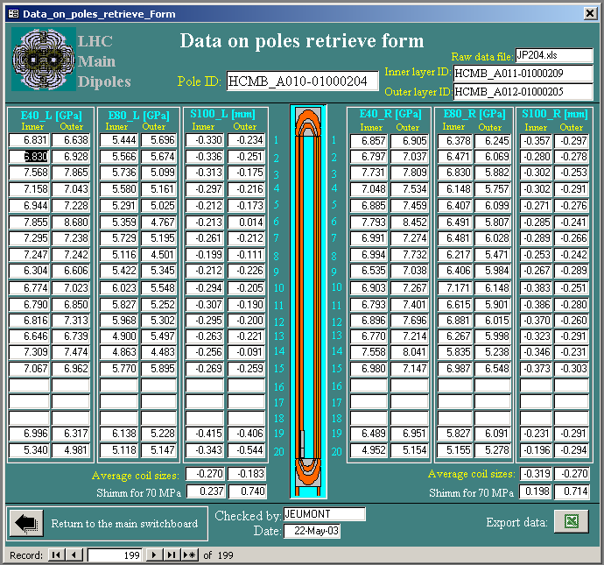

Figure 7 “Data on poles retrieve” form

