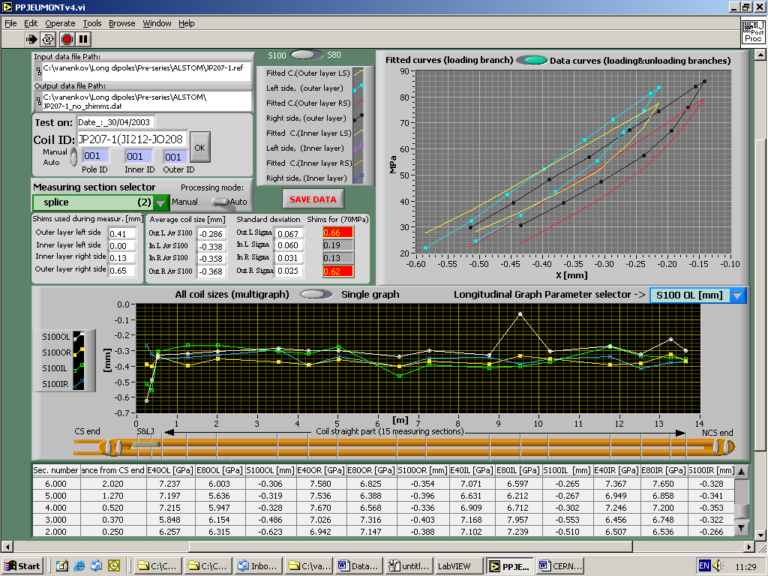

Figure 1 (Post-processor)
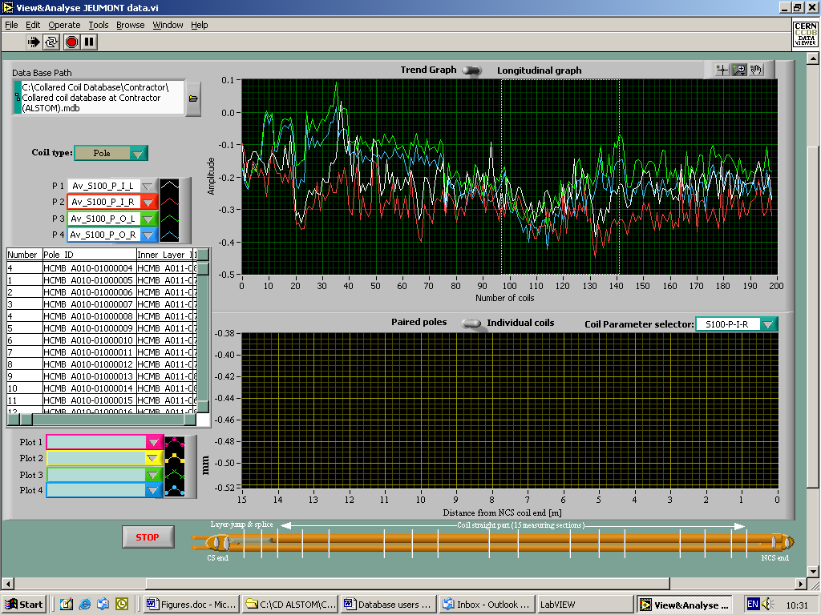
Figure 2 (Viewer, analyzing trends)
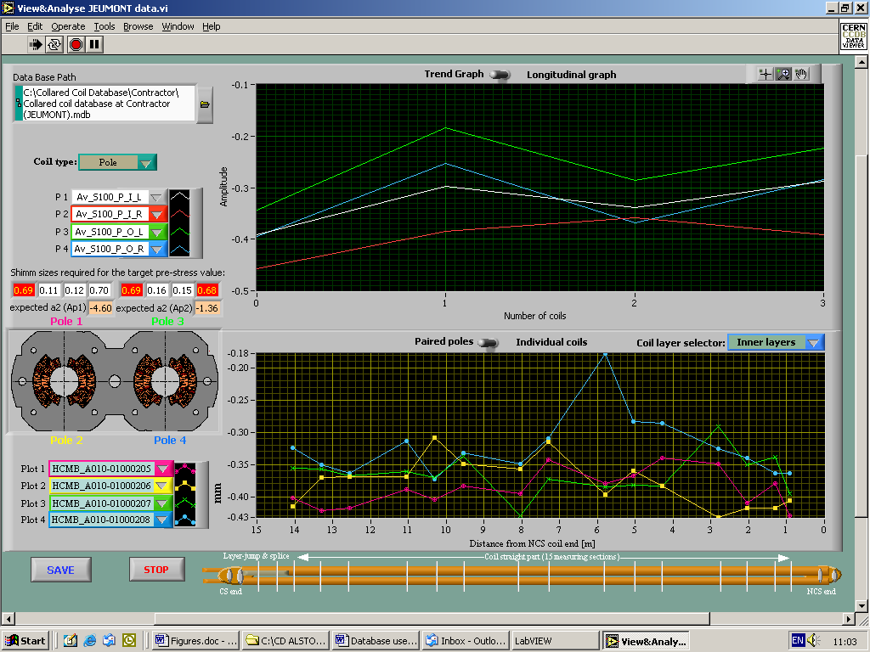

Figure 3 (Viewer, pairing the pols)
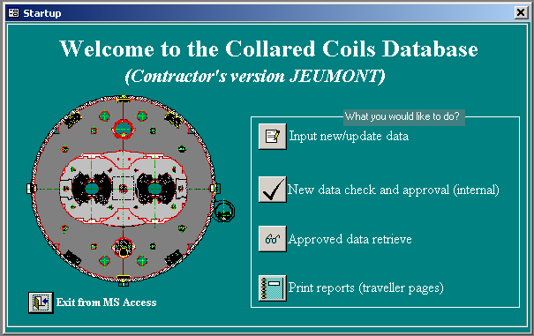

Figure 4 (Collared Coil Database start-up window)

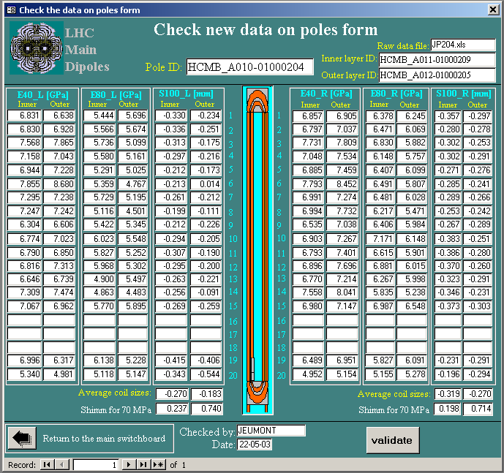

Figure 5 “Check new data on poles” form.

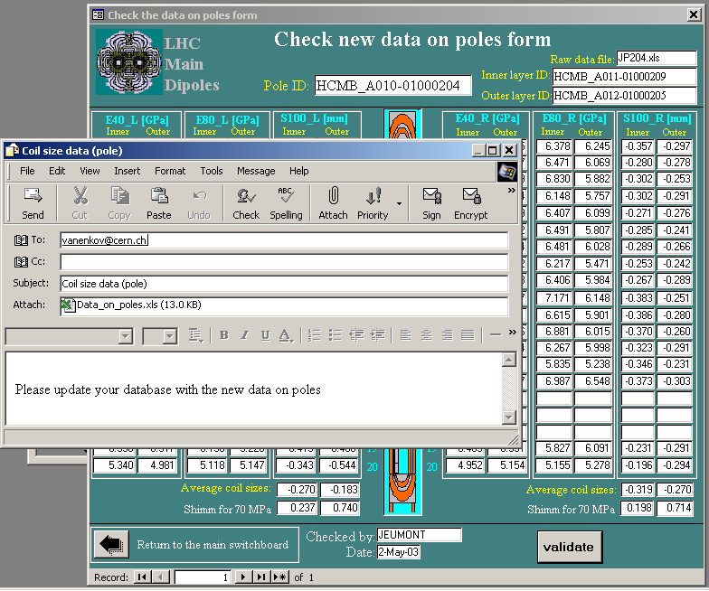

Figure 6. E-mail with data file attachment is send after pressing “Validate” button.

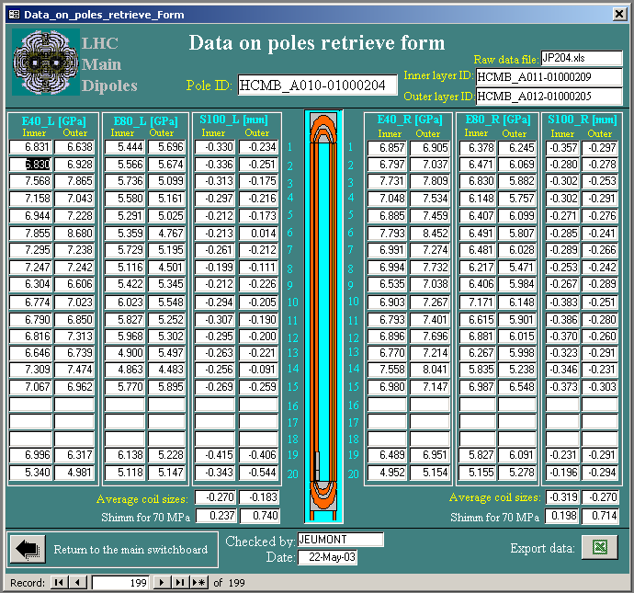

Figure 7 “Data on poles retrieve” form

