Step-by-step procedure for coil size measurements data upload into CERN database

(For the data of JEUMONT)

I.Vanenkov

Introduction.

During each mechanical test on the layers and poles the measured values are recorded using Pole measuring machines, which produce sets of files containing the detailed measurement raw data. For monitoring the layers and the pole azimuthal length, the raw data need to be treated and normalized in standard format. CERN supplied the Contractor with Collared Coil Database software package, which includes the Collared Coil Database (Database), PPJEUMONTv7.vi, application (Post-Processor) and the View&Analyse JEUMONT data.vi application (Data Viewer).
The Database is a core of this package and it used to store the treated data and exchange the data between JEUMONT, ALSTOM and CERN. It was designed using MS Access (MS Office 2000). The database includes also the retrieve forms with the possibilities to export stored data into the Excel format files and the main parameters summary reports, which can be used as traveller pages.
The Post-Processor (PP) application is written in LabView and it is used to treat the raw data files on coil size measurements and do an automatic upload of treated data into the Database. The PP also computes the poles shims for the coil straight part and layer jump area.
The Data Viewer application is written in LabView and it is used to view the stored in the database data in graphical presentation, do some pre-analysis on coil size trends and coils statistical profiles.
The post-processed data from JEUMONT is send to ALSTOM and to CERN via e-mail with attachment for analysis and final storage into CERN database (first into CERN copy of the Collared Coil Database and then into ORACLE database).
At the beginning of the magnet production the processed data from JEUMONT was send first to ALSTOM for pre-approval and after from ALSTOM to CERN for final check. Therefore there are two software packages were installed at each firm with some small difference in the structure of Database. Later, with the increase of production, the procedure was simplified and the raw and treated data from JEUMONT is send directly to CERN and ALSTOM. This has broken the standard procedure for easy data upload into CERN database. That’s why actually, at CERN the raw data has to be post-processed again and the pre-approval procedure of ALSTOM is replaced by CERN, which creates some complicity for the data upload.

Step by step procedure for data post-processing, pre-approval, approval and upload into DB.

A set of new data on coil size measurements is delivered to CERN via e-mail:

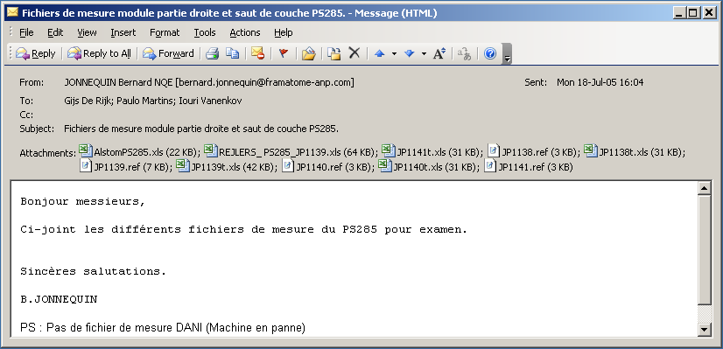

It contains the raw data file (with extension .ref) and treated data (in excel file format).

As explained in introduction, the raw data needs to be post-processed again using the PPJEUMONTv7bcern.exe program. Notice that the raw data files might be of 3 and 7 kb size. The once of 3kb includes only measurements on the coil ends and layer-jump area, the files of 7kb or bigger size includes also the data on 5 (or more) measuring positions in coil straight part.

POST-PROCESSING PROCEDURE

Step 1. Save all attached files under C:/MD/ 1 (Alstom)/XXXX folder, where XXXX is the magnet name.

Step 2. Run the PPJEUMONTv7bcern.exe program and treat the raw data files one by one which include the measurements data on coil straight part as shown below:

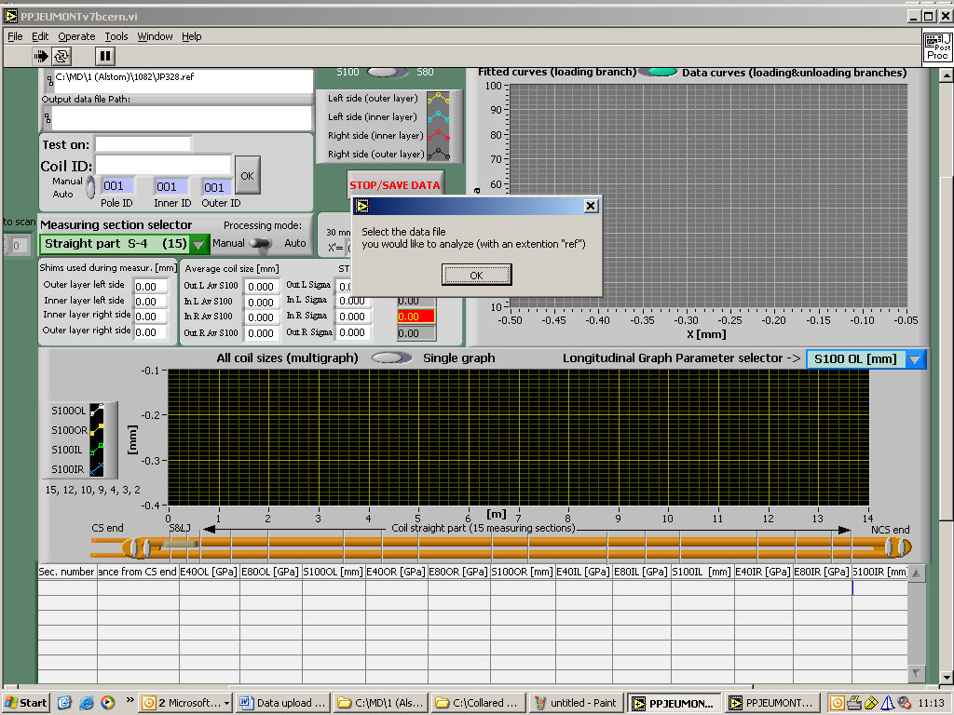

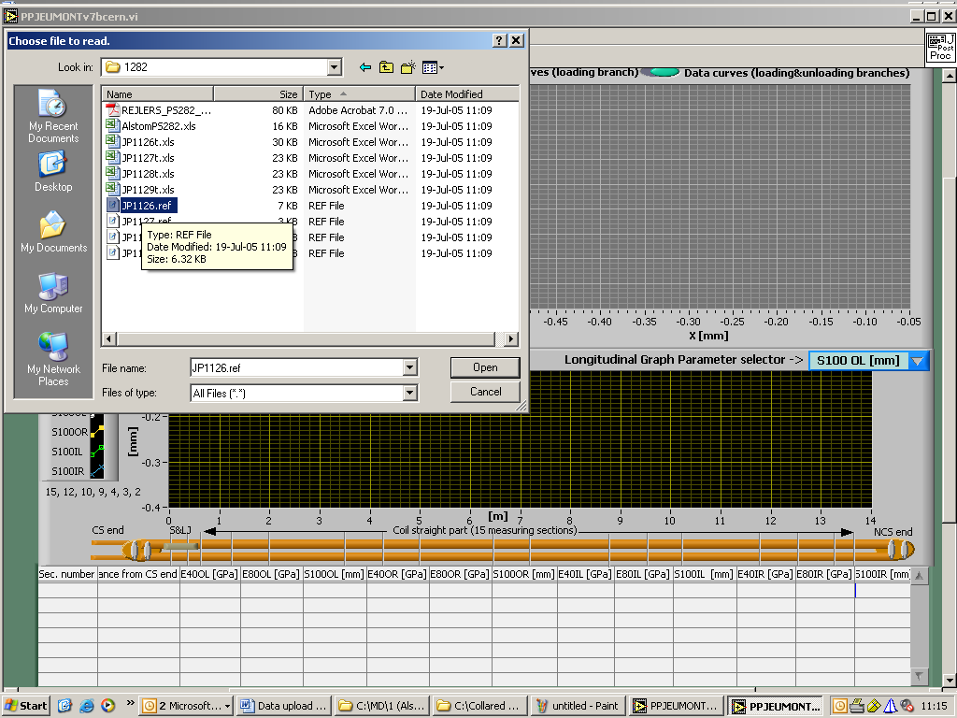

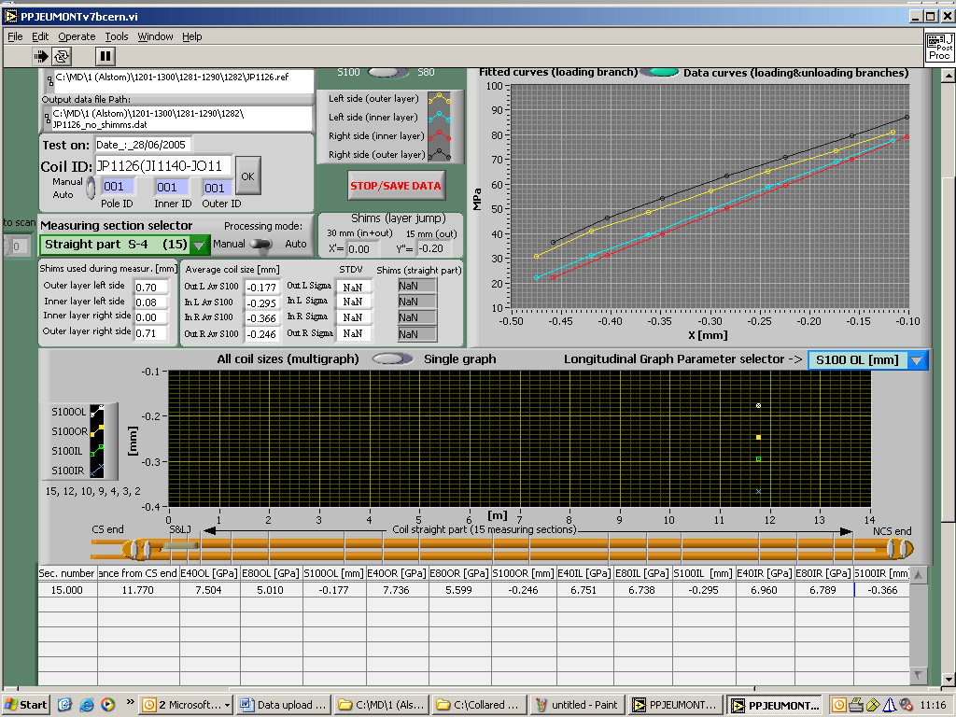

The PP will treat the first measuring section (№15). The post-processed data will be written into excel file which carries the name of the raw data file with an extension “t”, which means that it is treated data. The extension is also changed to .xls.

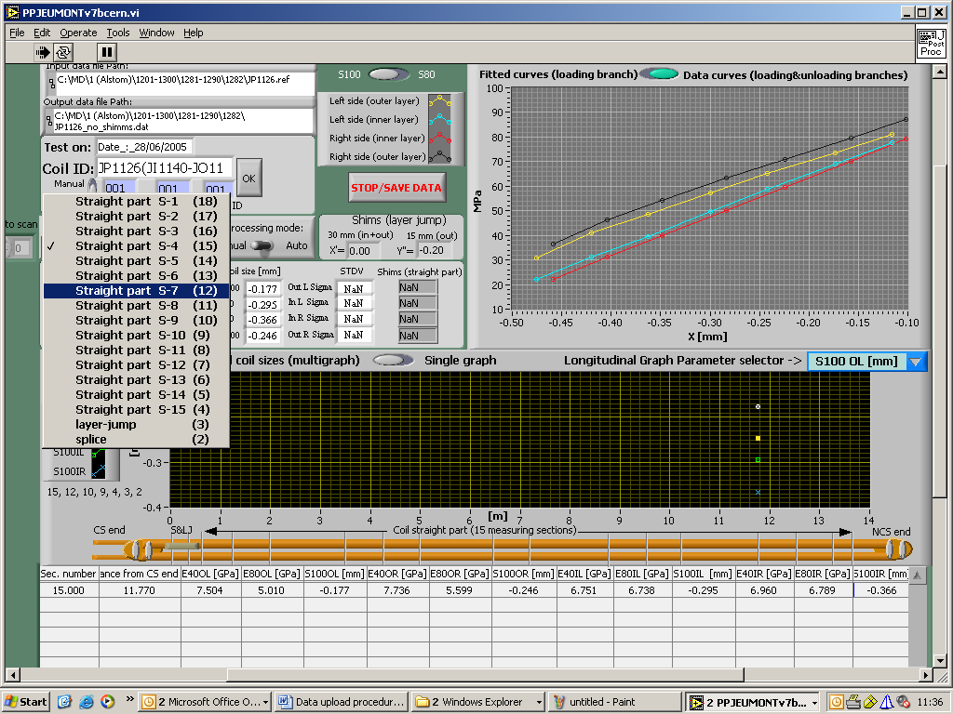

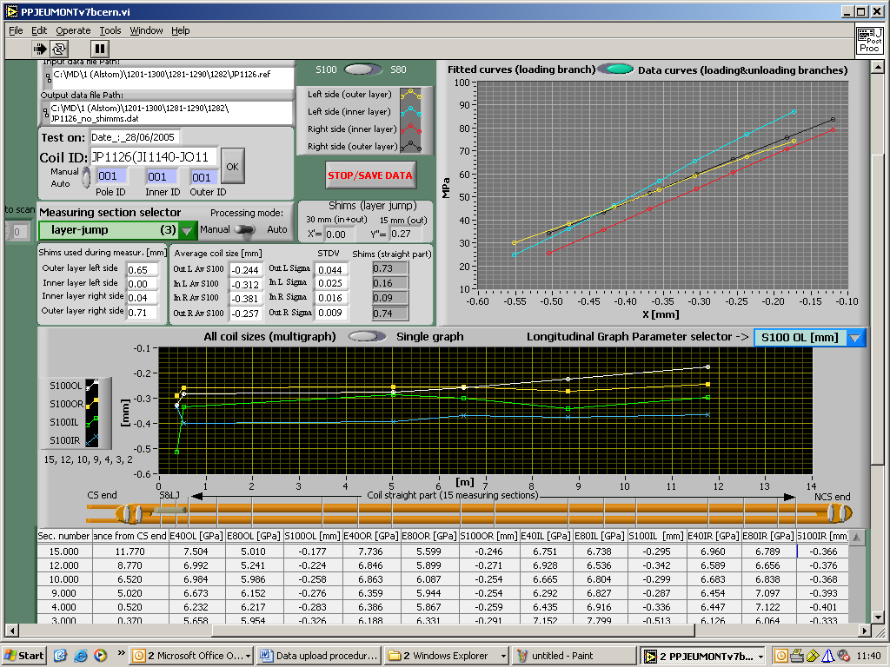

At the end of the treatment press the “Stop/Save data” button. This will result in creating of output data file in MS excel format in the same directory where the raw data file was stored. If there are already similar file exists due to similar treatment done at JEUMONT, a following message will appear:

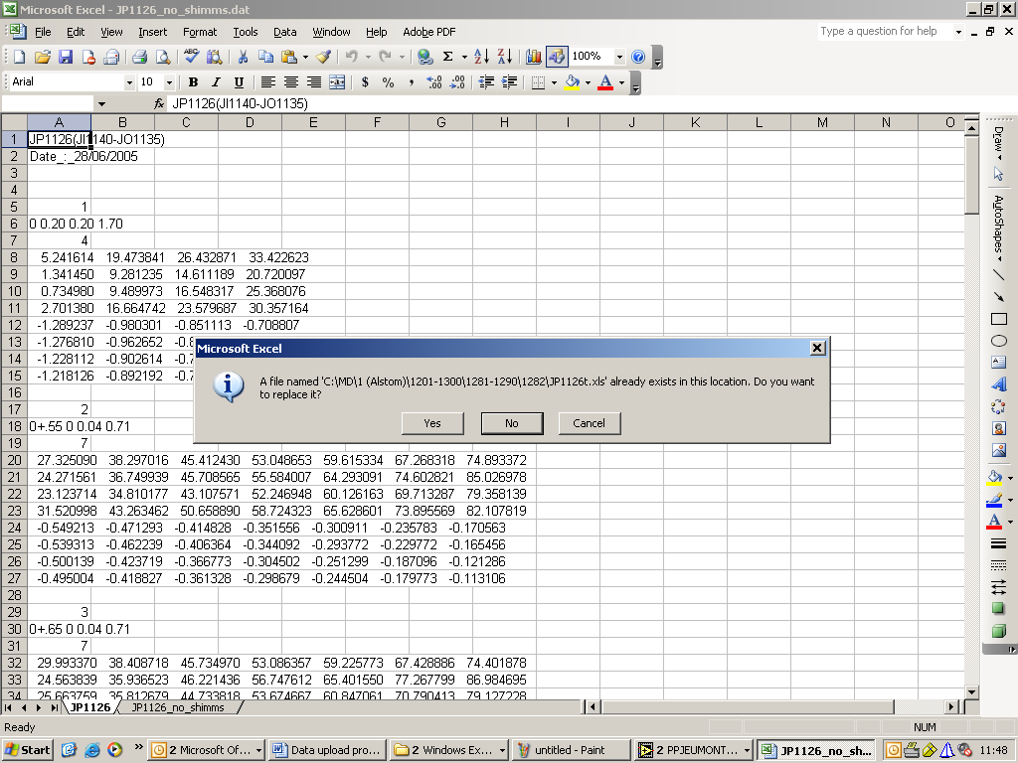

By pressing “Yes” button, the old file will be overwritten. If one has to verify the treatment done by JEUMONT, before running the PP the file name has to be modified, for example, by adding –or (original).
A following message will appear:

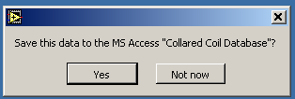

Press the “Yes” button.

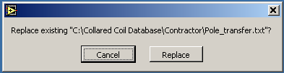

Press “Replace”.
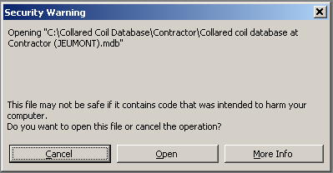
Press “Open”.
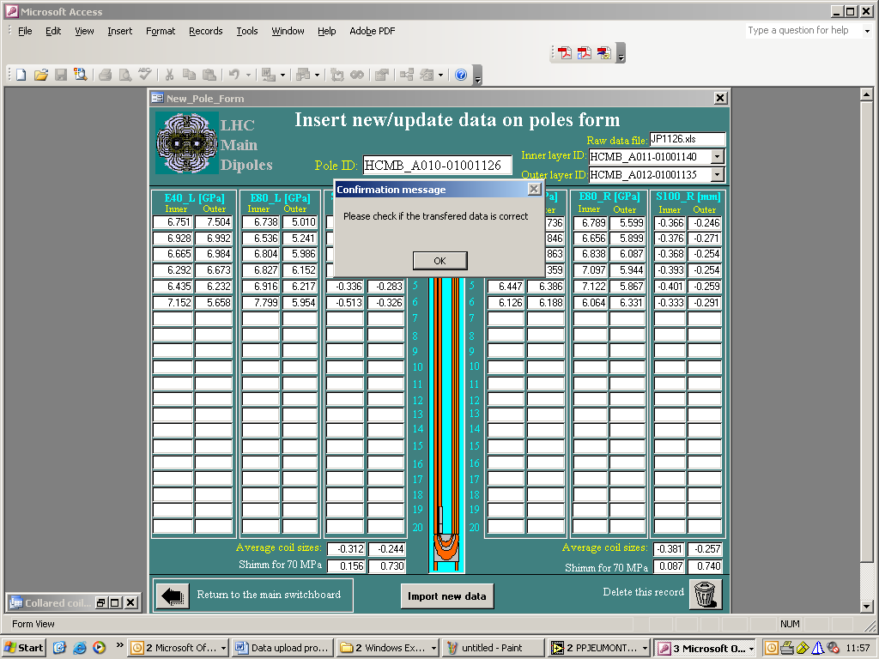
Press “OK”.
End of post-processing procedure.
PRE-APPROVAL PROCEDURE
(Intermediate step simulating JEUMONT approval and transfer to ALSTOM DB)

Open the “Collared coil database at Contractor (JEUMONT).mdb” database.

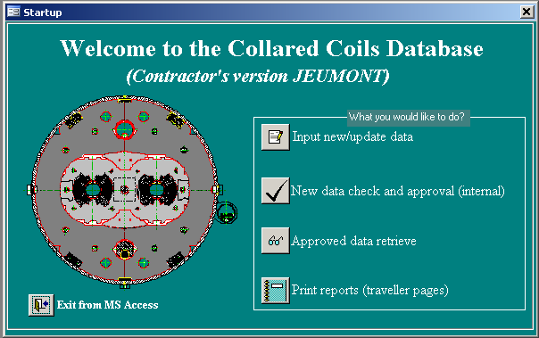

Press “New data check and approval (internal)” button:

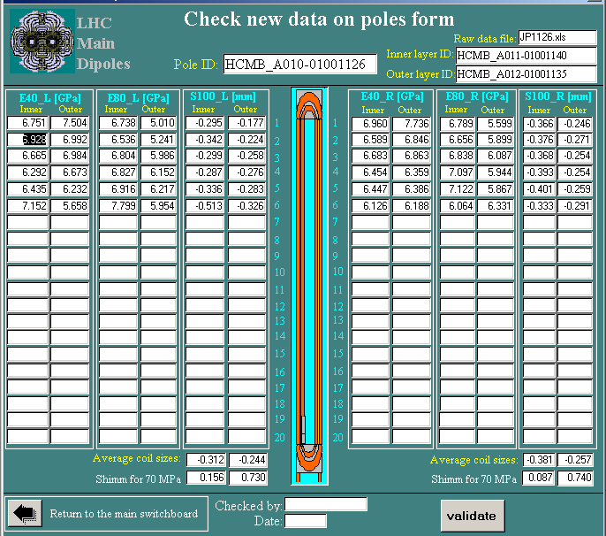

Put your signature, date and press the button “Validate”, an e-mail with attachment, containing the data in database file format will be generated:

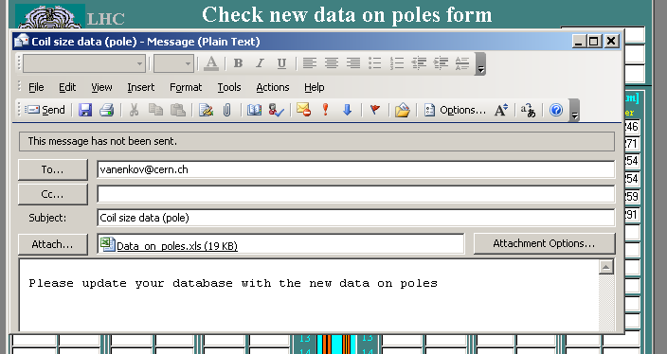

Press send button. The DB form “Check new data on poles” will be cleaned from this record and an e-mail will be send to the address pre-defined in the database macro:

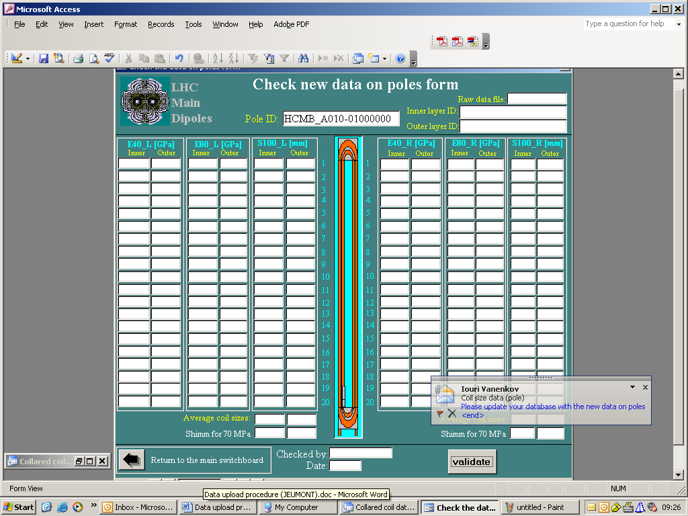

If there are more then one record (one record corresponds to the data on one coil) were treated before with the post-processor, this procedure must be repeated for each coil data.

APPROVAL PROCEDURE
(Intermediate step simulating ALSTOM approval and transfer to CERN DB)

Step 1. Open one of the e-mails with the pre-approved data and save the attached file into C:/Collared coil database/Contractor folder:

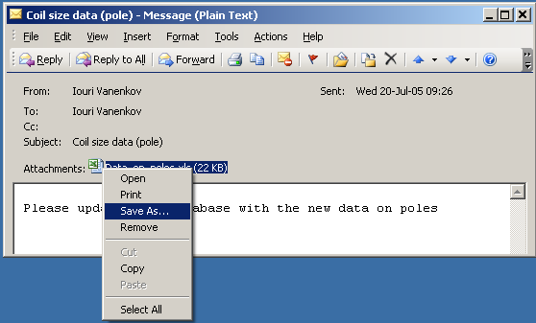

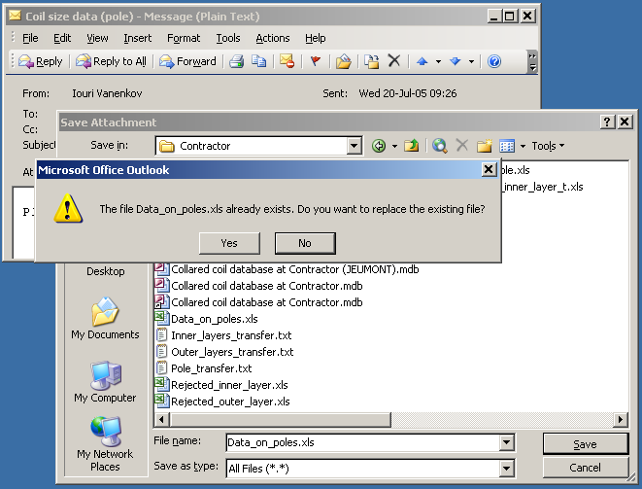
Ignore the message “the file Data_on_poles….” and press “yes” button.

Step 2. Open the “Collared coil database at Contractor (ALSTOM).mdb” database.

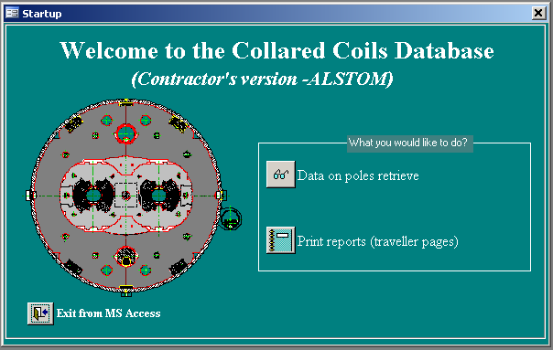

Press the “Data on poles retrieve” button:
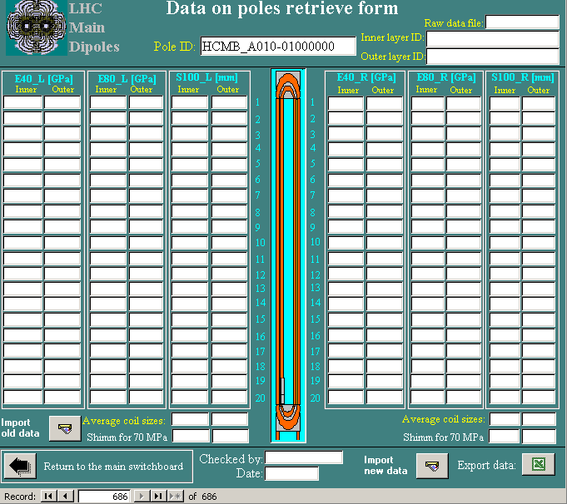

Press the “Import new data” and the pre-approved data will be imported into DB; press OK button.

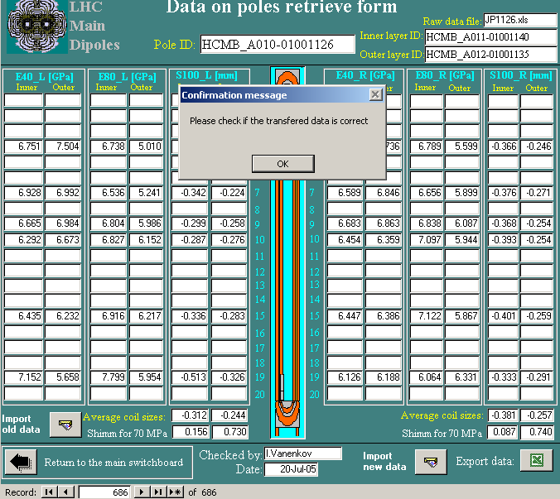

Repeat the steps 1 and 2 for other –emails.
Transfer to the ORACLE database procedure.

Open the CERN MS access database main window.

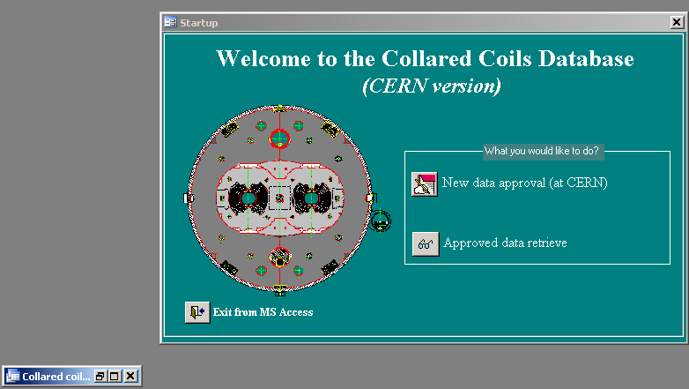

Go to Macros folder and double click on the “Update Oracle macro”:

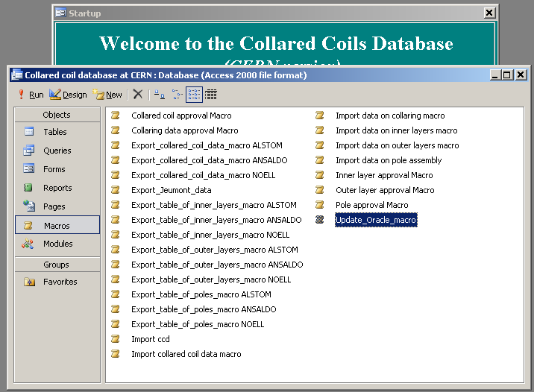

Type user name (mas_d_cs) and password (tach9v3ye2) to login into ORACLE DB. The macro will transfer data from Access into Oracle DB.

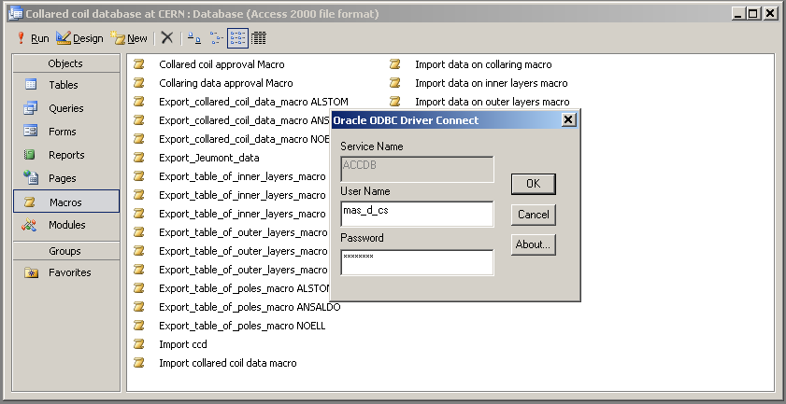

End of procedure.

