|  |  |
| --- | --- |
|  | Beta beam main dipole magnet design Report  2008-12-03  [Jens.Erik.Bruer@cern.ch](mailto:Jens.Erik.Bruer@cern.ch) |

The Beta Beam Decay Ring Main magnets: open mid-plane design

J. E. Bruer, E. Wildner

CERN, Accelerator Technology Department

Keywords: Superconducting magnets.

Abstract: Energy deposition calculations on the superconducting magnets in the Beta Beam Decay Ring have shown that the power deposited on the magnet mid-plane is too important and that the magnet would quench at normal operation. To remedy this, an open mid-plane magnet has been proposed as a possible solution. The idea is to replace the superconducting coil in the mid-plane and replace the material by aluminium or stainless steel. In this report we show the design of an open mid-plane magnet that satisfies the requirements regarding the magnetic field quality and mechanical requirements of the magnet.

# introduction

# Power deposition in the dipole

# In the lattice, there are absorbers between the dipoles, which absorb most of the high energy decay. There is however an increase in the power deposition towards the end of each magnet, see figure 1. The power deposition can reach up to 10 W/m in the magnets. If the energy causes the superconductors in the magnet to heat up above a critical limit, the magnet will quench, that is, loosing its supercondcting property. Locally, the power deposition should not exceed 4 mW/cm3. According to the similation shown in figure 2, the local power deposition can reach 20 mW/cm3. The aim is to reduce this number by a factor 10 in the magnet, to have a safe marginal for quenching.

# 

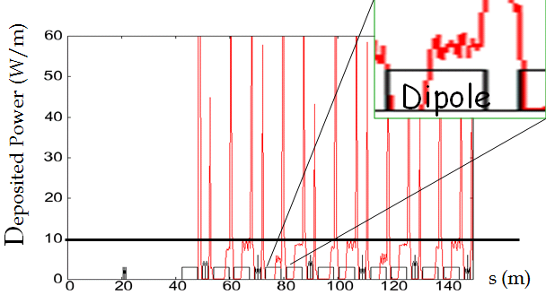

Figure . Power deposition over the lattice in the storage ring.



Figure . Power deposition locally.

* 1. Open midplane design

The power deposition is mainly concentrated in the midplane of the dipole, see figure 3. To reduce the peak power with a factor 10, the pink and the red areas should be avoided. One way to do this is to open up the midplane of the dipole, in a so called open midplane design. In an open midplane design, there are no superconductors in the midplane, but some light material, allowing the high energy particles to pass through the gap into absorbers, aided by a heat transfer system. See figure 4. More information about open midplane designs can be found in [1, 2].

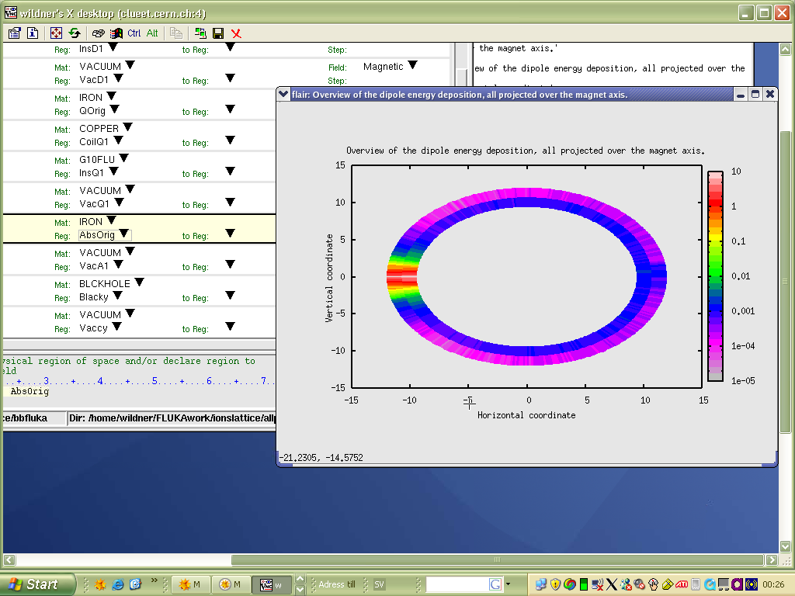

Figure . Cross section of the energy deposition in a dipole. The intensity is considerably increased near the midplane.

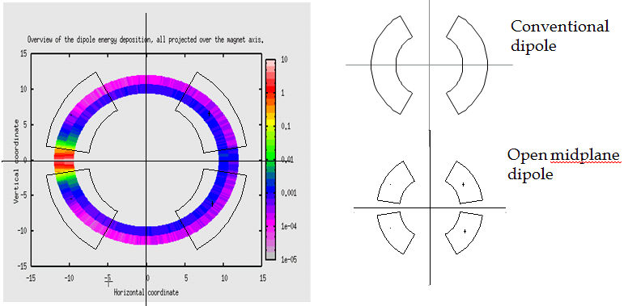

Figure . Left: Schematic sketch of an open midplane design superposed over the energy deposition. Right: The difference between a conventional and an open midplane design.

# Design of the dipole

Design requirements for the dipole were a 6 T operational central field and at least 60 mm aperture radius. A gap of 10 degrees (from the midplane to the coil) in the midplane was preferred, in order to avoid the peak of the energy deposition with some marginal. Before presenting the designs, which are classical cos*θ*-designs but with an open midplane, some background of the composition of a dipole is given, as well of the magnetic field quality and strength.

# Principal composition of an superconducting dipole

# The magnetic field in the dipole is generated by the currents in the superconducting cable. The cables are clustered together; forming superconducting sectors. The positioning of the conductors determines the field quality. Between the superconducting blocks are copper wedges, separating the conductors in a very precise way to achieve a high field quality.

# Around the coil, consisting of the superconducting sectors and the copper wedges, there are collars made of stainless steel. The main purpose of the collars is to keep the superconducting sectors fixed, despite the strong electromagnetic forces acting on them. Around the collars is the iron yoke, which purpose is to enclose the field lines as well as to enhance the magnetic field strength.

# In the specific design of an open midplane magnet, you also have a support structure in the gap of the midplane; using some light but strong material like aluminium.

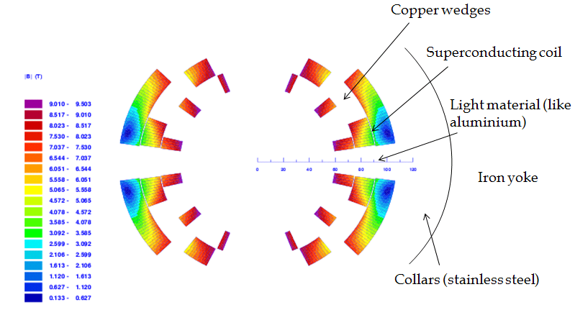

**Figure 5. Composition of a superconducting dipole, with an open midplane.**

# Main parameters of the dipole

# The two most important parameters of the dipole are the field quality and the field strength. The field quality is measured in the pureness of the magnetic field; for a dipole a pure homogenous field is desired. The magnetic field can be series expanded:

. (1)

Due to symmetry in the coil, the skew multipoles *An* and the even number normal multipoles *Bn* disappear. What remains is then:

. (2)

# The level of field quality is determined by measure the multipole coefficients in the multipolar expansion, normalized as

. (3)

# Good field quality means that the normalized coefficients should stay around a few units, preferably below one unit. The designs presented in this rapport all have the first five multipoles, *b3* to *b11*, below one unit.

# The strength of the field is in relation with the amount of superconductors in the coil; to get a higher field, more conductors have to be added. Of particular interest is the central field, where the beam is located. The theoretical limit of this field is called the *short sample* limit, denoted *Bss*, see [3] for more information. This limit is reached when the current in the conductors is equal to the critical current, hence just at the limit of quenching.

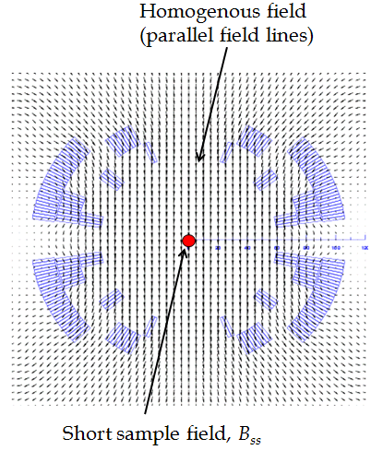

**Figure 6. The parallel field lines produced by the coil and the location of the short sample field.**

# The designs

# Three different designs are presented, with different aperture radiuses, sizes of the gap in the midplane and field strengths. All are based on the LHC MB cable; a Nb-Ti Rutherford cable with 28 strands [4]. Cross sections of the three designs are shown in figure 7. The two first are two layers designs, while the 3rd design has three layers, meaning more superconductors in the coil and hence giving a stronger magnetic field. Parameters of the three designs are given in table 1.

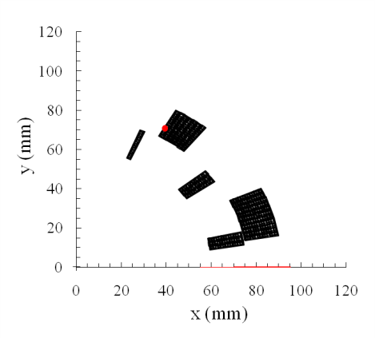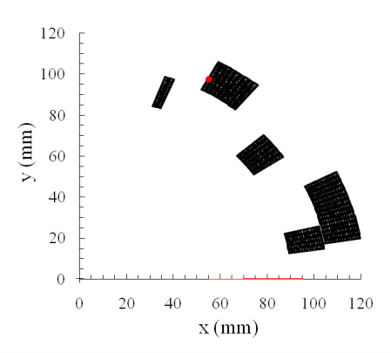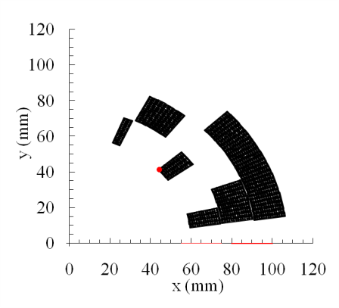

**Figure 7. Cross sections of the upper right quadrant of each design. Left: Design 1 with 60 mm aperture radius. Middle: Design 2 with 90 mm aperture radius. Right: Design 3 with 60 mm aperture radius.**



**Table 1. Parameters for the three designs.**

# In table 1, *r* is the aperture radius, *Ncon* is number of conductors, or turns of cable in each sector, Total *Ncon* is the total number of cable in each quadrant. Operational field means 80% of the critical current; it is set at 80% to have a safe marginal to quenching.

# The first two designs are similar in field; both have a short sample field above 6 T, at 1.9 K. The larger aperture radius of design 2 is helpful because it set the conductors further away from the decaying beam, plus it produce a bigger gap in the midplane, since it is a scaled up version of design 1. The drawback is that you need more conductors for about the same field; design 2 is scaled up by about 50% with respect to design 1 and hence has about 50% more conductors than design 1.

# However, the design requirement was to have an operational field of 6 T. To raise the field, we have to add more conductors. The solution for good field quality is not so flexible for a five sector coil; the solution should be very close to the layout in design 1 and 2. It is therefore not possible to add more conductors in the two layers and still achieve good field quality. To get around this problem, a third layer was added to design 3. This action allows the sector configuration in the two first layers to be the same, but still adding more conductors to the coil; design 3 has more than twice as much cable as design 1, while having the same aperture radius. This results in a considerable higher field; a short sample field of 8.7 T and an operational field at 7 T. Note that none of the designs manage to get beyond a 6 T operational field at 4.2 K.

# The multipoles and the angles for each design are displayed in table 2. The angles *γ*i mark the position of each sector according to figure 4. The inclination angle *α* is equal to the positioning angle *γ* for every sector and design here. The *r*i are the inner radiuses for each layer.



**Table 2. Multipoles and positioning angles for the sectors for each design.**



**Figure 8. Positioning *γ* and inclination angle *α*, describing the position for each sector.**

Lorentz forces and magnetic field maps

The force distribution can be found in figure 5 for each design. The pattern is similar; mostly radial forces in the inner layer, while we also have azimuthal forces in the outer. The magnitude of the force components can be found in table 3.



**Table 3. Force components for the sectors in each design.**

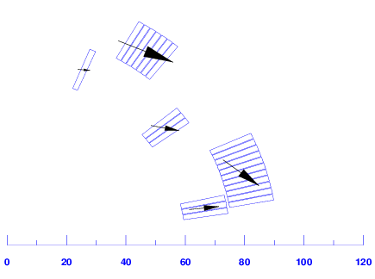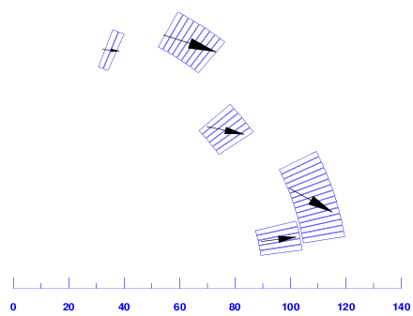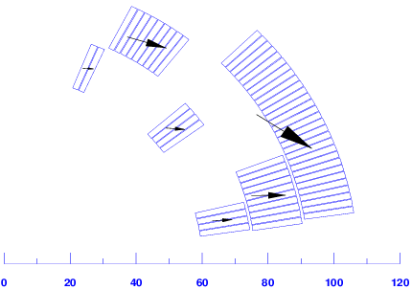

**Figure 9. Lorentz forces acting on the sectors for each design. Upper left: Design 1. Upper right: Design 2. Bottom: Design 3.**

The magnetic field maps for the three designs can be found in figure 6-8. Also here the pattern is similar; we have the highest field on the inner border of the inner sectors, as well as on sector 5. The area where the peak field is located also has the smallest marginal to quenching. This should be considered, especially on sector 1 that is very close to the midplane where the concentration of the high energy decay is located.

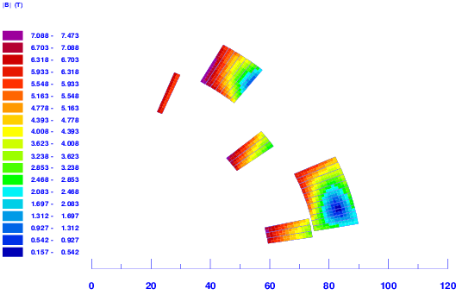

Figure . Magnetic field map of design 1.

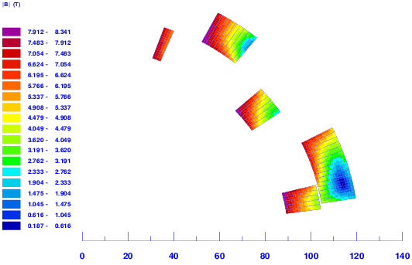

Figure . Magnetic field map of design 2.

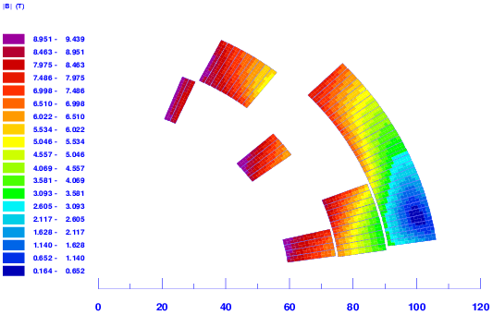

Figure . Magnetic field map of design 3.

# Cost estimation and infrastructure requirements

The cost estimation took the material cost, production cost, and cost for the cryoplants into consideration. The material cost was based on the cost of the material for the quadrupoles for the inner triplet of the LHC [5]. The cryostat and cryoplants cost was based on the ones used for LHC as well [6]. The estimation is fairly rough, but should give a hint of the magnitude of the cost, and also the difference between the designs. The cost estimation per unit of dipole is displayed in table 3. We can note that the total cost does not differ considerably, both regarding different designs and different operating temperatures; about 10% between design 1 and 3, and also 10% between the operating temperatures.



**Table 4. Cost estimation for each design at the two operating temperatures.**

1. Conclusion

By opening up the midplane, the power deposition can be decreased by a factor 10 or more. The open midplane design is feasible when it comes to field quality, but has some limitations on the field strength since you lose area where you normally have conductors, namely the gap in the midplane. In table 1 we saw that none of the design managed to achieve an operational field of 6 T at 4.2 K. To get up to 6 T at this temperature, another layer has to be added to design 3, adding up to 4 layers in total. However, the gain in field is not linear dependent to the amount of superconductors in the coil, but approaching a limit asymptotically. Design 3 might already be close to the limit of what field is possible to achieve at 4.2 K, given the open gap in the midplane of 10 degrees.

At 1.9 K, the 6 T requirement is not a problem even with an open midplane design, design 3 passed that limit with some marginal. According to the cost estimation in table 5, the total cost per dipole would roughly increase by 10% by going from a 4.2 K system to a 1.9 K. Furter research and analysis has to be done to find out the most cost efficient solution.

References

1. J. Bruér, Open midplane designs based on sector coils, thesis
2. R. Gupta, “Optimization of open midplane dipole design for LHC IR upgrade”, *Particle Accelerator Conference* (2003) 3055.
3. L.Rossi, E. Todesco, “Electromagnetic design of superconducting dipoles based on sector coils”, *Physical Review Special Topics - Accelerators and beams* **10**, 112401 (2007).
4. The LHC design report, vol. 1, page 161, ISBN 92-9083-224-0
5. P. Fessia, CERN, private communications
6. R. van Weelderen, CERN, private communications