Dipoles for Beta beams

|  |  |  |  |
| --- | --- | --- | --- |
| Design | 1 | 2 | 3 |
| *r* (aperture) | 60 | 90 | 60 |
| *b3* | -0.90 | -0.53 | -0.56 |
| *b5* | -0.73 | -0.85 | 0.29 |
| *b7* | 0.67 | -0.83 | 0.00 |
| *b9* | -0.25 | -0.51 | -0.34 |
| *b11* | 0.38 | -0.99 | -0.42 |
| *Bss* (T) at 1.9 | 6.54 | 6.86 | 8.76 |
| Nominal field at 1.9 | 5.2 | 5.5 | 7.0 |
| *Bss* (T) at 4.2 | 4.95 | 5.3 | 6.72 |
| Nominal field at 4.2 | 4.0 | 4.2 | 5.4 |
| Gap in midplane (mm) | 8.9 | 12.5 | 8.7 |
| ** | 8.500 | 8.000 | 8.300 |
| ** | 35.4 | 34.5 | 35.9 |
| ** | 66.3 | 67.4 | 65.6 |
| ** | 10.2 | 9.3 | 8.5 |
| ** | 51.00 | 51.20 | 51.40 |
| ** | - | - | 8.000 |
| *r1,r2,r3 (mm)* | 60,76,- | 90,106,- | 60,76,92 |
| *Ncon* | 3,3,1,11,7 | 5,6,2,15,9 | 4,4,2,10,9,29 |
| *Tot Ncon* | 25 | 37 | 58 |
| Collars (mm) | 30 | 30 | 30 |
| Copper wedge #1 (degrees) | 0-8.5 | 0-8 |  |
| Copper wedge #2 | 14.2-35.4 | 14.3-34.5 |  |
| Copper wedge #3 | 41.1-66.3 | 42.0-67.4 |  |
| Copper wedge #4 | 0-10.2 | 0-9.3 |  |
| Copper wedge #5 | 26.6-51.0 | 25.3-51.2 |  |
| Yoke (mm) | 180 | 270 | 240 |
| Sector 1 (degrees) | 8.5-14.2 | 8-14.3 |  |
| Sector 2 | 35.4-41.1 | 34.5-42.0 |  |
| Sector 3 | 66.3-68.2 | 67.4-69.9 |  |
| Sector 4 | 10.2-26.6 | 9.3-25.3 |  |
| Sector 5 | 51-61.4 | 51.2-60.8 |  |

r1,r2 are the radiuses for the inner and outer layer, respectively. *Ncon* is the number of conductors in each sector, starting with the inner layer. Tot Ncon is the total number of conductors. γ1 to γ5 are the angles of each sector, according to figure 7. (α = γ in these designs). The copper wedges are situated below its corresponding sector, with the same index system. Bss = central field at the critical current.

The cable used is LHC MB cable in both cases, with a width of 15.4 mm, making the whole coil about 31 mm thick.

Design 1

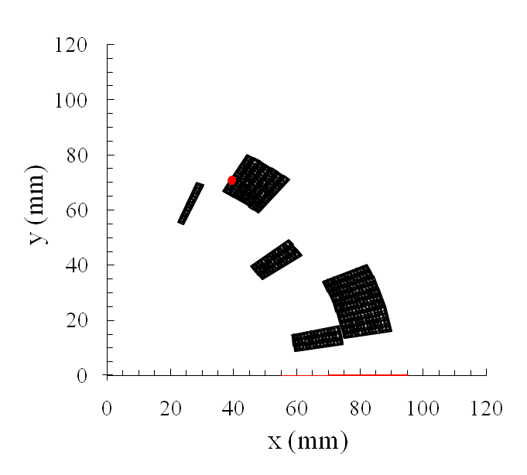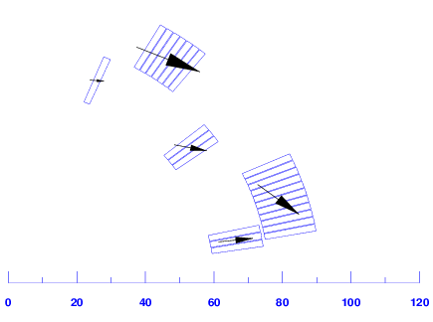

Figure 1. Left: Design 1. 60 mm aperture. The sectors are indexed from 1 to 5. The inner sectors are indexed 1-3, 1 starting at the sector closest to the midplane. Sector 4 is the sector closest to the midplane in the outer layer, 5 is the upper sector in the outer layer. 6 T central field at short sample. Right: Force vectors

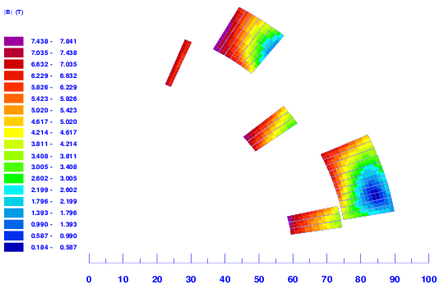

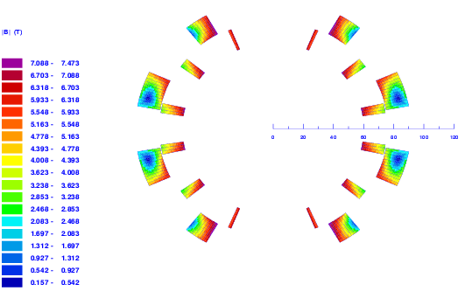

Figure . Magnetic field map

Design 2 loose loosing

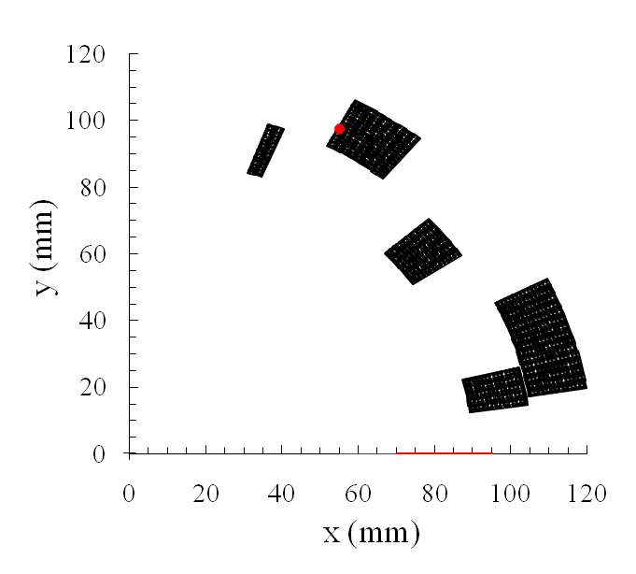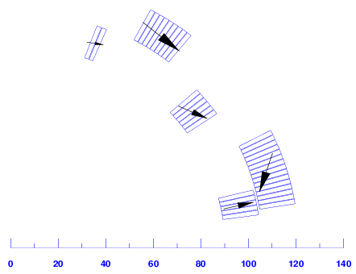

Figure 3. Design 2 90 mm aperture. 6 T short sample field.

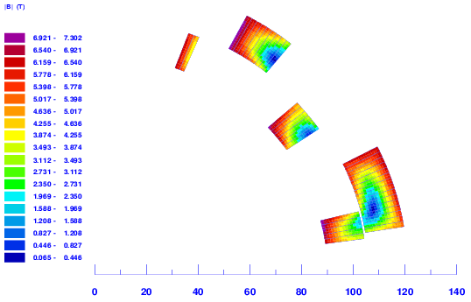

Figure

Design 3

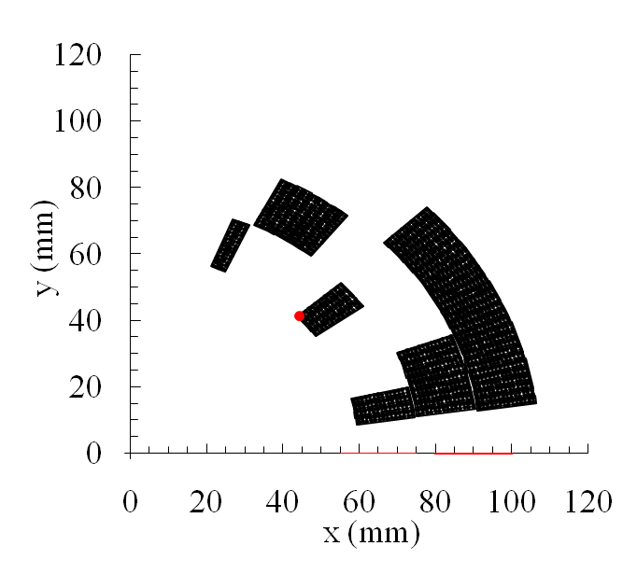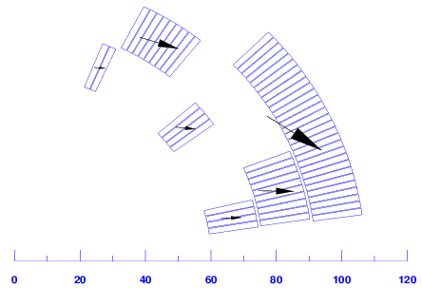

Figure 5. 60 mm aperture radius, 3 layers. 8.5 T central field (short sample) at 1.9 K.

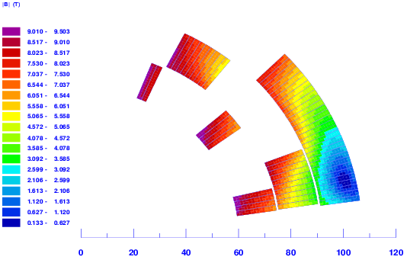

Figure

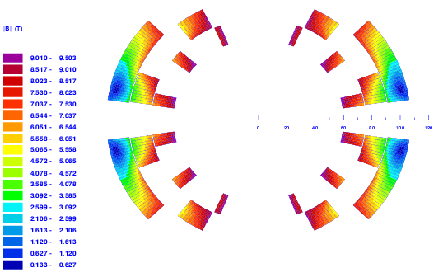

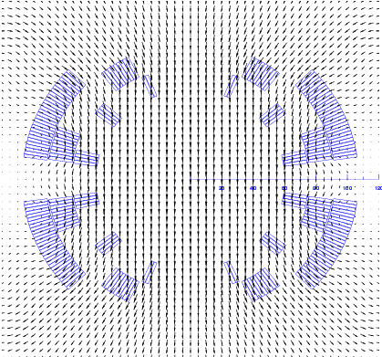

Parallel



|  |  |  |  |
| --- | --- | --- | --- |
| Design | 1 | 2 | 3 |
| *r* (aperture) | 60 | 90 | 60 |
| *Bss* (T) at 1.9 | 6.54 | 6.86 | 8.76 |
| Nominal field at 1.9 (T) | 5.2 | 5.5 | 7.0 |
| *Bss* (T) at 4.2 (T) | 4.95 | 5.3 | 6.72 |
| Nominal field at 4.2 | 4.0 | 4.2 | 5.4 |
| Gap in midplane (mm) | 8.9 | 12.5 | 8.7 |
| Yoke radius (mm) | 180 | 270 | 240 |

|  |  |  |  |
| --- | --- | --- | --- |
| Cost (MCHF per unit) | Design 1 | Design 2 | Design 3 |
| Magnet (material + fabrication) | 0.71 | 0.76 | 0.82 |
| Vacuum vessel | 0.1 | 0.1 | 0.1 |
|  |  |  |  |
| Total |  |  |  |

|  |  |  |  |
| --- | --- | --- | --- |
| Design | 1 | 2 | 3 |
| *Bss* (T) at 1.9 K | 6.5 | 6.8 | 8.7 |
| Operational field at 1.9 K (T) | 5.2 | 5.5 | 7.0 |
| *Bss* (T) at 4.2 K (T) | 4.9 | 5.3 | 6.7 |
| Operational field at 4.2 K | 4.0 | 4.2 | 5.4 |

|  |  |  |  |
| --- | --- | --- | --- |
| Forces on the sectors (kN/m) | | | |
| sector | X | Y | Radial |
| 1 | 413 | 17 | 408 |
| 2 | 407 | -39 | 289 |
| 3 | 225 | -16 | 72 |
| 4 | 738 | -11 | 707 |
| 5 | 803 | -248 | 215 |
| 6 | 1137 | -758 | 695 |