WP3 30 November 2018

MQXFA: the MQXFAP2 prototype had the last shell broken during the cool/down or during the first powering. The shell had visual differences with respect to the others and different manufacturing batch. Investigations are ongoing to understand if the material was faulty or if the design margin is not adequate. A piece of shell shall be sent to CERN for analysis. Acceptance criteria for the magnet are in the final phase of approval.

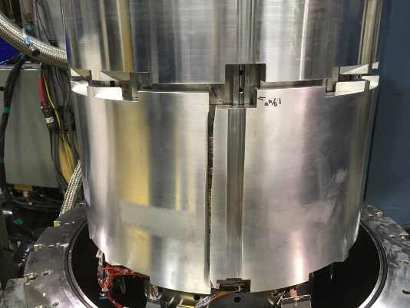

MQXFB: see LMF report

MCBXF: Magnet assembly in the inner dipole has been completed in 927 (see also LMF report), test foreseen for second week of December. Magnetic measurement at room temperature give field quality close to targets, but 40 units difference in b3 to be investigated.

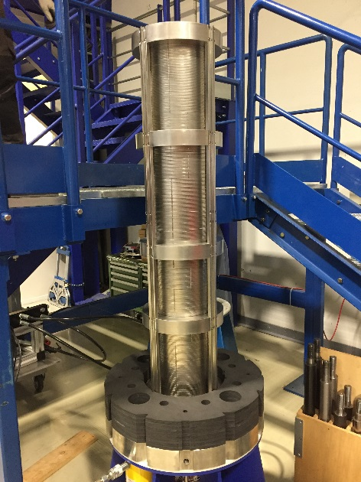 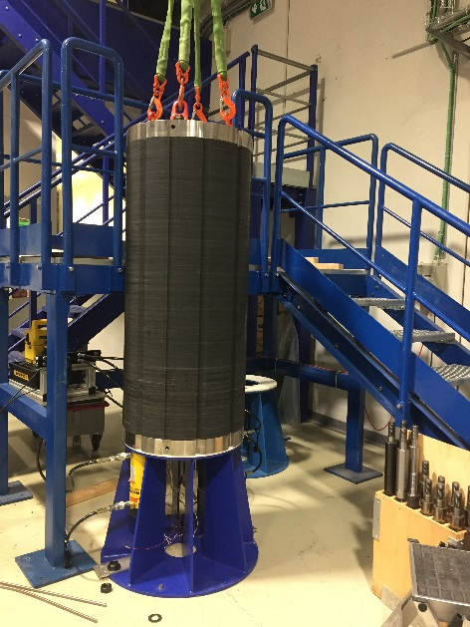

HO correctors: Call for tender for the series completed at INFN Genova, one offer received from SAES RIAL. Given that the INFN tender procedure has a price cap, there shall be no surprise on the amount of the offer.

D1: Analysis of the magnetic measurements is ongoing to understand the situation for the b3, which is still far from targets. Second test of MBXFS2 in December to verify the memory.

D2: Assembly of the two apertures in the Al sleeve and in the yoke has been completed in ASG. There is a weakness in the design of the collars on the layer jump that shall be corrected in the prototype. Magnetic measurements with the yoke shall be conclusive on the level of field quality reached.

D2 corrector: test of the prototype is completed, the second test after thermal cycle is postponed to January. Investigations are ongoing on (i) the difference between model and measured transfer function (ii) the 10 units of systematic b3 (iii) the longer training of the second aperture. A third aperture shall be built. The Chinese coloration agreed to suspend the former shaping until the b3 problem is clarified.