WP3 14 to 28 January 2019

D1: Winding of the first coil of the third model first coil is ongoing in KEK. Acquisition of the winding machine for the prototype and series magnets and installation in KEK.

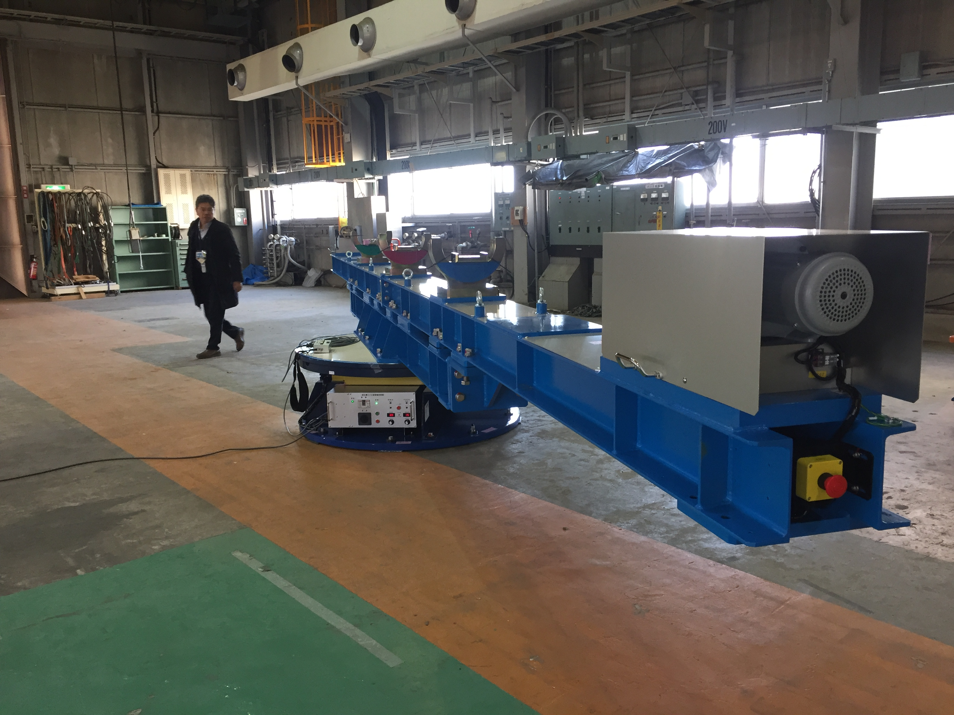

D2: Short model has been completed in ASG and sent to CERN for powering test. Room temperature magnetic measurements shown field quality balance between the apertures within 10 units; some fine tuning may be needed to satisfy b3 and b5 requirements, but the principles of magnet design are confirmed.

D2 corrector: Test of the prototype after thermal cycle: ultimate field reached in both apertures and all configurations.