**ADDENDUM No. 1 KExxx**

**to**

**FRAMEWORK COLLABORATION AGREEMENT KNxxx**

**between**

**THE EUROPEAN ORGANIZATION FOR NUCLEAR RESEARCH (CERN)**

**and**

**Istituto Nazionale di Fisica Nucleare (the “Institute”)**

**concerning**

**Collaboration in design and prototyping of the superconducting D2 magnets prior to series construction and design, procurement and testing of the high-order orbit corrector superconducting magnets in the framework of the High Luminosity upgrade for the LHC at CERN**

**CONSIDERING:**

* Framework Collaboration Agreement KNxxx (the “Agreement”) concluded between CERN and the Institute (individually the “Party” and collectively the “Parties”) defining the framework applicable to collaboration between them in areas of mutual interest, including but not limited to the domains of particle and accelerator physics;
* Article 2.1 of the Agreement which provides that the scope, each Party’s contribution and all other details of each specific Project shall be laid down in Addenda to the Agreement;
* That the Parties have identified the Project set out below, which shall be covered by the provisions of this Addendum No.1 KExxx (the “Addendum”). This Addendum shall be subject to the provisions of the Agreement, it being understood that in case of divergence the provisions of this Addendum shall prevail,

**THE PARTIES AGREE AS FOLLOWS:**

**Project**:

Collaboration in design and prototyping of the superconducting D2 magnets prior to construction and design, procurement and testing of the high-order orbit corrector superconducting magnetsin the framework of the High Luminosity upgrade for the LHC at CERN.

**Duration:**

The Project shall commence on 1 July 2016 and shall be completed no later than December 2020

**Work Packages:**

|  |  |
| --- | --- |
| **WP1** | **Higher-order corrector magnets** |
| **WP2** | **Design and prototypes of the D2 Magnets** |

Workpackage content description:

**Introduction**

The HL LHC project aims at collecting in the LHC 3000 fb-1 within the horizon of the mid 30’s. Among other hardware changes, it concerns the replacement of the magnets around ATLAS and CMS with larger aperture magnets, to allow a factor two smaller beam size in the interaction point. The changes concern the magnet from the first quadrupole (Q1) after the experiment to the fourth quadrupole (Q4). A schematic of the new layout is shown in Fig. 1. INFN has contributed in the stage of the design and in the first phase of the project with the collaboration agreement CERN-INFN KE2291/TE/HL-LHC on two specific developments

* Design, construction and test of the protoypes of five high order corrector magnets (Detailed layout shown in Fig. 2)
* Design of the separation dipole D2.

This new collaboration agreement will significantly extend the previous contribution to

* The construction of the series plus spares of the high order corrector magnets;
* The construction of a short model and of a full length prototype of the separation dipole D2.

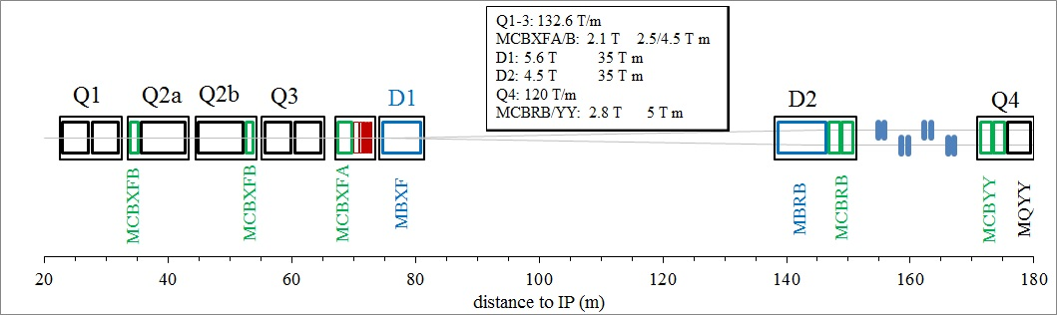

**Fig. 1 New layout of the magnets right of the interaction point**

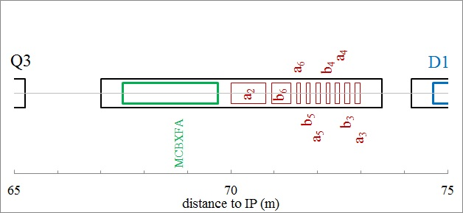

**Fig. 2 Magnification of the previous picture in the corrector package region**

**WP1 – High Order Correctors**

**INFN responsible Giovanni Volpini**

**CERN responsible Ezio Todesco**

**Start: January 2018**

**End: December 2020**

**Summary:** The agreement for the high order correctors is aimed to the tender and follow up of the production of the series of 54 units of nine different magnets, including spares, and their test in vertical position at 2.2 K in INFN-LASA. INFN is expected to finalizing the engineering of the magnets, organizing the procurement through industrial contracts, and test in a vertical cryostat. All operations will be performed in agreement with the HL-LHC QA plan.

**CERN roles:** 1)Define the magnet specifications and the interfaces and verify the compliance with the HL-LHC specifications; 2) Procure the iron raw material for the yoke laminations; 3) Procure the equipment for magnetic measurement test and train the INFN staff to its use

**INFN roles:** 1)Write the technical specification, in agreement with HL-LHC technical specification and with the HL-LHC quality assurance plan, and all the relevant documents finalised to an open bid and awarding an industrial contract for the construction of the series. 2) Follow-up the industrial contract for the series construction in close collaboration with CERN. 3) Test the magnets in INFN LASA and deliver to CERN.

**Technical description:** The high order correctors prototypes (one quadrupole, one sextupole, one octupole, one decapole, and one dodecapole) design, manufacturing and test at LASA-INFN fall within the scopes of the C.A. CERN-INFN KE2291/TE/HL-LHC. At the moment of writing the sextupole has been successfully built and tested. The five magnets will be completed and tested by the end of 2017. The scope of the present agreement is the construction and test of nine types of correctors

* Skew quadrupole
* Normal and skew sextupole
* Normal and skew octupole
* Normal and skew decapole
* Normal and skew dodecapole

The magnet specifications are given in Table I. The aperture is 150 mm, maximum lengths are about 180 mm with the exception of the normal dodecapole (about 514 mm) and the skew quadrupole (about 891 mm). The magnet mechanical lengths reported in Table I and Table II will be confirmed on the basis of the final prototype designs. Sextupole, octupole, and decapole will have the same gradient in the normal and skew case. Operational temperature is 1.9 K, and the maximum expected radiation dose during the HL-LHC lifetime is 35 MGy at ultimate integrated luminosity (4000 fb-1). CERN will endorse the compliance of the materials and components used with the maximum radiation dose. Field harmonics have to be below 100 units (1%) at the reference radius of 50 mm. These magnets will require a large margin on the loadline (>50%).

INFN LASA will test the magnets at 2.2 K during the production, qualifying them for the installation in HL-LHC. The magnets will have to reach 108% of the nominal current. This value must be reached with no training after the first thermal cycle. A detailed acceptance scheme, containing possible exceptions to the above general criterion, will be worked out later, based on the results of the previous C.A. KE2291/TE/HL-LHC.

**Table I. Functional requirements**

|  |  |  |  |  |  |
| --- | --- | --- | --- | --- | --- |
|  |  | MCSXF | MCOXF | MCDXF | MCTXF |
| Order |  | 3 | 4 | 5 | 6 |
| Orientation |  | Normal | Normal | Normal | Normal |
| Number of apertures | mm | 150 | 150 | 150 | 150 |
| Units, including spares |  | 6 | 6 | 6 | 6 |
| Integral magnetic field | T·m | 0.063 | 0.046 | 0.025 | 0.086 |
| Mechanical length end-to-end plate | (mm) | ≤184 | ≤160 | ≤172 | ≤514 |
| Operating temperature | K | 1.9 | 1.9 | 1.9 | 1.9 |
| Nominal Current | (A) | ≤105 | ≤105 | ≤105 | ≤105 |
| Load-line margin | (%) | >50% | >50% | >50% | >50% |
| Multipoles at Rref= 50 mm | (units) | <100 | <100 | <100 | <100 |
| Radiation resistance | (MGy) | >35 | >35 | >35 | >35 |

|  |  |  |  |  |  |  |
| --- | --- | --- | --- | --- | --- | --- |
|  |  | MCQSXF | MCSSXF | MCOSXF | MCDSXF | MCTSXF |
| Order |  | 2 | 3 | 4 | 5 | 6 |
| Orientation |  | Skew | Skew | Skew | Skew | Skew |
| Number of apertures | mm | 150 | 150 | 150 | 150 | 150 |
| Units, including spares |  | 6 | 6 | 6 | 6 | 6 |
| Integral magnetic field | T m | 1.00 | 0.063 | 0.046 | 0.025 | 0.017 |
| Mechanical length end-to-end plate | (mm) | ≤891 | ≤184 | ≤160 | ≤172 | ≤166 |
| Operating temperature | K | 1.9 | 1.9 | 1.9 | 1.9 | 1.9 |
| Current | (A) | ≤200 | ≤105 | ≤105 | ≤105 | ≤105 |
| Load-line margin | (%) | >50% | >50% | >50% | >50% | >50% |
| Multipoles  at Rref= 50 mm | (units) | <100 | <100 | <100 | <100 | <100 |
| Radiation resistance | (MGy) | >35 | >35 | >35 | >35 | >35 |

The final engineering design for the series production will be based on the prototype design, accounting for (i) feedback from the test and (ii) finalization of the interfaces with other magnets in the corrector package, provided by CERN. A sketch of the present magnet cross-sections used for the prototypes are given in Fig. 3. The prototype design is based on the superferric concept, with a cold iron yoke and superconducting Nb-Ti coils with a peak operational field in the range of 2-3 T.

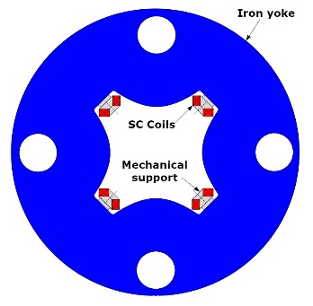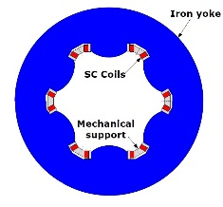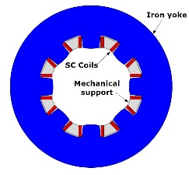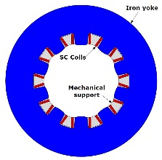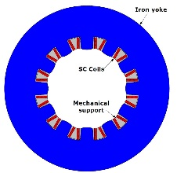

**Fig. 3 Cross section of the high order correctors (skew cases shown)**

**INFN structures involved: INFN** LASA

**Cost, resources and sharing between CERN and INFN**

The total value for the design, construction, test and shipment to CERN of the HO corrector magnets is evaluated in 5442 k€. CERN will pay 2762 k€ in cash to INFN; the CERN supplied materials is evaluated at a value of 100 k€; the INFN contribution amounts to 2580 k€ , including personnel (about 24 FTE-y in total) and general expenditures.

**Milestones:**

|  |  |  |
| --- | --- | --- |
| **M1.1** | Engineering Design of the series completed | April 2018 |
| **M1.2** | First coil wound | February 2019 |
| **M1.3** | First batch delivered to INFN-LASA for test (2 magnets per type) | September 2019 |
| **M1.4** | Second batch delivered to INFN-LASA for test (2 magnets per type) | April 2020 |
| **M1.5** | Third batch delivered to INFN-LASA for test (2 magnets per type) | September 2020 |

**Deliverables**:

|  |  |  |
| --- | --- | --- |
| **D1.1** | Award for the contract of the series construction | October 2018 |
| **D1.2** | First tested batch delivered to CERN (2 magnets per type) | December 2019 |
| **D1.3** | Second tested batch delivered to CERN (2 magnets per type) | July 2020 |
| **D1.4** | Third tested batch delivered to CERN (2 magnets per type) | December 2020 |

**A batch is composed of two magnets per type (total of 9 magnets)**

**WP2 - D2 magnet**

**INFN Responsible Pasquale Fabbricatore**

**CERN responsible Ezio Todesco**

**Start: June 2016**

**End: October 2019**

**Summary:** The agreement for D2 is aimed to the delivery to CERN of a short model (1.5 m) and of a full scale prototype (8 m) of D2 magnet fulfilling the required functional characteristics specified by CERN. INFN is expected finalizing the engineering of the magnet and organizing the procurement of both short model and prototype through industrial contracts, which shall be performed in agreement with the HL-LHC QA plan.

**CERN roles:** 1)Define the magnet specifications and the interfaces and verify the compliance with the HL-LHC specifications. 2) Procure the following material for both short model and prototype construction: (a) Insulated superconducting cable (outer cable of LHC dipoles); b) Iron laminations; c) Collar laminations; d) Quench heaters. 3) Perform the test of the short model in a vertical cryostat according to schedule inn view of the award of the contract for prototype.

**INFN roles: 1)** Write the technical specification, in agreement with HL-LHC technical specification and with the HL-LHC quality assurance plan, and all the relevant documents finalised to an open bid and awarding an industrial contract for the construction of the short model. 2) Follow-up the industrial contract for the short model construction in close collaboration with CERN. The short model will be directly delivered to CERN 3) Finalise the engineering design of the prototype and in agreement with the HL-LHC technical specification. 4) Organise the tender for the industrial construction contract of the prototype 5) Follow-up of the industrial contract for the prototype construction in close collaboration with CERN, implementing tzhe HL-LHC QA plan. The prototype will be directly delivered to CERN for test.

**Technical description:** The D2 magnet is presently under design at INFN Sezione di Genova, which is engaged in providing the engineering design of the D2 magnet within the end of 2016, according to the C.A. CERN-INFN KE2291/TE/HL-HLC. The following specifications are based on both the required functional characteristics of the D2 magnet and the outcome of the INFN design. The 2D cross section is shown in Fig.1. It is a twin aperture magnet with a separation between apertures of 188 mm, generating in both apertures an integrated magnetic dipolar field of 35 T·m with the same polarity. The cold mass consists of two asymmetric coils with aperture 105 mm in mechanical (collars) and magnetic structure operating at a temperature of1.9 K in superfluid helium. The dipole cold mass has an elliptic shape with an overall length of about 8200 mm (ancillaries included), a maximum diameter of 624 mm (at room temperature) and a mass of about 13 t. The functional requirements are shown in Table II. More detailed specification will be agred later between CERN and INFN, according to the project needs and state-of-the-art accelerator magnet technology. The dipole will be enclosed, at CERN site by CERN team, in a circular stainless steel shell 8 mm thick.

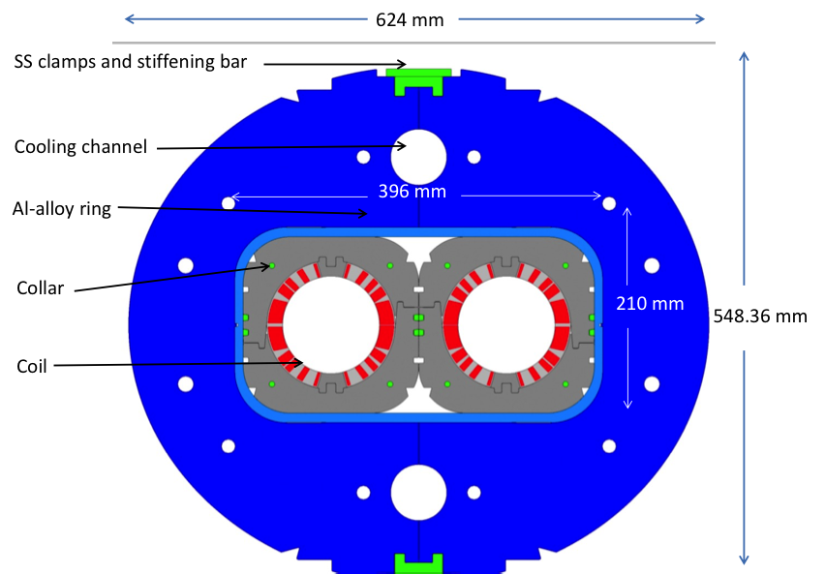

**Fig.1 Cross section of the D2 magnet**

**Table II. Functional requirements**

|  |  |  |
| --- | --- | --- |
| Characteristics | Units | Value |
| Aperture | mm | 105 |
| Number of apertures |  | 2 |
| Distance between apertures (cold/warm) | mm | 188.00/ 188.45 |
| Cold mass(without shell) max diameter | mm | 614 |
| Integral magnetic field | T m | 35 |
| Bore field | T | 4.5 |
| Operating temperature | K | 1.9 |
| Load-line margin | (%) | >35 |
| Multipole variations due to iron saturation | Units in 104 | <10 |
| Radiation resistance | (MGy) | >35 |

**INFN structures involved: INFN** Sezione di Genova

**Cost, resources and Committed resources to be sharinged between INFN and CERN and INFN**

The total value for the design, construction, test and shipment to CERN of the D2 model and prototype magnets is evaluated in 5847 k€. CERN will pay 1832 k€ in cash to INFN; the CERN supplied materials is evaluated at a value of 774 k€; the INFN contribution amounts to 3242 k€ , including personnel (about 12 FTE-y in total) and general expenditures.

**Milestones:**

|  |  |  |
| --- | --- | --- |
| **M2.1** | Engineering Design with construction plan of the prototype completed | December 2017 |
| **M2.2** | Collaring of first aperture of the short model | May 2017 |
| **M2.3** | Test of short model at CERN | March 2018 |
| **M2.4** | Collaring of firt aperture of the prototype | January 2019 |

**Deliverables**:

|  |  |  |
| --- | --- | --- |
| **D2.1** | The contract for the construction of the short model awarded | September 2016 |
| **D2.2** | Short model delivered to CERN * | December 2017 |
| **D2.3** | The contract for the prototype construction awarded | April 2018 |
| **D2.4** | Prototype delivered to CERN | October 2019 |

* The short model (1.5 m) shall be delivered with electrical and mechanical interfaces suitable for a cryogenic test in the vertical position at CERN.

**Final Property:**

Both for the HO corrector magnets and the model and prototypes will remain property of CERN. The tooling for construction and test will remain property of INFN. The CERN supplied tooling, like the magnetic measuring system and other possible tooling or equipment, will return to CERN after completion of the scope of the programme. This disposition may be changed upon deliberation of the Steering Committee.

**General Conditions :**

INFN has to grant access to CERN personnel, with modality to be agreed, to INFN laboratories and to main contractors where works (including components constructions9 for the execution of the contract are carried out.

INFN commit to repair and intervene on any possible hidden defect, and imputable to INFN scope of delivery, that may be discovered within two years from acceptance.

Acceptance procedure(s):

CERN shall grant acceptance of each Work Package after the successful completion such Work Package and the provision by the Institute of the associated documentation, within two (2) months from the date of such completion.

PAYMENT SCHEDULE

|  |  |  |  |
| --- | --- | --- | --- |
| **D1.1** | Award for the contract of the series construction | October 2018 | 25% |
| **D1.2** | First tested batch delivered to CERN (2 magnets per type) | December 2019 | 20% |
| **D1.3** | Second tested batch delivered to CERN (2 magnets per type) | July 2020 | 20% |
| **D1.4** | Third tested batch delivered to CERN (2 magnets per type) | December 2020 | 35% |

(% of the WP1 payment of 2762 k€)

|  |  |  |  |
| --- | --- | --- | --- |
| **D2.1** | The contract for the construction of the short model awarded | September 2016 | 25% |
| **D2.2** | Short model delivered to CERN * | December 2017 | 10% |
| **D2.3** | The contract for the prototype construction awarded | April 2018 | 25% |
| **D2.4** | Prototype delivered to CERN | October 2019 | 40% |

(% of the WP2 payment of 1832 k€)

Subject to the continued validity of the Agreement, this Addendum shall remain in force for as long as necessary to give effect to the Parties’ respective rights and obligations under this Addendum.

This Addendum may be amended by written agreement by the Parties.

Thus drawn up in two copies in the English language and signed by the authorized representatives of the Parties.

|  |  |
| --- | --- |
| The European Organization  for Nuclear Research (CERN) | The Istituto Nazionale di Fisica Nucleare |
| …………………..  xxx  On:……………………………2016 | ……………………  xxx  On:………………………………….2016 |