**ADDENDUM No. 2 KE3085/TE/HL-LHC**

**to**

**FRAMEWORK COLLABORATION AGREEMENT KN3083**

**between**

**THE EUROPEAN ORGANIZATION FOR NUCLEAR RESEARCH (CERN)**

**and**

**Istituto Nazionale di Fisica Nucleare (the “Institute”)**

**concerning**

**Collaboration in design, procurement and testing of the high-order orbit corrector superconducting magnets in the framework of the High Luminosity upgrade for the LHC at CERN**

**CONSIDERING:**

* Framework Collaboration Agreement KN3083 (the “Agreement”) concluded between CERN and the Institute (individually the “Party” and collectively the “Parties”) defining the framework applicable to collaboration between them in areas of mutual interest, including but not limited to the domains of particle and accelerator physics;
* Article 2.1 of the Agreement which provides that the scope, each Party’s contribution and all other details of each specific Project shall be laid down in Addenda to the Agreement;
* That the Parties have identified the Project set out below, which shall be covered by the provisions of this Addendum No.2 KE3085 (the “Addendum”). This Addendum shall be subject to the provisions of the Agreement, it being understood that in case of divergence the provisions of this Addendum shall prevail,

**THE PARTIES AGREE AS FOLLOWS:**

**Project**:

Collaboration in design, procurement and testing of the high-order orbit corrector superconducting magnetsin the framework of the High Luminosity upgrade for the LHC at CERN.

## 2. Personnel of the Project

Contact persons:

CERN: Ezio Todesco, e-mail: Ezio.Todesco@cern.ch

INFN: Massimo Sorbi e-mail: Massimo.Sorbi@mi.infn.it

Or such successor as each Party may designate

**Duration:**

The Project shall commence on 1 January 2018 and shall be completed no later than December 2021

1. **Each Party’s contribution**

4.1 CERN’s contribution:

4.1.1 CERN shall provide the following:

1) Definition of the magnet specifications and interfaces and verification of their compliance with the HL-LHC specifications;

2) Procurement of the iron raw material for the yoke laminations in accordance with Annex 1.

3) Procurement of the equipment for magnetic measurement test and training of the INFN staff to its use.

* + 1. CERN shall make a financial contribution that shall not exceed the amount(s) set out in Annex 2.

4.1.3 CERN’s contribution under Article 4.1.2 shall be subject to receipt of a correct debit note. Payment details are set out in Annex 2.

4.2 INFN’s contribution:

1) Preparation of the technical specification, in accordance with the HL-LHC technical specification and with the HL-LHC quality assurance plan, and of all the relevant documents finalised to an open bid and awarding an industrial contract for the construction of the series to be performed by INFN;

2) Follow-up of the industrial contract(s) for the series construction and the implementation of the HL-LHC QA plan in close collaboration with CERN.

3) Test the magnets in operative conditions (as described in the Annex 1) in INFN LASA and deliver to CERN.

With regard to item 1 above, INFN shall ensure that the provisions of its contracts with any industrial partner are consistent with the provisions of this Addendum and/or the Agreement, in particular with Article 5 thereof concerning intellectual property, which will be regulated by specific agreements once the industrial contracts will be awarded.

1. **Work Package**

The Work Package, related milestones and deliverables are defined in Annex 1.

1. Organization and coordination

6.1 **Steering Committee**

A Steering Committee shall be created with a composition of qualified representatives for each Party. Each Party shall have the right to replace its representatives subject to prior written notification to the other Party.

As and when required, each of the representatives may be assisted by any specialist of their choice, including its Technical Coordinator as defined in the Article 6.2 hereafter, subject to notifying the other representatives thereof in advance. These specialists shall participate in the Steering Committee’s meetings only in an advisory capacity.

The Steering Committee shall monitor the performance of the work specified in this Addendum. It shall ensure compliance with the deliverables and the delivery schedule specified in Annex 1 and if necessary and upon the Technical Coordinator’s advice, shall male recommendations on solutions to the Parties in the event of execution problems. It may also propose any modification to this Addendum it deems useful in technical and financial matters.

The Steering Committee shall also act as a body enabling the Parties to resolve difficulties or disputes.

The Steering Committee shall meet at least once a year, or more frequently upon the request of a Party, in the presence of INFN and CERN ad hoc representatives.

The INFN representatives at the Steering Committee shall be:

Antonio Zoccoli

Eugenio Nappi

The CERN representatives at the Steering Committee shall be:

Frédérick Bordry

Lucio Rossi

6.2 **Technical Coordinators**

CERN and INFN shall each nominate a Technical Coordinator whose role shall be to co-ordinate the activities related to the performance of the work packages within the project. The Technical coordinators shall also act as Safety Correspondents and be responsible for safety matters.

The Technical Coordinators shall report to the Steering Committee on the performance of the work packages. In case of difficulties in the performance of the work packages, they shall present solutions and options to the Steering Committee.

The CERN Technical Coordinator shall grant acceptance of the deliverables in accordance with Article 7 hereafter.

The Technical Coordinators and Safety Correspondents shall be:

For CERN: Ezio Todesco

For INFN: Massimo Sorbi

1. Acceptance procedure(s):

7.1 CERN shall grant acceptance of the Work Package after the successful completion of each milestone or deliverable defined therein and the provision by INFN of the associated documentation, within two (2) months from the date of such completion.

7.2 The corrector magnets shall become, upon acceptance, property of CERN. The tooling for construction and test shall remain INFN’s property. The CERN supplied tooling, like the magnetic measuring system and other possible tooling or equipment, shall return to CERN after completion of the Project. This arrangement may change upon deliberation by the Steering Committee.

1. **Miscellaneous**

8.1 INFN shall grant access to CERN personnel, with modalities to be agreed, to INFN laboratories and to main contractors where works (including component constructions) for the execution of this Addendum are carried out.

8.2 INFN shall intervene and repair any possible hidden defect that is caused by the non-compliant execution of the quality assurance procedures forming part of INFN’s scope of delivery and that may be discovered within two (2) years from acceptance.

Subject to the continued validity of the Agreement, this Addendum shall remain in force for as long as necessary to give effect to the Parties’ respective rights and obligations under this Addendum.

This Addendum may be amended by written agreement by the Parties.

Thus drawn up in two copies in the English language and signed by the authorized representatives of the Parties.

|  |  |
| --- | --- |
| The European Organization  for Nuclear Research (CERN) | The Istituto Nazionale di Fisica Nucleare (INFN) |
| …………………..  Dr. Fabiola GIANOTTI  Director-General  On:……………………………2016 | ……………………  Prof. Fernando FERRONI  President  On:………………………………….2016 |

ANNEX 1: Work Package

|  |  |
| --- | --- |
| **WP1** | **Higher-order corrector magnets** |

1. Work-package content description:

**Introduction**

The HL-LHC project aims at collecting in the LHC 3000 fb-1 within the horizon of the mid 30’s. Among other hardware changes, it concerns the replacement of the magnets around ATLAS and CMS with larger aperture magnets, to allow a factor two smaller beam size in the interaction point. The changes concern the magnet from the first quadrupole (Q1) after the experiment to the fourth quadrupole (Q4). A schematic of the new layout is shown in Fig. 1. INFN has contributed in the stage of the design and R&D and prototyping phase of the project with the Collaboration Agreement CERN-INFN KE2291/TE/HL-LHC to the following two developments:

* Design, construction and test of the prototypes of five high order corrector magnets (Detailed layout shown in Fig. 2)
* Design of the separation dipole D2.

This new collaboration agreement will significantly extend the previous contribution to

* The construction of the series plus spares of the high order corrector magnets, which is the subject of this agreement;
* The construction of a short model and of a full-length prototype of the separation dipole D2.

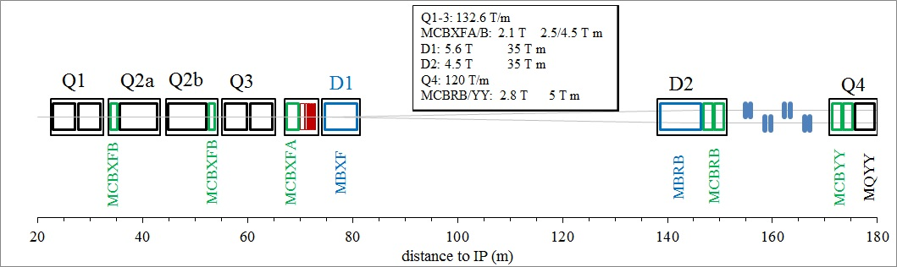

**Fig. 1 New layout of the magnets right of the interaction point**

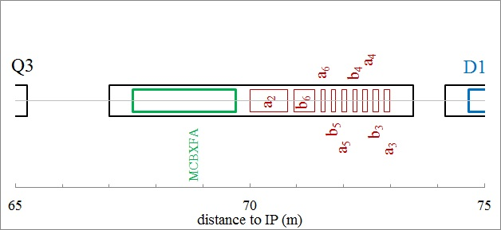

**Fig. 2 Magnification of the previous picture in the corrector package region**

**Scope**

The agreement for the high order correctors is aimed to the tender and follow up of the production of the series of 54 units of nine different magnets, including spares, and their test in vertical position at 4.2 K in INFN-LASA. INFN is expected to finalizing the engineering of the magnets, organizing the procurement through industrial contracts, and test in a vertical cryostat. All operations will be performed in agreement with the HL-LHC QA plan.

**Technical description**

The high order correctors prototypes (one quadrupole, one sextupole, one octupole, one decapole, and one dodecapole) design, manufacturing and test at LASA-INFN fall within the scopes of the C.A. CERN-INFN KE2291/TE/HL-LHC. At the moment of writing the sextupole has been successfully built and tested. The five magnets will be completed and tested by the end of 2017. The scope of the present agreement is the construction and test of nine types of correctors:

* Skew quadrupole
* Normal and skew sextupole
* Normal and skew octupole
* Normal and skew decapole
* Normal and skew dodecapole

The magnet specifications are given in Table I. The aperture is 150 mm, maximum lengths are about 180 mm with the exception of the normal dodecapole (about 514 mm) and the skew quadrupole (about 891 mm). The magnet mechanical lengths reported in Table I and Table II will be confirmed on the basis of the final prototype designs. Sextupole, octupole, and decapole will have the same gradient in the normal and skew case. Operational temperature is 1.9 K, and the maximum expected radiation dose during the HL-LHC lifetime is 35 MGy at ultimate integrated luminosity (4000 fb-1). CERN will endorse the compliance of the materials and components used with the maximum radiation dose. Field harmonics have to be below 100 units (1%) at the reference radius of 50 mm. These magnets will require a large margin on the loadline (>50%).

INFN LASA will test the magnets at 4.2 K (or below) during the production, qualifying them for the installation in HL-LHC. The magnets will have to reach 108% of the nominal current. This value must be reached with no training after the first thermal cycle. A detailed acceptance scheme, containing possible exceptions to the above general criterion, will be worked out later, based on the results of the previous C.A. KE2291/TE/HL-LHC.

**Table I. Functional requirements**

|  |  |  |  |  |  |
| --- | --- | --- | --- | --- | --- |
|  |  | MCSXF | MCOXF | MCDXF | MCTXF |
| Order |  | 3 | 4 | 5 | 6 |
| Orientation |  | Normal | Normal | Normal | Normal |
| Aperture diameter | mm | 150 | 150 | 150 | 150 |
| Units, including spares |  | 6 | 6 | 6 | 6 |
| Integral magnetic field at Rref= 50 mm | T·m | 0.063 | 0.046 | 0.025 | 0.086 |
| Mechanical length end-to-end plate | (mm) | ≤184 | ≤160 | ≤172 | ≤514 |
| Operating temperature | K | 1.9 | 1.9 | 1.9 | 1.9 |
| Nominal Current | (A) | ≤105 | ≤105 | ≤105 | ≤105 |
| Load-line margin | (%) | >50% | >50% | >50% | >50% |
| Multipoles at Rref= 50 mm | (units) | <100 | <100 | <100 | <100 |
| Radiation resistance | (MGy) | >35 | >35 | >35 | >35 |

|  |  |  |  |  |  |  |
| --- | --- | --- | --- | --- | --- | --- |
|  |  | MCQSXF | MCSSXF | MCOSXF | MCDSXF | MCTSXF |
| Order |  | 2 | 3 | 4 | 5 | 6 |
| Orientation |  | Skew | Skew | Skew | Skew | Skew |
| Number of apertures | mm | 150 | 150 | 150 | 150 | 150 |
| Units, including spares |  | 6 | 6 | 6 | 6 | 6 |
| Integral magnetic field | T m | 1.00 | 0.063 | 0.046 | 0.025 | 0.017 |
| Mechanical length end-to-end plate | (mm) | ≤891 | ≤184 | ≤160 | ≤172 | ≤166 |
| Operating temperature | K | 1.9 | 1.9 | 1.9 | 1.9 | 1.9 |
| Current | (A) | ≤200 | ≤105 | ≤105 | ≤105 | ≤105 |
| Load-line margin | (%) | >50% | >50% | >50% | >50% | >50% |
| Multipoles  at Rref= 50 mm | (units) | <100 | <100 | <100 | <100 | <100 |
| Radiation resistance | (MGy) | >35 | >35 | >35 | >35 | >35 |

The final engineering design for the series production will be based on the prototype design, accounting for (i) feedback from the test and (ii) finalization of the interfaces with other magnets in the corrector package, provided by CERN. A sketch of the present magnet cross-sections used for the prototypes are given in Fig. 3. The prototype design is based on the superferric concept, with a cold iron yoke and superconducting Nb-Ti coils with a peak operational field in the range of 2-3 T.

The mechanical (supporting and alignment interfaces), electrical (voltage, protection and instrumentation), powering (envelope of operating scenario) and idraulic (temperature and pressure conditions, cooling and interconnections) interfaces and acceptance conditions will be listed by the time of the first SC meeting (within 6 months of signature) and specified by the time of the second Steering Committee meeting (within 12 months from the signature).

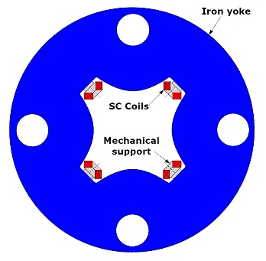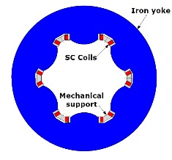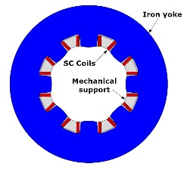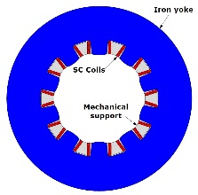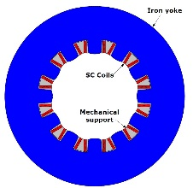

**Fig. 3 Cross section of the high order correctors (skew cases shown)**

**INFN structures involved: INFN** LASA

**1.2 Work package milestones and deliverables**

**Milestones:**

|  |  |  |
| --- | --- | --- |
| **M1.1** | Engineering Design of the series completed | July 2018 |
| **M1.2** | First coil wound | May 2019 |
| **M1.3** | First batch delivered to INFN-LASA for test (2 magnets per type) | November 2019 |
| **M1.4** | Second batch delivered to INFN-LASA for test (2 magnets per type) | July 2020 |
| **M1.5** | Third batch delivered to INFN-LASA for test (2 magnets per type) | March 2021 |

**Deliverables**:

|  |  |  |
| --- | --- | --- |
| **D1.1** | Award for the contract of the series construction | January 2019 |
| **D1.2** | First tested batch delivered to CERN (2 magnets per type) | March 2020 |
| **D1.3** | Second tested batch delivered to CERN (2 magnets per type) | November 2020 |
| **D1.4** | Third tested batch delivered to CERN (2 magnets per type) | June 2021 |

A batch is composed of two magnets per type (total of 10 magnets)

ANNEX 2: CERN’s financial contribution and payments details

**Cost, resources and sharing between CERN and INFN**

The total value for the design, construction, test and shipment to CERN of the HO corrector magnets is evaluated in 5760 k€. CERN will pay 2780 k€ in cash to INFN; the CERN supplied materials is evaluated at a value of 100 k€; the INFN contribution amounts to 2880 k€, including personnel (about 24 FTE-y in total) and general expenditures.

Payment schedule:

|  |  |  |  |  |
| --- | --- | --- | --- | --- |
| **Deliverable** | Description | Date | % | Amount (€) |
| **D1.1** | Award for the contract of the series construction | Jan. 2019 | 25% | 695 000 |
| **D1.2** | First tested batch delivered to CERN (2 magnets per type) | Mar. 2020 | 20% | 556 000 |
| **D1.3** | Second tested batch delivered to CERN (2 magnets per type) | Nov. 2020 | 20% | 556 000 |
| **D1.4** | Third tested batch delivered to CERN (2 magnets per type) | Jun. 2021 | 35% | 973 000 |

Payment details:

Payment within thirty (30) calendar days from CERN’s acceptance of a deliverable and receipt of a correct debit note.

Debit notes shall be sent to:

CERN — FAP Department

Accounts Payable

CH- 1211 GENEVA 23.